Transversals Practice 1 Label Measure of Every Angle (Use pencil!) Name _________________________________________
Given: m∠JAB = 118° m∠PBI = 51° m∠LND = 24° RA║SK JK║AN SC║DN Period___ Date _______
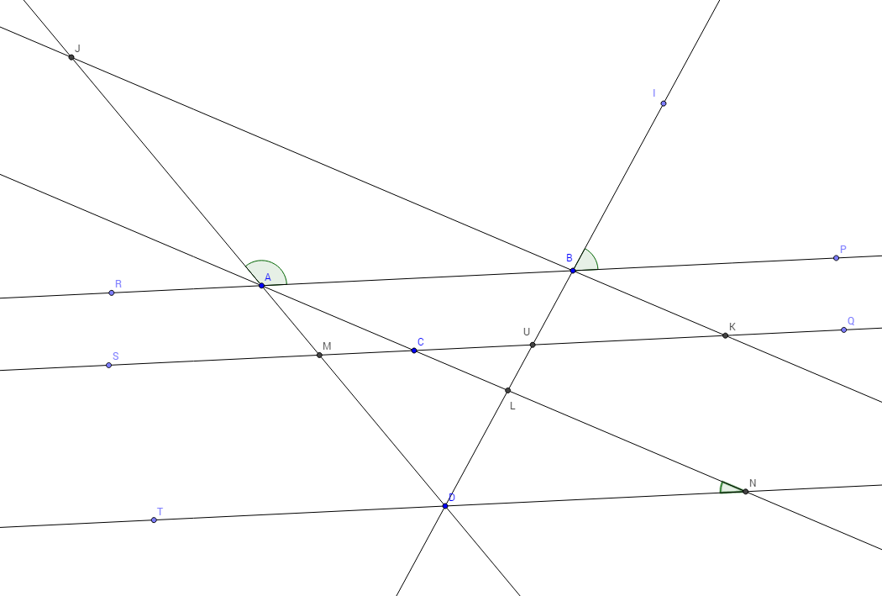
Theorems and Postulates to Use: Vertical ∠’s, Corresponding ∠’s, Alt. Interior ∠’s, Alt. Exterior ∠’s, Same-side Interior ∠’s, Linear Pairs
Note: The three angles in any triangle must add to 180°
The four angles in any quadrilateral must add to 360°

