Name:______________________ Date:________ Hour:______ Assignment #_______

Ray Diagrams
To determine where an image is, it is very helpful to draw a ray diagram. The image will be located at the place where the reflected rays intersect. These reflected rays can intersect in front of the mirror or behind.
You could just draw random rays from the object to the mirror and follow the reflected rays, but there are three rays in particular that are very easy to draw. (Only two rays are necessary to locate the image on a ray diagram, but it's useful to add the third as a check.)
Typically when drawing ray diagrams, it is helpful to use solid lines as the actual light ray and dashed lines for the reflected rays.

Example 1: Follow the rules for a CONCAVE mirror! USE A RULER (OR STRAIGHT EDGE ) TO DRAW STRAIGHT LINES!!!!

1) The first light ray is drawn from the tip of the object parallel to the optical (principal) axis. It then reflects off the mirror and passes through the focal point. (label this as ray 1)
2) The second light ray is drawn from the tip of the object and through the focal point (F), reflecting off the mirror parallel to the principal axis. (The second light ray is similar to the parallel ray, but drawn in reverse order.) (label this as ray 2)
3) The third light ray is drawn from the tip of the object through the center of curvature (C). This ray will reflect back along the same path it came. (label this as ray 3)
Once all three rays are drawn, the point where the light rays intersect represents the tip of the object and must be drawn accordingly from the optical axis.
Example 1:
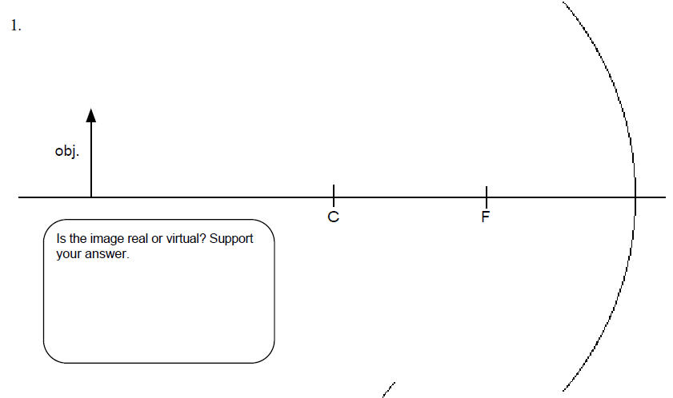

Example 2: Follow the rules for a CONCAVE mirror! USE A RULER (OR STRAIGHT EDGE ) TO DRAW STRAIGHT LINES!!!!

1) The first light ray is drawn from the tip of the object parallel to the optical (principal) axis. It then reflects off the mirror and passes through the focal point. (label this as ray 1)
2) The second light ray is drawn from the tip of the object and through the focal point (F), reflecting off the mirror parallel to the principal axis. (label this as ray 2)
3) The third light ray is drawn from the tip of the object through the center of curvature (C). This ray will reflect back along the same path it came. (label this as ray 3)
4) Now that all three lines have been drawn, you can see that they DO NOT intersect in front of the mirror. If this is the case, then maybe they intersect from behind the mirror. To determine this, go back to each reflected ray and extend them to the back of the mirror using dashed lines.
Example 2:
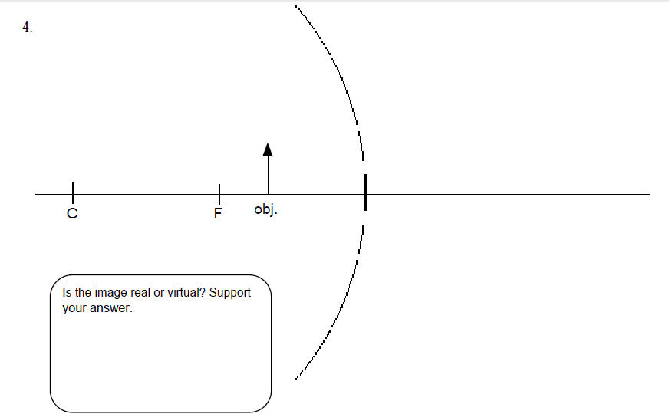

Example 3 : Follow the rules for a CONVEX mirror!

1) The first light ray is drawn from the tip of the object parallel to the optical (principal) axis. It then reflects off the mirror at an angle that passes through the focal point. (label this as ray 1)

2) The second light ray is drawn from the tip of the object towards the focal point (F), reflecting off the mirror parallel to the principal axis. (NOTE THAT THE FOCAL POINT IS BEHIND THE OBJECT) (label this as ray 2)

3) The third line is drawn from the tip of the object through the center of curvature (C). (label this as ray 3)

4) Because the reflected rays diverge (spread apart), we MUST extend the reflected rays back behind the mirror! Use dashed lines for this. Where the lines intersect is our image.

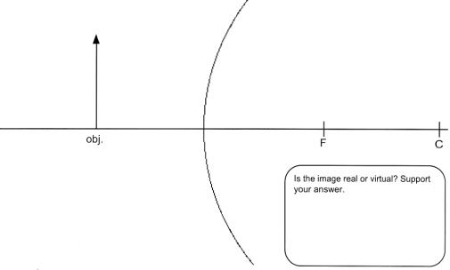

Draw ray diagrams for the following using the rules for concave or convex mirrors! Answer the questions by circling the correct answer.
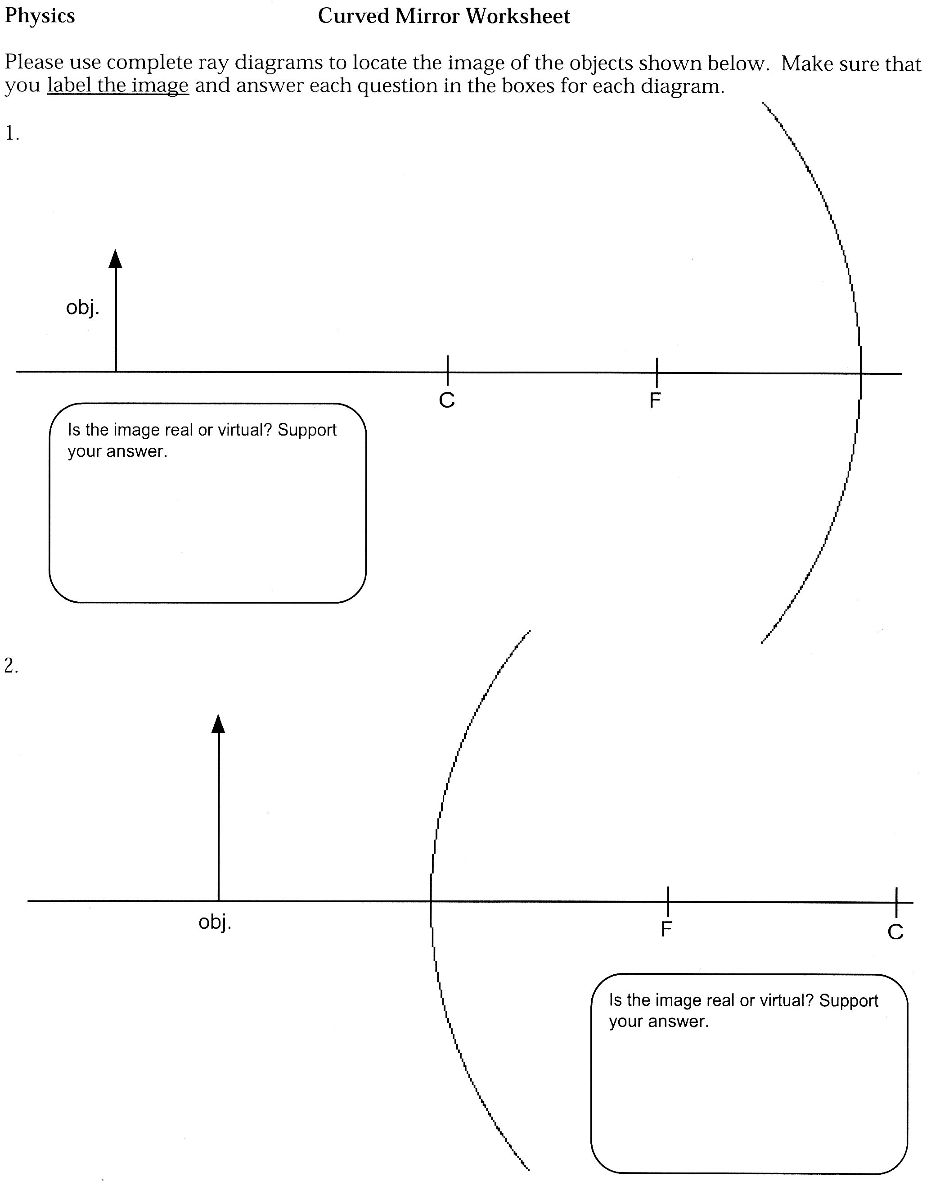
Concave or convex mirror?

Is the image real or virtual?

Is the image smaller or larger?

Is the image upside down or right side up?
Concave or convex mirror?

Is the image real or virtual?

Is the image smaller or larger?

Is the image upside down or right side up?

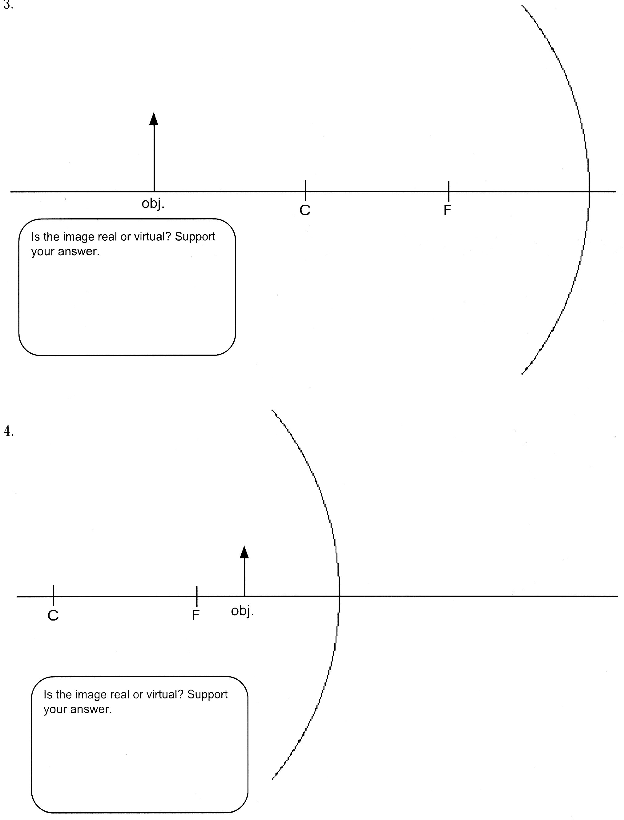
Concave or convex mirror?

Is the image real or virtual?

Is the image smaller or larger?

Is the image upside down or right side up?
Concave or convex mirror?

Is the image real or virtual?

Is the image smaller or larger?

Is the image upside down or right side up?

