INVESTIGATION- “CHRISTOPHER COLUMBUS ”
Was Christopher Columbus’ arrival in North America a positive or negative event long-term?
Our human narrative began with small hunting and gathering bands that left Africa and spread throughout the world. When Homo Sapien arrived in Argentina it marked the beginning of the end of hunting and gathering as the dominant way to live. This led to the rise of Agriculture and eventually civilizations along the four River Valley Civilizations. Following these, the classical world established the framework and important cultural precedents for future people. When the Silk Roads and Trans-Saharan Trade Routes were established the world increased its hemispheric interactions greatly. This left our world interregionally divided along the four world zones of Afro-Eurasia, the Americas, Australasia, and the Pacific. What made our story global for the first time was the arrival of Columbus to North America in 1492. Many historians argue this was the most important event in world history. I want you to research this and make your own assertions. This is an assessment grade and due a week from today.
YOUR RESEARCH WILL BE ALONG THREE AREAS:
EXPLORE YOUR PRIOR KNOWLEDGE AND MAKE SOME HYPOTHESIS | When beginning an investigation it is good to start with your conjectures. A conjecture is a speculation or a guess we make without having lots of evidence. Write down what you already know. State what you would guess the effect Columbus had on the world. What thoughts come to mind when you think of Columbus.
RESEARCH | Utilize Internet sources, your textbook, and reference books to delve into the study of Columbus. Treat this as a detective would treat a crime, keeping an open mind and relying on evidence. Capture your notes in a word document that contains an MLA citation.
SHOW YOUR THINKING | It is now time to show your thinking. You will write a formal paper that will be used as your writing sample. It will follow a format and will graded using a rubric. It is the expectation that this is your best work. OVERUSAGE OF CUTTING AND PASTING WILL RESULT IN HAVING YOUR PAPERS RETURNED UNTIL YOU DEMONSTRATE ORIGINAL THINKING AND YOUR OWN WRITING VOICE!

PART I: “EXPLORE YOUR PRIOR KNOWLEDGE AND MAKE SOME HYPOTHESIS”
Write down everything you know, or think you know about Columbus. Also guess what changes his arrival in North America had on the world. Do not worry about grammar, or being right. Simply empty your brain.

“PART II: “RESEARCH”
I want you to find a minimum of ten separate historical sources. I also want you to find sources that are a combination of positive and negative accounts and portrayals of Columbus. There are primary and secondary sources. If you forgot what constitutes a primary source, it can be any of the following items:
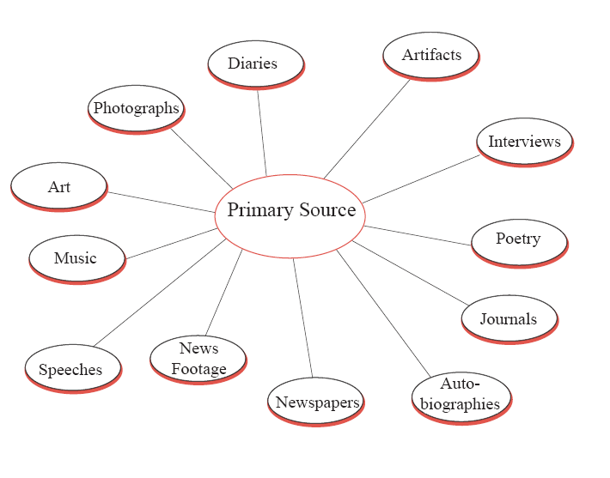
Secondary sources are other people’s accounts of the event. In short, they are individuals’ interpretation of primary sources.
Primary or secondary?  Source in MLA format- (Can create this sources using: http://www.calvin.edu/library/knightcite/ | Meaning of the Source? | How does it affect your view of Columbus?
EXAMPLE: PRIMARY SOURCE- because it is the original account from the pen of Columbus, free from biased  Plannck, Stephan (Interpreter). Epistola Christofori Colom (Letters of Christopher Columbus). Rare Book and Special Collections ed. Washington D.C.: Library of Congress, 1493. N. pag. LOC.gov. Web. 22 Jan. 2016. <http://www.loc.gov/exhibits/exploring-the-early-americas/columbus-and-the-taino.html>. | This is the account Columbus left after his arrival claiming there were countless people upon his arrival. The most important excerpt was, “There I found very many islands, filled with innumerable people, and I have taken possession of them all for their Highnesses, done by proclamation and with the royal standard unfurled, and no opposition was offered to me.” | I feel this is him being a good soldier of sorts. He seems to be motivated to claim this land for Spain. He seems to also have little regard for the people he is taking over. However, if they didn’t put up a fight, can you blame him for taking over?
1)

2)

3)

4)

5)

6)

7)

8)

9)

10)

PART III: SHOW YOUR THINKING:
"IN 1492, CHRISTOPHER COLUMBUS ARRIVED IN NORTH AMERICA. THIS MADE THE WORLD A ____________ PLACE BECAUSE OF ______________, ________________, ________________AND HE SHOULD BE PORTRAYED IN THE HISTORY BOOKS AS A ______________, AND A ________________". ALTHOUGH THERE ARE THOSE WHO WOULD SEE COLUMBUS AS ___________________ (Opposing viewpoint), I STILL FEEL ______________, ______________, ______________ (Restatement of thesis and your own personal beliefs)
Reminder that each paragraph needs to be a minimum of 5 sentences.
Paragraph 1: Lead in sentences to set the tone, statement of your opinion, and telling me what will be contained in your paper. Your thesis.
Paragraph 2: Evidence and citation of your first point.
Paragraph 3: Evidence and citation of your second point
Paragraph 4: Evidence and citation of your third point
Paragraph 5: Your counterargument, or in other words, how those who disagree with you would see this.
Paragraph 6: Re-cap- Re-state your claims and the evidence you provided earlier in the paper.

GRADING RUBRIC:
Category and Score | 4 | 3 | 2 | 1-0
Conjectures/  Hypothesis | Conjectures are well thought out, using prior knowledge and contain cogent hypothesis. | Uses prior knowledge and tries on every conjecture, significance is sometimes listed. Lacks adequate number of hypothesis and thoughts. | Uses some prior knowledge, does not provide significance in human history and lacks a cogent hypothesis. | Most of the responses is left empty, does not demonstrate any effort in showing prior knowledge, very little or no effort displayed in conjectures.
Research | Uses reliable sources, cited correctly, researched the significance of human history. Follows model of the example accurately. | Sources are not always reliable or may not be cited correctly, significance of human history are not listed. However, the majority of the research is well done. | Sources not always reliable, sometimes cited correctly, significance not always listed, failure to model the example for much of the research. | Research is incomplete, sources are not listed, no sources are cited, and/or done incorrectly.
Paper Content | Fully exhibits original thought. Follows the six-paragraph model correctly and it well-thought out and demonstrates full effort. | Somewhat exhibits original thought. Follows the six-paragraph model for the most part and it is a respectable effort, with some problems. | Mediocre effort with minimal adherence to the paper format. An over-reliance on one source, cutting and pasting, lack of coherent thought. | Paper is incomplete or not completed correctly, evidence is not used to back up claims, and does not answer the question on Columbus.
Paper Quality | Grammar and spelling are exceptional, paper has edits from peer review, paper flows from one subject matter to the other nicely | Grammar and spelling are generally good, paper has edits from peer review, flows generally well with a few exceptions. | Grammar and spelling are not correct on several occasions, paper is not organized and does not flow well with information. | Overall quality of paper suffers grammatically, misspelled words are throughout the paper, citations are not included in the paper

FINAL GRADE:
CONJECTURE/HYPOTHESIS: ________/4
RESEARCH: ________/12 (3X)
PAPER CONTENT: ________/ 12 (3X)
PAPER QUALITY: ________/ 12 (3X)
CLASS CONDUCT/FULL EFFORT: ________/12

TOTAL ASSESSMENT GRADE: _____/52

