Name ________________________________ date __________ hour ______
Over the Counter Drugs and Chemical reactions
Over the counter drugs might seem harmless but they can cause accidental poisoning and people can overdose or even die. Over the counter drugs like antacids, aspirin, acetaminophen (like Tylenol), and other pain relievers can be especially dangerous for children.
Let’s take a closer look at some chemical reactions involving over the counter drugs.
Antacids like Alka Seltzer try to neutralize the HCl (hydrochloric) acid in a person’s stomach.
In the presence of water, citric acid[C6H8O7] and sodium bicarbonate [NaHCO3] (the 2 main ingredients in Alka Seltzer) react to form sodium citrate [Na3C6H5O7], water, and carbon dioxide [CO2] gas. The chemical formula looks like this:
NaHCO3 + C6H8O7 → H2O + Na3C6H5O7 + CO2
- When Alka Seltzer is hydrolyzed (broken down by water), it fizzes or bubbles. Look at the chemical reaction. Which product would cause this reaction? How do you know?

- As previously mentioned, Alka seltzer and other antacids try to neutralize the HCl acid. Look at the chemical reaction. Which product most likely acts to relieve hyperacidity?

Aspirin is a commonly used narcotic (pain reliever). It also can be hydrolyzed in water. The chemical reaction looks like this: 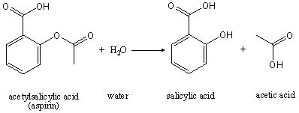
- When aspirin is hydrolyzed, does it create a basic, acidic, or neutral solution? How do you know?

Acetaminophen (like Tylenol) can also be hydrolyzed in water but it doesn’t produce salicylic acid so it is easier on the stomach and preferable to some people.
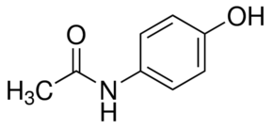

Acetaminophen -------->

These over the counter drugs would need to be properly identified at a crime scene using chemical tests. One test involves adding Ferric Nitrate to the drug once it has been hydrolyzed in water. Ferric nitrate will react with Salicylic acid to form a compound with a purple color. This is an example of a Screening test – a quick, easy, cheap test that can give you the possible identity of a drug. Back at the lab, chemists and toxicologists would have to perform more elaborate Confirmation tests to identify the drug with a high probability.

- Let’s put it all together! Using these chemical reactions and the information provided, how would you be able to tell Alka Seltzer, Tylenol, and Aspirin apart?

