DNA extraction Basics-A routine procedure used to isolate DNA from the nucleus of cells.

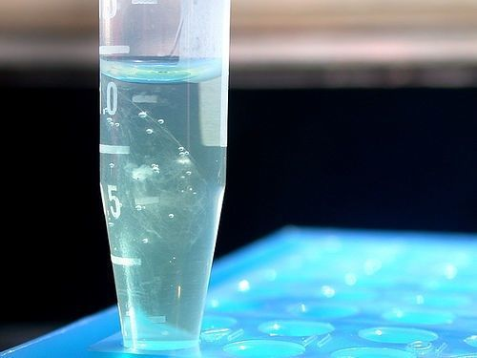
DNA precipitate
When an ice-cold alcohol is added to a solution of DNA, the DNA precipitates out of solution. If there is enough DNA in the solution, you will see a stringy white mass.
Scientists can buy ready-to-use DNA extraction kits. These kits help extract DNA from particular cell types or sample types. However, they can be expensive to use routinely, so many labs have their own methods for DNA extraction

What does DNA extraction involve?

Step 1. Breaking cells open to release the DNA
The cells in a sample are separated from each other, often by a physical means such as grinding or vortexing, and put into a solution containing salt. The positively charged sodium ions in the salt help protect the negatively charged phosphate groups that run along the backbone of the DNA.
A detergent is then added. The detergent breaks down the lipids in the cell membrane and nuclei. DNA is released as these membranes are disrupted.

Step 2. Separating DNA from proteins and other cellular debris
To get a clean sample of DNA, it’s necessary to remove as much of the cellular debris as possible. This can be done by a variety of methods. Often a protease (protein enzyme) is added to degrade DNA-associated proteins and other cellular proteins. Alternatively, some of the cellular debris can be removed by filtering the sample.

Step 3. Precipitating the DNA with an alcohol
Finally, ice-cold alcohol (either ethanol or isopropanol) is carefully added to the DNA sample. DNA is soluble in water but insoluble in the presence of salt and alcohol. By gently stirring the alcohol layer with a sterile pipette, a precipitate becomes visible and can be spooled out. If there is lots of DNA, you may see a stringy, white precipitate.

Step 4. Cleaning the DNA
The DNA sample can now be further purified (cleaned). It is then resuspended in a slightly alkaline buffer and ready to use.

Step 5. Confirming the presence and quality of the DNA
For further lab work, it is important to know the concentration and quality of the DNA.
Optical density readings taken by a spectrophotometer can be used to determine the concentration and purity of DNA in a sample. Alternatively, gel electrophoresis can be used to show the presence of DNA in your sample and give an indication of its quality.

What can this DNA be used for?
Once extracted, DNA can be used for molecular analyses including PCR, electrophoresis, sequencing, fingerprinting and cloning.

Published 18 June 2009
Science Learning Hub © 2007-2017 The University of Waikato
https://www.sciencelearn.org.nz/resources/2036-dna-extraction

