Equations of Circles: Why they are what they are. Name ________________________________________ Date __________ Hour ____
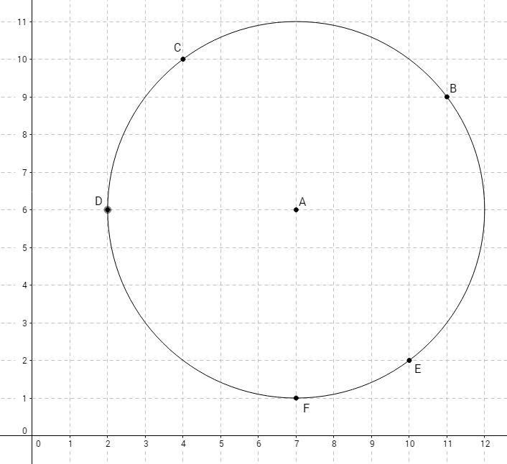
- Label the coordinates of A, B, and C.
- Show the calculation of the distance between A and B. (Make A the point whose coordinates are subtracted.)

d_{AB}=

- What circle measurement is this?

- Rewrite the formula, but replace the coordinates of B with (x,y).

- Square both sides to remove the square root, and replace “d” with “r”, for radius.

- ANY point on the circle, must have the same distance from A, so this is the general rule that defines the circle.
Show that it works when you substitute the coordinates of C for x and y in the equation.
- Draw the circle whose equation is (x−4)² + (y−3)² = 4.
Label the center P, and show its coordinates.

