Righteousness in the Face of Evil
A natural reaction to learning about genocide is attempting to rationalize and understand why, and how, such events can occur. It is understandable that the study of genocide would make one see human nature and human history in a less than favorable light. However, people did show courage, kindness, and decency during these dark historical episodes. There were people who shunned hatred and division and choose to embrace altruism, or the desire to help others just because it was the ethical, and moral way to behave. In Israel, Yad Vashem was built to commemorate the Holocaust. There they honor the righteous from nations throughout the world as a testament to goodness in the face of evil. We will be exploring some of these righteous individuals in the hope that they serve as inspiration to you to live a righteous life.
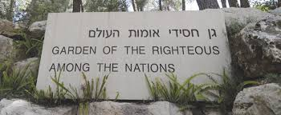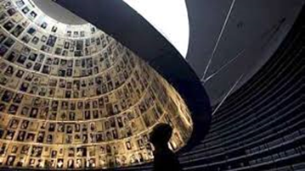
Garden of the Righteous The Hall of Names at the Yad Vashem
Armin Wegner
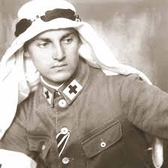 Armin Wegner was a German soldier and medic in World War I, a prolific author, and a human rights activist. While he was stationed in the Ottoman Empire during World War I, Wegner was a witness to the Armenian Genocide and the photographs he took documenting the plight of the Armenians today "comprises the core of witness images of the Genocide." In the years following the end of World War I, Wegner also voiced his opposition, at great risk to his own life, against the anti-Semitic policies of the Nazis. In 1933, he authored an impassioned plea to Adolf Hitler on behalf of the Jews of Germany. He suggested that the persecution of the Jews was not just a question of "the fate of our Jewish brothers alone, but also the fate of Germany." Noting that he was writing the letter as a proud German who could himself trace his Prussian familial roots back to the time of the Crusades, Wegner asked Hitler what would become of Germany if it continued its persecution of Jews. Answering his own question, Wegner declared, "There is no Fatherland without justice!" He was persecuted by the Nazis and, for his efforts, is recognized by Yad Vashem as Righteous among the Nations.

Nicholas Winton
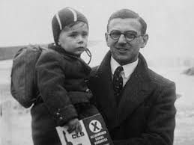 Sir Nicholas Winton was a 29-year-old stockbroker who in 1939 organized trains out of Prague to secure the safe passage of 669 Jewish children from Czechoslovakia to England at the dawn of World War II. The evacuees, later known as "Winton's Children," knew little about their rescuer until the 1980s, when his work finally came to light. He was knighted in 2003 and died on July 1, 2015, at the age of 106. Please watch this video: https://www.youtube.com/watch?v=c0aoifNziKQ
Irena Sendler
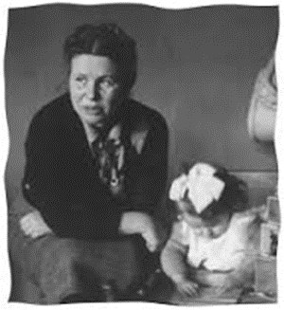 When Hitler and his Nazis built the Warsaw Ghetto and herded 500,000 Polish Jews behind its walls to await liquidation, many Polish gentiles turned their backs or applauded. Not Irena Sendler. An unfamiliar name to most people, but this remarkable woman defied the Nazis and saved 2,500 Jewish children by smuggling them out of the Warsaw Ghetto. As a health worker, she sneaked the children out between 1942 and 1943 to safe hiding places and found non-Jewish families to adopt them.
Raoul Wallenberg
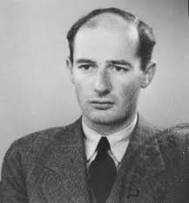 Wallenberg was a Swedish diplomat who helped save thousands of Hungarian Jews. Wallenberg provided thousands of Jews with special Swedish passports and also set up a bureaucracy in Budapest designed to protect Jews by using "safe houses" where they could receive food and medical supplies. More than 90,000 Budapest Jews were deported to death camps; Wallenberg's efforts may have saved an equal number. Following the liberation of Budapest, Wallenberg was arrested by the Soviets and was never heard from again.

Oskar Schindler
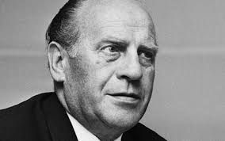 One of the most famous Righteous Gentiles from the Holocaust, Schindler helped to save thousands of Polish Jews by shielding them as workers in his factories. Referring to them as his “Schindlerjuden”, meaning, “Schlinder’s children”. Schindler ensured that the Jews in his factories worked but were also fed, no-one was beaten, and no-one was killed. It became an oasis of humanity in a desert of moral torpor. His story his immortalized in a film called "Schindler's List." https://www.youtube.com/watch?v=M5FpB6qDGAE
Yad Vashem, who houses the memorial and database of the Righteous Among the Nations, has a strict criterion their committee uses to determine who is considered part of the righteous. Righteous individuals must have had active involvement in being a rescuer with acknowledged mortal risk during the endeavor. Their motives must have been humanitarian and there must be testimonial or archival materials to support their actions. These individuals stand a testament to human goodness in the face of overwhelming evil. They remind us that we all have a choice to behave ethically and not be a perpetrator, or bystander, as many of their countrymen were.

Albania | 75 | Japan | 1
Armenia | 24 | Latvia | 136
Austria | 109 | Lithuania | 891
Belarus | 641 | Luxembourg | 1
Belgium | 1,731 | Macedonia | 10
Bosnia | 43 | Moldova | 79
Brazil | 2 | Montenegro | 1
Bulgaria | 20 | Netherlands | 5,595
Chile | 2 | Norway | 67
China | 2 | Peru | 2
Croatia | 115 | Poland | 6,706
Cuba | 1 | Portugal | 3
Czech Republic | 116 | Romania | 60
Denmark* | 22 | Russia | 204
Ecuador | 1 | Serbia | 135
Egypt | 1 | Slovakia | 572
El Salvador | 1 | Slovenia | 10
Estonia | 3 | Spain | 9
France | 3,995 | Sweden | 10
Georgia | 1 | Switzerland | 49
Germany | 601 | Turkey | 1
Greece | 335 | Ukraine | 2,573
Hungary | 844 | United Kingdom | 22
Indonesia | 2 | USA | 5
Ireland | 1 | Vietnam | 1
Italy | 682
Total: 26,513
Names and Numbers of Righteous Among the Nations - per Country & Ethnic Origin, as of January 1, 2017

