Class/Subject: Philosophy | Lesson 45: “What is Love?”
Objective(s):  SWBAT evaluate the origin of love. SWBAT also discern the different forms of love and create a criterion on what constitutes love in its various forms. | Unit- “METAPHYSICS”
Philosophical Quote of the Day:  “At the touch of love everyone becomes a poet.”  - Plato | Philosophical Song of the Day: Haddaway- What is Love?  https://www.youtube.com/watch?v=HEXWRTEbj1I
Key Points of the Day:  - Philosophy of love is the field of social philosophy that attempts to explain the nature of love  - This issue has been debated from the times of the Ancient Greeks to today | - Generally, there are three types of love focused on by Western Philosophers being agape (Christian love of all mankind and the world), Eros (Romantic and sexual), and filial (Family and children)  - There are a number of questions and conundrums that exist within these three types of love.
Journal Entry:  What types of love are there, according to the Ancient Greeks? Is it possible for a human being to possess all forms of love in the course of a human life? What can you do to ensure that you have healthy forms of these loves and avoid the pitfalls that are inherent in each type? | Featured philosopher and supplemental reading:  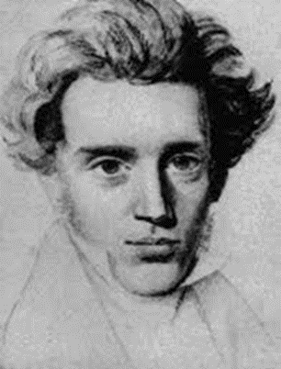“Works of Love” by: Søren Kierkegaard  Søren Kierkegaard was a Danish philosopher, theologian, poet, social critic and religious author who is widely considered to be the first existentialist philosopher. His work on love emphasizes the distinctions between Agape, Eros, and Filial forms of love.

