UNIT III WRITING PORTION
- Label the Triangular Trade Route appropriately, telling the story of how it was the, “engine of the European economy”
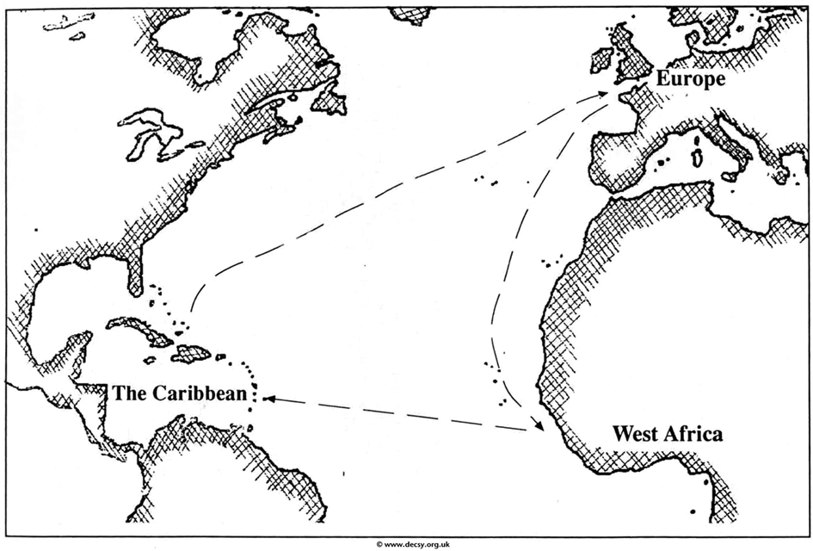

- What were the six things that the Scientific Revolution changed in human thinking from medieval times? What are some tangible examples of how it is part of our modern thinking?

- What inventions were instrumental in changing world hegemony, economies, and culture during this time period in history?

