Stimulus 1

Cells use cholesterol, a lipid-like molecule, as a component of cell membranes, as a precursor for a class of lipids known as steroid hormones, and in the production of liver bile salts to help disperse fats in the digestive system. Cholesterol is transported in the blood as part of particles called low-density lipoproteins (LDLs; popularly known as "bad cholesterol"). The pathway by which cholesterol is transported was elucidated through investigations conducted by Michael Brown and Joseph Goldstein at the University of Texas Health Sciences Center. These scientists won the Nobel Prize in Physiology for this work in 1985, in part because these results revealed that if cholesterol remains in the blood, it could be deposited onto artery walls and increase the risk of cardiovascular disease. This deposition of cholesterol on artery walls, called atherosclerosis, restricts blood flow that may in turn lead to a heart attack. Although the body produces cholesterol, a significant amount of blood cholesterol is the result of dietary intake. This has led to the strong recommendation to minimize the consumption of cholesterol.
It has been shown that as cells utilize cholesterol, the LDL levels in the blood decrease. Based on the work of Brown and Goldstein, a medical scientist has proposed that LDL particles are moved out of the blood and into cells through the process of endocytosis (the engulfing of large particles by the cells' plasma membrane). The hypothesis further states that the cells have receptor molecules that combine with the LDL and facilitate the endocytotic event.

How can these receptors be investigated? Additional studies by the Brown and Goldstein group revealed that the LDL particle contained a protein, in addition to the cholesterol component. Based on these results, the medical scientist further proposed that this protein interacts specifically with the receptor molecule, allowing the receptor to recognize the LDL and transport the particle via endocytosis.

The scientist conducted an experiment (Experiment 1) in which the protein in the LDL particle was changed. The LDL particle was then radioactively labeled and injected into the bloodstream of an animal. The level of radioactivity remaining in the blood was measured at various times after the initial injection. This allowed the scientist to determine the uptake rate of LDL into the cells. The results of the experiment revealed that when the LDL protein was altered, the LDL particles remained in the blood much longer than particles with an unaltered protein.
The scientist concluded that a receptor must be involved in the transport of LDL since altering the LDL protein that is purportedly recognized by the receptor caused the LDL to be removed from the blood more slowly.

Stimulus 2

A new drug, called Cissus, is hypothesized to greatly reduce and possibly eliminate the buildup of cholesterol in the blood. This drug (Cissus) acts by interfering with the transport of cholesterol into the blood. The drug was administered to human subjects, and the levels of cholesterol were monitored in the blood. The results of their tests are shown in the following three graphs. Interpretation of these results led the scientists to conclude that their drug Cissus was successful.
Graph 1
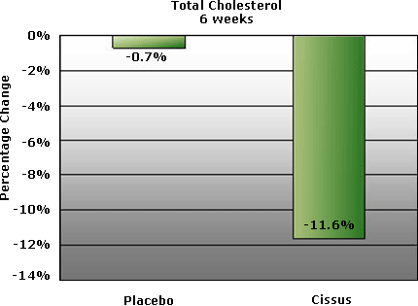

Graph 2
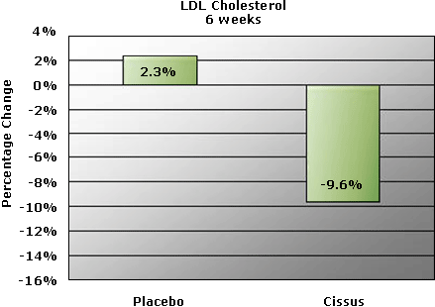
Graph 3
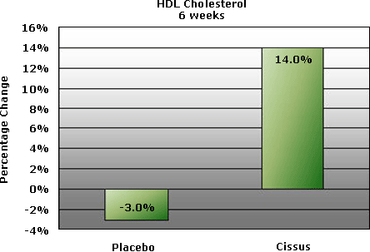

1. Which statement explains some of the strategy employed in experiment 1?
a. Adding a radioactive label to the LDL particle ensured that the particle would be soluble in the blood.
b. Adding a radioactive label to the LDL particle allowed the rate of transport to be measured.
c. Adding a radioactive label to the LDL particle allowed the test animal to metabolize the LDL.
d. Adding a radioactive label to the LDL particle altered the protein component of the particle.

2. A minor criticism of the scientist's strategy employed for experiment 1 is
a. the method used for measuring the rate of transport.
b. the use of an animal as a model for a human disease.
c. the use of radioactivity, because it is dangerous.
d. the injection of the LDL particle instead of the ingestion through diet.

3. A major criticism of the scientist's interpretation of the result of experiment 1 is that
a. measurement of radioactivity does not accurately reveal the relative amount and, therefore, the rate, of LDL in the blood.
b. variation in the rate of transport of the altered LDL is controlled by a receptor molecule.
c. variation in the rate of transport of the altered LDL is a result of the alteration of the protein component in the particle.
d. there must be a comparison to unaltered LDL transport rates.

4. Based on the hypothesis, as the radioactivity decreases from the blood, it would increase
a. in the fur of the animal.
b. in the body cells of the animal.
c. nowhere; the radioactivity would be degraded.
d. in the lungs of the animal.

5. In support of the scientist's interpretations of the result of experiment 1, one would predict that which of the following tissues would exhibit the greatest number of cholesterol receptors?
a. liver.
b. adrenal glands.
c. ovaries.
d. all of the above.

6. Graph 1 reveals that
a. total cholesterol levels are reduced approximately 15-fold more in individuals who were administered the drug Cissus versus individuals who did not receive the drug.
b. total cholesterol increased in subjects who did not receive the drug Cissus in the experiment.
c. total cholesterol decreased at a faster rate in individuals who received the drug Cissus versus those who did not receive the drug.
d. no change in cholesterol levels was observed in any test subjects.

7. What does Graph 2 state about the source of blood cholesterol?
a. LDL particles are the only source of total blood cholesterol.
b. LDL particles are a major but not sole source of total blood cholesterol.
c. LDL particles do not contribute to total blood cholesterol levels.
d. The graph does not reveal any meaningful data about the source of blood cholesterol.

8. The scientist concluded the drug is effective in controlling total cholesterol levels. This means that
a. high HDL levels in the blood may contribute to a reduction in total blood cholesterol.
b. low HDL levels in the blood contribute to an increase in total blood cholesterol.
c. high LDL levels contribute to a reduction in total blood cholesterol.
d. HDL levels increase when LDL levels increase.

Passage 1

It is believed that there have been at least five mass extinctions (the end of a lineage) since life began on the planet. The most recent mass extinction occurred 65 million years ago. This event resulted in the loss of all dinosaurs on the planet. Two hypotheses have been proposed to explain the event that could have caused such a mass extinction. Hypothesis 1 states that a giant asteroid crashed into the Earth. Hypothesis 2 states that massive volcanic eruptions occurred. Both hypotheses would generate enormous amounts of ash and debris into the atmosphere. This would result in a blockage of sunlight with the resulting death of the majority of photosynthetic organisms, followed by the death of many organisms in the food chain on the planet.

As both hypotheses result in the same outcome, global climate change, how can one distinguish between the two hypothesized causes of this outcome? If a giant asteroid hits the planet, some evidence should be available on the planet surface. In fact, the element iridium has been found in the geologic sediment layer distinguishing the Cretaceous and Triassic periods. This element is rare on Earth but is found in high abundance in extraterrestrial materials such as asteroids. If an asteroid impacted the planet, an iridium layer should be found coincident with the geological sediment of the Cretaceous/Triassic periods. It has also been shown by a number of scientists, however, that large amounts of the rare iridium element are released during volcanic eruptions.

Passage 2

It is obvious that the reasons for the mass extinction are still unclear. New evidence emerges all the time through geological explorations. In fact, extensive lava flows dating back 65 million years ago have recently been discovered. These lava flows are coincident with the geological sediment of the Cretaceous/Triassic period. In addition, quartz grains with striations common in quartz found near asteroid impact craters have also been found and date back 65 million years.

9. Which of the two hypotheses should be rejected based on the evidence described?
a. hypothesis 1.
b. hypothesis 2.
c. Neither hypothesis should be rejected.
d. Both hypotheses should be rejected.

10. What type of evidence would allow for the acceptance of hypothesis 2?
a. identification of a large crater resulting from an asteroid impact occurring approximately 65 million years ago.
b. no evidence of a large crater resulting from an asteroid impact occurring approximately 65 million years ago.
c. the remains of extensive lava flows dating back to 65 million years ago.
d. no evidence for lava flows dating back to 65 million years ago.

11. The recently uncovered evidence discussed in passage 2 lends support to
a. hypothesis 1.
b. hypothesis 2.
c. neither hypothesis.
d. both hypotheses.

12. The discovery of additional evidence supporting both hypotheses allows which of the following conclusions to be drawn?
a. Both events occurred approximately 65 million years ago, leading to global climate change and a mass extinction.
b. A massive asteroid impacted first, which led to extensive volcanic eruptions and the resulting mass extinction.
c. The iridium deposition was the result of both asteroid impact and volcanic eruptions occurring 65 million years ago.
d. all of the above.

Photosynthesis is the sequence of events during which light energy is converted into chemical energy in the cell. Organisms that employ photosynthesis must be able to capture visible light and convert it to chemical energy in the form of organic molecules.
Visible light is a small component of a larger continuous range of radiation called the electromagnetic spectrum. All radiation in this spectrum travels as a wave. All waves have a defined length (called the wavelength), and the wavelength is inversely related to the amount of energy the wave carries. It has further been shown that light is composed of small particles called photons. When a molecule absorbs a photon of light, some of the energy of the photon is transferred to the electron. The electron becomes "excited" and moves farther away from the nucleus of the atom. This excited state, however, is short-lived. The captured energy is soon released by the electron, resulting in the movement of the electron back to its original, lower energy position near the nucleus (the ground state). The energy is released as heat or captured by another electron in another molecule.
Certain molecules, called pigments, absorb light of different wavelengths. It is these pigments that are used by living organisms to capture the light energy from the sun. Chlorophyll is the main pigment molecule of photosynthesis. It is located in a special organelle of the cell called the chloroplast. It can absorb light in the visible range of the electromagnetic spectrum, thereby absorbing the energy that light carries. This energy is used by the cell to carry out a series of reactions (photosynthesis) that convert carbon dioxide and water to oxygen and sugar. The result is the conversion of light energy to chemical energy.

Graph A (y-axis is energy absorbed)
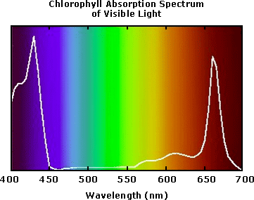
13. Graph A demonstrates
a. the length of the light waves absorbed by chlorophyll.
b. the ultraviolet portion of the electromagnetic spectrum absorbed by chlorophyll.
c. the extent to which chlorophyll absorbs light of all wavelengths in the electromagnetic spectrum.
d. nothing conclusive about chlorophyll.

14. Chlorophyll exhibits the greatest absorption of light of
a. high energy.
b. low energy.
c. equal energy.
d. You cannot determine the energy content of light from this graph.

15. A scientist wants to measure the photosynthetic activity of the common aquatic plant Elodea under various growth conditions. A good indicator of photosynthetic activity would be
a. the amount of carbon dioxide produced.
b. the amount of oxygen produced.
c. the amount of water produced.
d. the rate of stem/leaf growth.

The scientist first generated data (Table A) by growing Elodea at various pH levels and measuring carbon dioxide usage and oxygen generation.

Table A
pH | CO₂ used (mol) | O₂ released (mol)
7 | 0.3 | 0.3
6 | 0.9 | 0.9
5 | 1.5 | 1.5

16. Which of the following conclusion(s) can be drawn from the data in Table A?
a. The lower the pH, the greater the photosynthetic activity.
b. The higher the pH, the more oxygen is generated.
c. Increased acidity leads to a reduction in photosynthetic activity.
d. Carbon dioxide uptake is not indicative of photosynthetic activity.

17. Based on the results reported in Table A, the rate of photosynthesis is limited by
a. the amount of oxygen available.
b. the amount of oxygen available.
c. the amount of carbon dioxide available.
d. an acidic environment.

The scientist then decided to grow Elodea in a closed test tube in the presence of sugar and oxygen. The organism was monitored for 24 hours. The sugar was used up by the end of the 24 hours. Both oxygen and carbon dioxide levels were measured and plotted versus time (Graph B).

Graph B
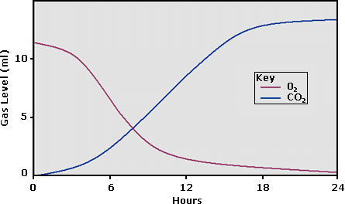

18. The results of this graph can be described in which of the following way(s)?
a. Oxygen levels are decreasing as the sugar levels decrease.
b. Carbon dioxide levels are decreasing as the sugar levels decrease.
c. The amount of sugar available has no impact on carbon dioxide production.
d. Carbon dioxide levels are increasing with increasing sugar levels.

19. What conclusion(s) can be drawn from the interpretation of these results?
a. The reverse reaction of photosynthesis must be occurring.
b. A plant will use carbon dioxide instead of oxygen to make sugars.
c. Not enough time passed to draw a conclusion.
d. Under low oxygen conditions, sugar can still be generated by this plant.

20. The scientist repeated the previous experiment (question 18) in the absence of light. The results obtained were identical to those plotted in Graph B. These results
a. indicate that the reverse reaction of photosynthesis can occur in the absence of light.
b. are an anomaly.
c. refute the data obtained in the first experiment (Graph B).
d. do not provide any new data.

Forest decline, the gradual deterioration and eventual death of trees, has been documented all over the globe. General symptoms include decrease in vigor and growth, along with some specific symptoms such as yellowing leaves. There have been several studies that looked at the causes of forest decline. The studies suggest that air pollution is the primary causative agent. Several pollutants have been implicated, including sulfur dioxide and nitrous oxide along with toxic heavy metals such as cadmium, lead, and copper. In areas exhibiting the greatest forest damage, concentrations of these pollutants are substantially higher than in unaffected areas. Based on these observations, scientists now hypothesize that airborne pollutants cause long-term forest decline.

21. Which of the following is a valid way to test this hypothesis?
a. Compare the rate of photosynthesis in all trees in an area that exhibits forest decline.
b. Compare the rate of photosynthesis between only two species of trees in areas that exhibit forest decline.
c. Compare the rate of photosynthesis among trees of the same species in regions exhibiting forest decline with trees in regions not exhibiting forest decline.
d. Compare the rate of photosynthesis between trees of the same species within an area exhibiting forest decline.

22. What is a criticism of the experimental strategy that analyzes trees at one site where air pollutants are high and comparing those to trees of the same species at another site where air pollutants are low?
a. Trees growing in two distinct sites are exposed to many uncontrolled variables in their environments.
b. Individuals of the same species living in two different environments are really not the same species.
c. Pollutants such as sulfur dioxide and nitrous oxide are different in different parts of the world.
d. none of the above.

23. An ecologist decided to explore the mechanism by which air pollutants impact the growth of the tree. The ecologist recognized that growth requires the use of nutrients and minerals in the soil. Which of the following hypotheses reflects these two ideas?
a. Soil nutrients are unaltered by the presence of high concentrations of air pollutants.
b. Trees cannot efficiently take in nutrients in the presence of a high concentration of air pollutants.
c. Changes in the soil are induced by high concentrations of air pollutants.
d. Tree growth requires the use of nutrients and minerals in the soil.

24. Would a tree that normally exhibits slow growth be a good subject for testing the ecologist's hypotheses and why?
a. No; altered growth and vigor are the hallmarks of forest decline.
b. Yes; growth rate has nothing to do with forest decline.
c. No; all trees grow fast, so a slow-growing tree already has something wrong with it.
d. Yes; a slow growth rate is easier to measure.

The study of the inheritance of genetically determined traits in humans requires the observation and analysis of several generations in the same family. This requires careful documentation of family lines. A family tree that shows inheritance patterns, or the transmission of genetic traits within a family, is known as a pedigree. Pedigrees are produced using standardized symbols (Figure 1). Each horizontal row represents a separate generation with the earliest generation at the top. A horizontal line between two individuals represents a mating pair or parents and a vertical line connects this pair to their offspring or children. As the goal is to follow inheritance patterns of a particular trait, individuals exhibiting the trait are identified by a filled-in symbol.

FIGURE 1
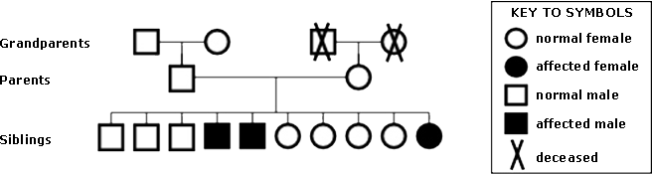

A variety of genetic traits and diseases have been studied using this technique, including blood type, sickle cell anemia, and cystic fibrosis. For traits or diseases that are not readily identifiable in the individuals, alternative analysis must be employed in conjunction with pedigree analysis. Recently, genetic analysis has been utilized to determine if individuals in a lineage carry a genetic defect or mutation. By comparing that data to the pedigree chart, one can predict the possibility of offspring inheriting this mutation. This technique analyzes the DNA from the individuals in the family lineage to determine if specific genetic mutations are present. A comparison of the results within the family, in conjunction with the pedigree chart, can reveal the way a genetic mutation is transmitted and predict the possibility of inheritance of the mutation by the offspring and ultimately the manifestation of the trait in that individual.

The Jones family was interviewed and a pedigree chart established. DNA was isolated from all the individuals and subjected to chemical manipulation that fragments the linear DNA molecules into shorter lengths. All individuals receive 50% of their DNA, or one of two copies of each gene, from each parent. Because each individual receives 50% of his or her DNA from each parent, he or she has a 50% chance of inheriting specific genetic attributes of each parent. Some traits will not manifest unless both copies of the gene are mutated (called recessive). Other traits require only a single copy of the gene be mutated in order to manifest in the individual (called dominant). A comparison of the DNA fragments of each parent to the DNA fragments of the offspring should reveal if the offspring inherited any specific DNA segment from the parent.

The DNA that is isolated must be separated by size in a gel matrix. The resulting fragments or bands can then be compared for similarities or differences.
Figure 2 shows the result of a pedigree analysis of the Jones family. In this situation, the trait is not readily apparent, so all individual symbols are filled-in until the genetic analysis is conducted. DNA was isolated from each family member indicated. Both copies of a single gene were specifically examined. If both copies are identical, then a single DNA fragment or band is present. Any differences (mutations) in the genes will result in two bands of different sizes. Larger DNA fragments or bands are closer to the top; smaller bands are closer to the bottom.

Figure 2
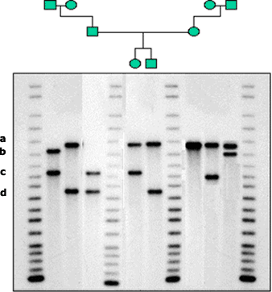

25. In Figure 1, the male and female in the second generation had ten offspring. Neither parent exhibits the genetic trait studied in this example. However, three of their offspring do exhibit the trait. Which of the following statements explains this?
a. These individuals were dead at the time of the pedigree analysis.
b. These individuals are not the parents of these offspring.
c. The trait exhibited by the offspring requires genetic information from both parents in order to manifest in the individual.
d. The trait is sex specific in its manifestation.

26. Which of the following statements is true about the inheritance pattern of this mutation?
a. The mutated gene is inherited only by males.
b. The mutated gene is inherited only by females.
c. Only males manifest the trait.
d. Both males and females inherit and manifest this trait.

27. This genetic mutation and its manifestation in the individual who inherit it can be termed
a. recessive.
b. dominant.
c. lethal.
d. X-linked.

28. According to the passage, what is the possibility that the offspring of the affected individuals will also be affected by this trait (i.e., manifest the trait)?
a. 50 %.
b. 100 %.
c. 0.
d. This cannot be determined with the information provided.

29. A criticism of the technique of pedigree analysis as depicted in Figure 1 is that
a. information is obtained through word of mouth.
b. the identity of the mother is not always ensured.
c. information from earlier generations is obtained through interviews.
d. both A and C.

30. In Figure 2, the DNA fragment or band labeled a is present in which members of the Jones family?
a. paternal grandmother, the mother, both offspring, and both maternal grandparents.
b. the grandfathers only.
c. the siblings only.
d. all family members.

31. If the mutated version of the gene represented by band a was for a recessive trait, would the siblings of the most recent generation exhibit the trait?
a. yes.
b. no.
c. There is not enough information to determine this.
d. It depends on the sex of the offspring.

32. If the mutated version of the gene represented by band a was for a dominant trait, would the siblings of the most recent generation exhibit the trait?
a. yes.
b. no.
c. There is not enough information to determine this.
d. It depends on the sex of the offspring.

33. The female offspring inherited her version of the gene in band c from her
a. father.
b. mother.
c. paternal grandmother.
d. paternal grandfather.

34. Which individual has two identical copies of the gene under study?
a. mother.
b. father.
c. maternal grandfather.
d. male offspring.

35. If an individual has a single copy of a mutant gene that is for a dominant trait and he or she does NOT exhibit or manifest the trait physically, this is because
a. dominant traits require two copies of the mutant gene.
b. a recessive trait is the type that manifests with only one copy of the gene.
c. other factors contribute to the gene's ability to manifest on the individual.
d. dominant traits are usually sex-linked.

The Earth's surface temperature is determined primarily by how much the gases in the atmosphere absorb outgoing infrared (heat) radiation. These gases trap the heat, without which, the average temperature on the planet would be approximately 20 degrees Celsius, instead of the current temperatures seen today. It has been proposed that the addition of carbon dioxide gas into the atmosphere enhances the ability to trap infrared radiation, resulting in increased global temperatures (greenhouse effect). It is further proposed that the burning of fossil fuels by humans has greatly increased the amount of carbon dioxide introduced into the atmosphere. Analysis of global temperature reveals that average global temperatures have increased during the past several decades. (See Figure 1.)

The primary way of predicting the behavior of the Earth's atmosphere is through computer global circulation modeling. These models break the atmosphere into sections, or regions, for ease of calculation. Global circulation modeling is not ideal, however, as these sections are unrealistic, because the atmosphere is a dynamic environment that is not static in one region or section. The world's oceans also make global circulation models difficult because the interplay between the ocean waters and the atmosphere cannot be predicted all the time. Finally, short-term increases in solar output have been shown to influence global temperatures. It is these factors that have made analysis of global climate change and its causes extremely difficult.

FIGURE 1
ATMOSPHERIC CO₂ AT MAUNA LAO
OBSERVATORY

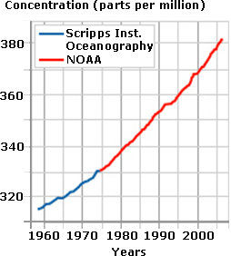

SOURCE: NOAA

36. Which of the following is a hypothesis addressing the causes of global warming?
a. The burning of fossil fuels decreases carbon dioxide levels in the atmosphere and leads to increased global temperatures.
b. Fluctuations in the Earth's temperatures occur in cycles over the course of the planet's existence.
c. Decreased carbon dioxide in the atmosphere leads to increased global temperatures.
d. Global circulation models are not valid representations of the Earth's atmosphere.

37. Which would be a valid means of testing the hypothesis that fossil fuel consumption is increasing the amount of carbon dioxide in the atmosphere?
a. Measure the atmospheric levels of carbon dioxide in regions of the planet where no fossil fuels are burned or consumed.
b. Measure the atmospheric levels of carbon dioxide in regions of the planet where no fossil fuels are burned or consumed and compare it to regions where fossil fuels are burned.
c. Measure the amount of carbon dioxide levels in the atmosphere in regions where fossil fuels are burned.
d. Measure the atmospheric levels of carbon dioxide resulting from the burning of fossil fuel.

38. What major criticism can be made about the hypothesis stating that fossil fuels are the main contributor of carbon dioxide to the atmosphere and therefore lead to global climate change?
a. An increase in global temperatures (Figure 1) is not direct data in support of the hypothesis.
b. Other factors may contribute to carbon dioxide levels in the atmosphere.
c. An increase in global temperatures is not clearly established.
d. both A and B.

39. A hypothesis that would address the contribution of the sun's activity in global temperature increase would be which of the following?
a. Does the sun add to global warming.
b. The sun's light adds to global temperature increase.
c. Temporary solar output adds to global temperature increase.
d. Global temperature increase affects temporary output of the sun.

40. A criticism of the data depicted in Figure 1 is that
a. temperatures were measured over only 30 years.
b. temperatures were measured in only one location.
c. temperatures were measured in Celsius.
d. temperatures were measured in different ways.

