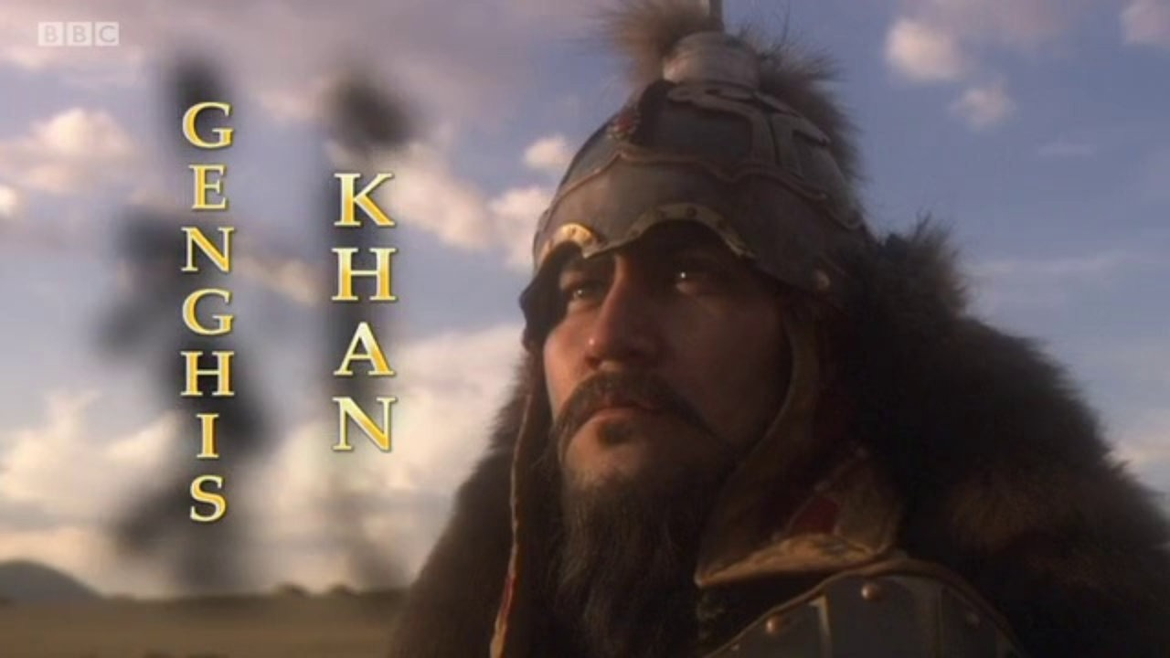

- Why was it believed that Genghis Khan was going to be great when he was born?

...........................................................................................................................................................................
- What was the name of the biography of Genghis Khan, written soon after his death?
...........................................................................................................................................................................
- Who was Temujin? What happened to him when he was 9 years-old?

.....................................................................................................................................................................................................................................................................................................................................................

- Who was Borte? Why did Temujin need to marry her?
......................................................................................................................................................................................................................................................................................................................................................
- What happened to Borte?
.....................................................................................................................................................................................................................................................................................................................................................
- Who was Jamuka? What was his relationship to Temujin?

......................................................................................................................................................................................................................................................................................................................................................
- How did Temujin get Borte back?

......................................................................................................................................................................................................................................................................................................................................................
- Why did Temujin believe that men are only loyal to strong leaders?

............................................................................................................................................................................

- Why did Temujin and Jamuka differ over the commander Subatay?
......................................................................................................................................................................................................................................................................................................................................................
- How did Temujin’s tribe challenge Jamuka’s tribe?
.....................................................................................................................................................................................................................................................................................................................................................
11. How did Jamuka’s tribe defeat Temujin’s tribe?
......................................................................................................................................................................................................................................................................................................................................................
- What did Tenujin do to establish a professional fighting machine?

......................................................................................................................................................................................................................................................................................................................................................

- How effective was the Mongol bow and archery skills?
................................................................................................................................................................................................................................................................................................................................................
- What methods of psychological warfare did Temujin use against Jamuka’s army?
........................................................................................................................................................................................................................................................................................................................................................................................................................................................................................................................
- Why did a cavalry squadron suddenly leave the battlefield? Did this tactic work?
................................................................................................................................................................................................................................................................................................................................................
- What happened when Jamuka’s generals betrayed him and delivered him to Temujin?
................................................................................................................................................................................................................................................................................................................................................
17. What new title was given to Temujin? What did it mean?
................................................................................................................................................................................................................................................................................................................................................
- Why did Genghis Khan invade China? How many warriors did he have?

........................................................................................................................................................................................................................................................................................................................................................................................................................................................................................................................
19. Describe the city of Beijing at the time Genghis Khan attacked it.
....................................................................................................................................................................................................................................................................................................................................................

20. What were Genghis Khan’s two tactics to defeat the city of Beijing?
- ..........................................................................................................................................................................................................................................................................................................................
- ..........................................................................................................................................................................................................................................................................................................................
- What did the Chinese commander in Beijing do to defend the city? Was he successful?
.............................................................................................................................................................................................................................................................................................................................................................................................................................................................................................................................
- How did foreign ambassadors describe the city of Beijing one year after it fell to the Mongols?
.........................................................................................................................................................................
- What was Karakorum? What was built there?
....................................................................................................................................................................................................................................................................................................................................................
- List some of the changes that Genghis Khan made to Mongol society.
- .............................................................................................................................................................
- .............................................................................................................................................................
- .............................................................................................................................................................
- .............................................................................................................................................................
- Why did Genghis Khan send ambassadors to Persia?
..........................................................................................................................................................................
- What surprising package did Genghis Khan receive in the summer of 1218?
..........................................................................................................................................................................
- What was Genghis Khan’s response to this?
..............................................................................................................................................................................................................................................................................................................................................................................................................................................................................................................................
28. Who succeeded Genghis as the Khan?
..........................................................................................................................................................................
29. Why do we not know where Genghis Khan was buried?
....................................................................................................................................................................................................................................................................................................................................................

