NAME____________________
Unification of Italy

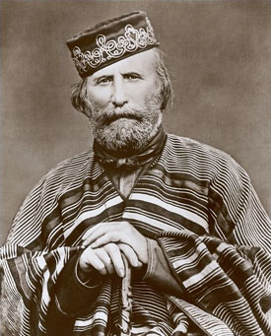
I offer neither pay, nor quarters, nor food; I offer only hunger, thirst, forced marches, battles and death. Let him who loves his country with his heart, and not merely with his lips, follow me.

