Civil Rights Influential People Notes

Rosa Parks Refused to give up her seat on a bus in Montgomery, AL.
Leader in the Montgomery Bus Boycott. She spent a lot of her career working with youth education programs. She moved to Detroit after the Montgomery Bus Boycott and lived there until her death in 2005.
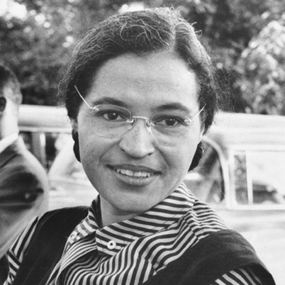

Martin Luther King Jr. President of the SCLC. Lead numerous
protests/marches for the civil rights cause.
Was assassinated in April of 1968.
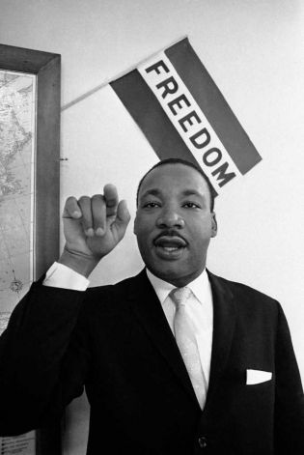

Medgar Evers WWII veteran. He was denied admission
into the University of Mississippi. He became the NAACP’s first field officer in Mississippi. Assassinated in 1963.
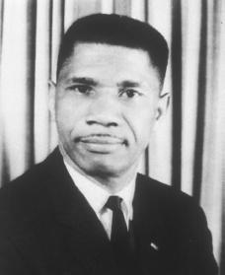

Julian Bond Helped form the SNCC. Had a lengthy career in politics as
a representative for the state of Georgia. He became the
chairman of the NAACP in 1998.
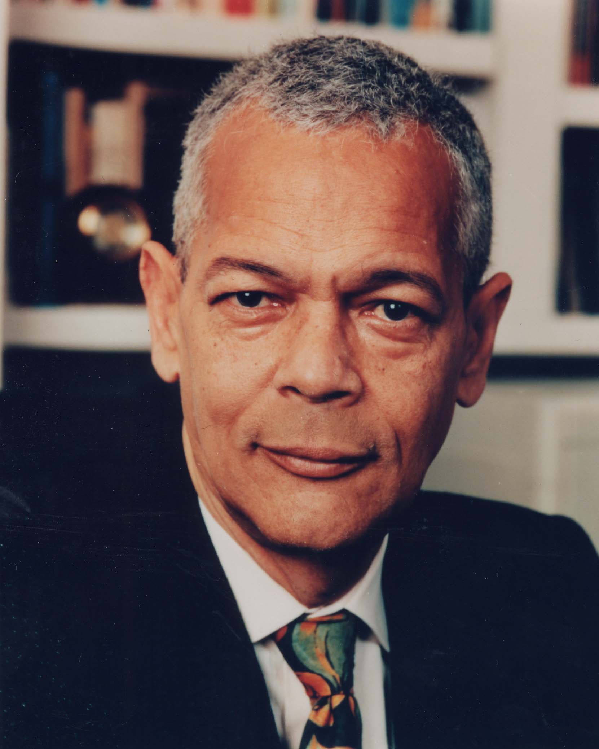

Fannie Lou Hamer Was arrested for trying to vote as part of a SNCC
protest in Mississippi. She helped found the
Mississippi Freedom Democratic Party. She personally went around the South and helped get blacks registered to vote.
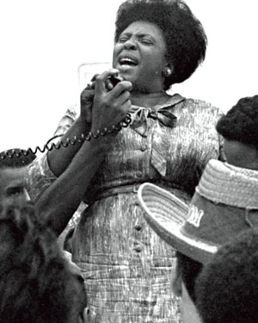

Thurgood Marshall Arguably the greatest of all civil rights leaders. He
was the head lawyer in the Brown v. Board case.
He would later become the first black Supreme
Court justice.
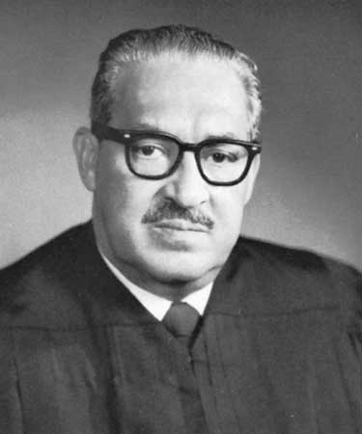

Malcolm X Member of the Nation of Islam. Called for black pride
and separation from whites. Rejected the ideas of MLK.
After a trip to Mecca, he returned to the U.S. and changed
views regarding civil rights….he now began calling for
integration and equality. He would be assassinated by
Nation of Islam members in 1965.
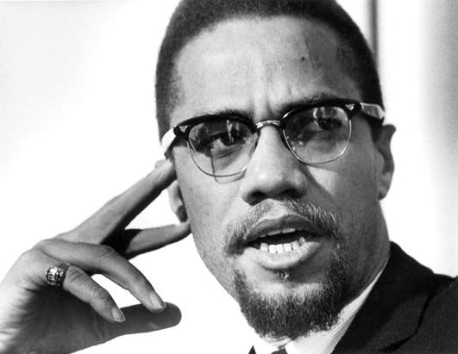

Stokely Carmichael Rose to power in the SNCC. Famous for coining
the term “black power.” Called for more radical/
violent responses to injustice/discrimination. Moved to Africa and became politically active there.
