Book VII: Conflicts of the Cold War
Unit 1: Roots of the Cold War
Lesson 4: Arms Race

Topic Overview:

The Korean War experience convinced President Eisenhower that attempting to constantly contain communism worldwide would be very costly. Instead, he chose to contain Soviet communism, overcome the threat of Soviet nukes, and prevent a Soviet invasion of Europe by announcing that aggressive acts by the Soviets would be met with a “massive retaliation” of nuclear weapons. An arms race resulted between the US and the Soviet Union as both sides stockpiled nuclear weapons to outdo the other in the event of a nuclear exchange. Many feared mutual assured destruction, or “MAD,” the idea that a massive nuclear exchange would destroy both sides. Late in the race, the strong American economy could absorb high weapons costs, but the Soviets could not. Their inability to match the massive spending on weapons development led to the economic collapse and political demise of the USSR.

Activity Overview:

In this recreation simulation students will be playing both the US and the USSR to recreate the nuclear arms race between them. After each round, students will decide whether or not to escalate the race, to fire missiles, or to negotiate for peace.

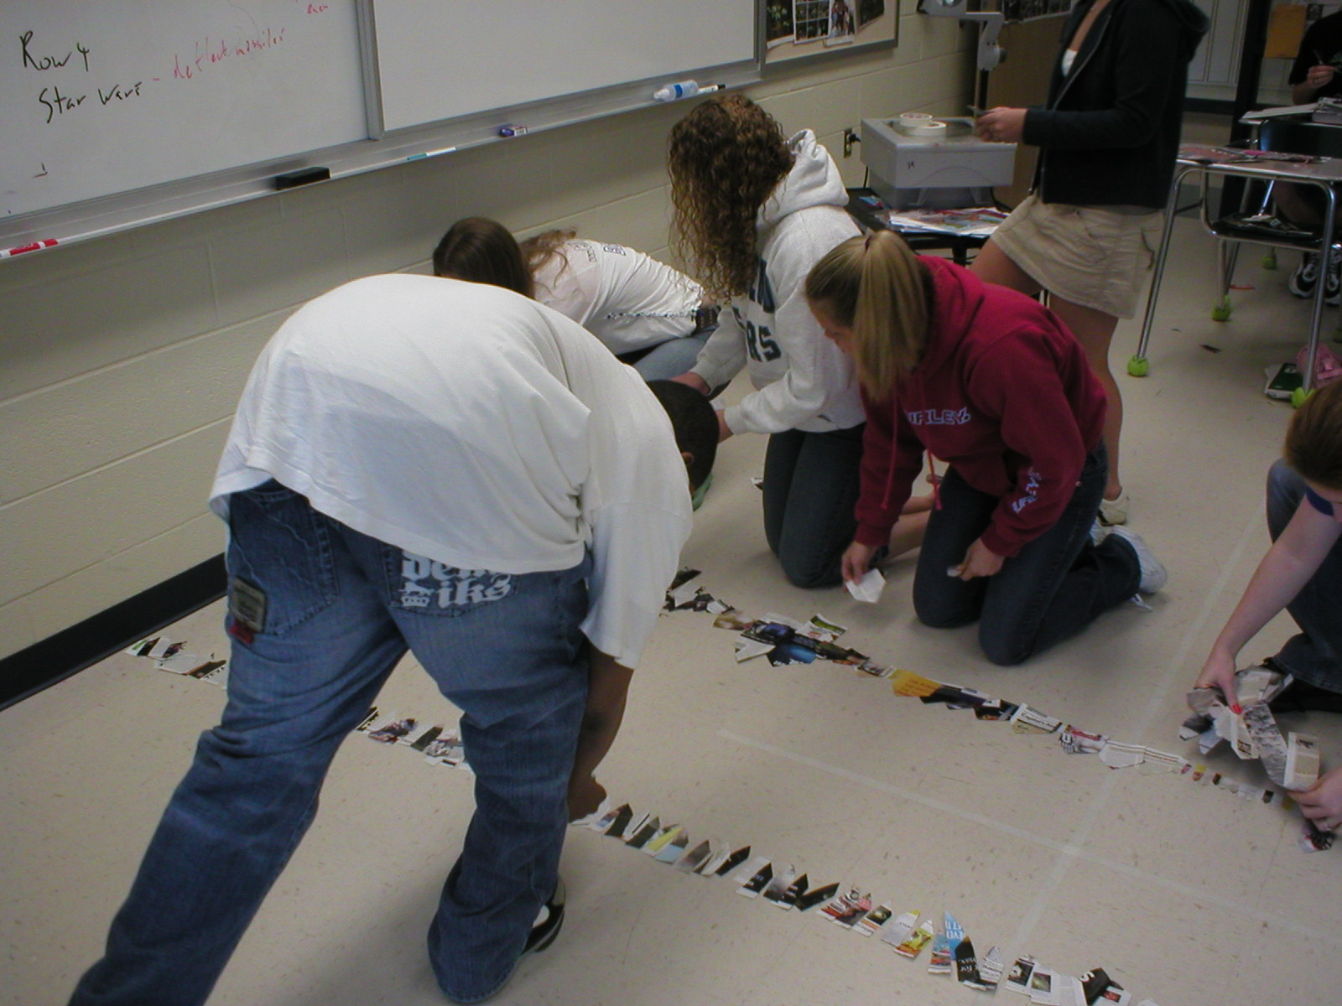
Objectives:
- Students will be able to identify the massive retaliation strategy and MAD.
- Students will be able to evaluate the effectiveness of the nuclear arms race.
- Students will be able to explain how the nuclear arms race could have led to WW III.

Materials:
- Roll of masking tape or string
- 1 old magazine or newspaper for every 3 students
- Scrap paper
- Class set of scissors
- Missile Production and Options (p.9)
- Arms Race Worksheet (p.10)
- Arms Race Worksheet Key (p.11)
- Nuclear Weapons Stockpiles Overhead (p.12)
- Nuclear Weapons 2004 Status Overhead (p.13)
- Broom

Setup:
- According to the setup diagram, divide the chairs in half along the walls, with the seats facing each other. Leave the middle of the room open.
- Give each side 4 magazines.
- In the middle of the room, create 7 rows of tape stretching roughly from one side of the class to the other.
- Separate the front board into 2 halves by drawing a line down the middle. On one half largely write the following 3 city names: Kiev, Moscow, and Stalingrad. On the other half, in a different color, write the following city names: New York, Los Angeles, and the city in which the class is located.
- Make an overhead transparency of the Missile Production and Options page.

Activity in Detail:
- Divide students in half and send them to opposite sides of the room. Tell them: “Today you will be recreating the nuclear arms race of the Cold War. Half of you will be the USA, and half the USSR.”
- Tell students: “We play in rounds of 2-3 minutes. During each round, your team will:”
- “Manufacture missiles.”
- “Align missiles.”
- “Strategize: fire missiles or negotiate peace.”
- “Declare your plans.”
- “Carry out plans and react.”
- “The USA will also be making bread with which to buy more materials.”
- Ask students: “Who is the physically strongest Soviet student? You will be the Premiere of the Soviet Union. Who are 2 volunteers to be US Presidential candidates? Let’s vote to decide the winner.” Hold the vote.
- Read the following guidelines:
- “For every city of yours left untouched by nuclear attack at the end, you will receive 2 points extra credit. For example, the USSR will receive 6 extra credit points if it successfully defends Kiev, Moscow and St. Petersburg from nuclear attacks.”
- “Missiles are made only by cutting out missile shapes from magazine pages. Regular scrap paper is reserved for bread making.”
- “You may cut out as many missiles and pieces of bread per round as possible.
- “After cutting out missiles, lay them down in a connected row, facing the other team. There can be no gaps between missiles. The floor-length tape designates the required length of a row of missiles.”
- “Once you have created one row you can move on to create another one.”
- Read the guidelines for each team:
- “2/3’s of the Americans can only create missiles. 1/3 can only make bread.”
- “Bread is made by cutting a piece of scrap paper into 8 squares.”
- “For every 100 pieces of bread made you make, you will receive another magazine at the end of the round from which to make missiles.”
- “The USSR cannot receive any more magazines, but you have more people making missiles.”
- Manipulate the time to keep the simulation competitive. For Round 1, see to it that teams make only about 1 row of missiles per round, but they must believe that they can do more.
- To keep the competition even in the early going, try to find gaps between the missiles of the faster team. Make them correct them. Be more generous with the team that is lagging behind.
- Round 1:
- Manufacture Missiles: cut out missiles and bread.
- Align Missiles: missiles must touch without gaps and face the other team.
- Strategize: teams confer with their leader on a course of action. The US President must act based on a majority consensus. The Premiere can do what he/she wants. Discuss their options:
  - If both teams choose to negotiate: They must eliminate half of their missiles. Begin Round 2.
  - If one or both teams choose to fire: The firing team does so according to the amount of completed rows they made. The other team just has to watch. Remind students that the only way to get points is to ensure that their cities remain safe and that buying paper to make missiles will escalate the conflict.
  - The USA can purchase magazine/newspaper to make missiles for 100 pieces of bread (scrap paper) each.
- Declare your plans: Both must verbally declare their team has chosen only after the 3 count. After a count of 3, the leaders must declare their intentions. Have them hold their hands behind a piece of paper. At the count of 3, they either hold up a fist to fire or a thumb to negotiate. Remind students that if they fire, the other side will probably retaliate, causing them to lose points.
- Carry out plans and react:
  - If either or both teams decide to fire, they tape one missile over as much of a city name as possible to “nuke” that city (only one missile because they were only able to complete one row in the allotted time).
- Round 2:
- Follow the above steps for missiles and bread production. Stop the round after both teams have finished their second row of missiles. Some students may ask to spy on the other team by listening across the lines. Allow them to do it and discuss the use of spies during the Cold War while debriefing later.
- Manufacture Missiles: as in Round 1.
- Align Missiles: as in Round 1.
- Strategize: as in Round 1. However, the result of negotiation will be the elimination of one row so that the worst any leader can do during the Reaction phase is to fire one missile since 2 rows are needed to use submarines.
- If both teams choose to negotiate they must eliminate half of their missiles. Begin Round 2.
- If one or both teams choose to fire missiles, then the team that wants to negotiate will have to wait while the other team fires. Submarines allow a team to pick 2 students and for 10 seconds fire as many missiles as possible at enemy cities (tape missiles over the city names).
- The USA can purchase magazine/newspaper to make missiles for 100 pieces of bread (scrap paper) each.
  - Declare your plans: Count to 3 and have leaders declare their intentions as in Round 1. They will probably choose to fire missiles.
  - Carry out plans and react: as in Round 1, except that the attacks will probably be more deadly due to submarine usage. Have each side pick two people and give them tape. Students have 10 seconds to fire missiles -cover up enemy cities.
- Round 3:
- The USSR should start to run out of paper. Allow the US to trade bread for more magazines. Stop this round before either side reaches Star Wars.
    - Manufacture Missiles: as in Round 2.
    - Align Missiles: as in Round 2.
    - Strategize: Remind them again that by escalating the war, both sides are currently losing points. Allow students the option of multi-warhead missiles. Negotiation results in removing two rows of missiles.
      - If both teams choose to negotiate they must eliminate two rows of their missiles. Begin Round 3.
      - If one or both teams choose to fire missiles, then the team that wants to negotiate will have to wait until the next round to buy materials and the team(s) that chooses to launch does so according to the amount of completed rows they possess.
      - The USA can purchase magazine/newspaper to make missiles for 100 pieces of bread (scrap paper) each.
    - Declare your plans: Count to three and have leaders declare their intentions as in Round 1. They will probably choose to fire missiles.
    - Carry out plans and react: Allow the side(s) that chooses to fire to send 5 people for 30 seconds to destroy enemy cities. If both sides kill each other, announce that neither team receives any points since everyone is now dead.
- Play Round 4 if necessary.
- Clean the room. It is helpful to not award points until this is done.
- Debrief using the Worksheet.
Debriefing:

The Nuclear Arms Race of the Cold War

Cold War leaders in the race
  - The USA and USSR emerged as “superpowers” after WW II
  - Presidents Eisenhower (50’s) to Reagan (80’s) defended democracy worldwide
  - Premieres Stalin (40’s-50’s) to Gorbachev (80’s) sought to extend communism worldwide

Beginning of the nuclear arms race

Germany had developed nuclear technology during WW II, cited by Einstein

The first nation to develop and use it would probably win WW II

The US was the first and is the only nation to ever use a nuclear weapon

2 atomic bombs, “Fat Man” and “Little Boy,” were dropped on Japan, 1945

They destroyed much of Japan’s industrial capacity and ended the War

They destroyed more than thousands of conventional bombs could combined

It intimidated the Soviets into backing down from invading Japan

The USSR detonated its first nuclear bomb in 1949, and the race was on

Escalation of the nuclear arms race

In Asia: war in Korea introduced the world’s 1st nuclear standoff

An entire invasion force could be destroyed in seconds

Both sides were susceptible to nuclear destruction at the push of a button

Both sides had to be prepared to strike first or retaliate heavily

In Europe: President Eisenhower vowed to protect democracy in Western Europe from Soviet aggression

Any aggressive Soviet act would be met with a massive nuclear response

He ordered huge increases in missile production for “massive retaliation”

The number of US nukes went from about 1,000 in 1953 to 25,000 in 1961

The USSR kept pace in numbers of missiles and surpassed the US in the 80’s

Effect of the nuclear arms race

Mutually Assured Destruction: if one side launches, both sides lose

Astronomical expenditures on missiles, delivery systems, and defense

Both US and Soviet nuclear arsenals numbered in the tens of thousands

Large US bomber squadrons required skilled crews, bases worldwide, and massive amounts of supplies

Both sides built and constantly up-dated state-of-the-art submarines

2 kinds: “boomers” and “hunter / killers”

They either launched missiles or hunted ones that did

Subs offered the “second-strike” capability

Both sides patrolled worldwide and required logistical support

Giant ”missile boats” were on constant alert

Virtually silent hunter / killers hunted “missile boats” everywhere, even in enemy waters

Both were hugely expensive to build, maintain, and update

Expensive defense systems were implemented

Actual: interceptor missiles launched by plane, boat, or by hand

Conceptual: Reagan’s space-based, laser-shooting, “Star Wars” missile shield

Response of the American public to nuclear proliferation

Fear, paranoia

School kids hid under desks during attack drills

Consumers purchased underground “fallout” shelters

End of the nuclear arms race

The Soviet economy buckled under the weight of missile expenditures

The US economy outlasted that of the USSR, but incurred massive debt

Arms limitation treaties were signed (SALT I and II)

Domestic unrest in the USSR led to independence movements and the breakup of the USSR

Assessment:
- Arms Race Worksheet
- Essay Question: How did the arms race almost lead to nuclear war and the downfall of the USSR?
Missile Production and Options

MISSILE PRODUCTION | OPTION A | OPTION B
1 row | Negotiate | Fire 1 missile at an enemy city.
2 rows | Negotiate | Fire missiles from submarines:  2 people can fire an unlimited amount of missiles for 10 seconds at enemy cities
3 rows | Negotiate | Fire multi-warhead missiles:  5 people can fire an unlimited amount of missiles for 30 seconds
4 rows | Negotiate | Fire multi-warhead missiles:  5 people can fire an unlimited amount of missiles for 45 seconds
5 rows | Negotiate | Build “Star Wars” laser defense system:  All of your cities are protected from all missile attacks

Arms Race Worksheet

- Who was able to build more missiles in the beginning? Why?

- Why would the United States have a better chance of being able to purchase “Star Wars”?

- If the United States had “Star Wars” what would that mean for the USSR?

- Why was it hard to negotiate?

- Would you fire your nuclear missiles at another country knowing that they could fire nuclear missiles at you killing you? Why or why not?
Arms Race Worksheet Key

- Who was able to build more missiles in the beginning? Why?
USSR, because they had more people building missiles.

- Why would the United States have a better chance of being able to purchase “Star Wars”?
The US could get more missiles buy making bread while the USSR could not. US had a stronger economy.

- If the United States had “Star Wars” what would that mean for the USSR?
They would be vulnerable to a nuclear attack. They could either attack or be at the whim of the United States. Gorbachev the Premier of USSR tried to change the Soviet economy to keep up. Those changes led to the downfall of the USSR.

- Why was it hard to negotiate?
Had to trust the other side or they could take advantage.

- Would you fire your nuclear missiles at another country knowing that they could fire nuclear missiles at you killing you? Why or why not?
Various answers.
Nuclear Weapons Stockpiles Overhead
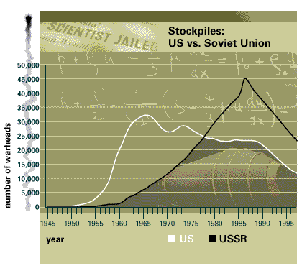

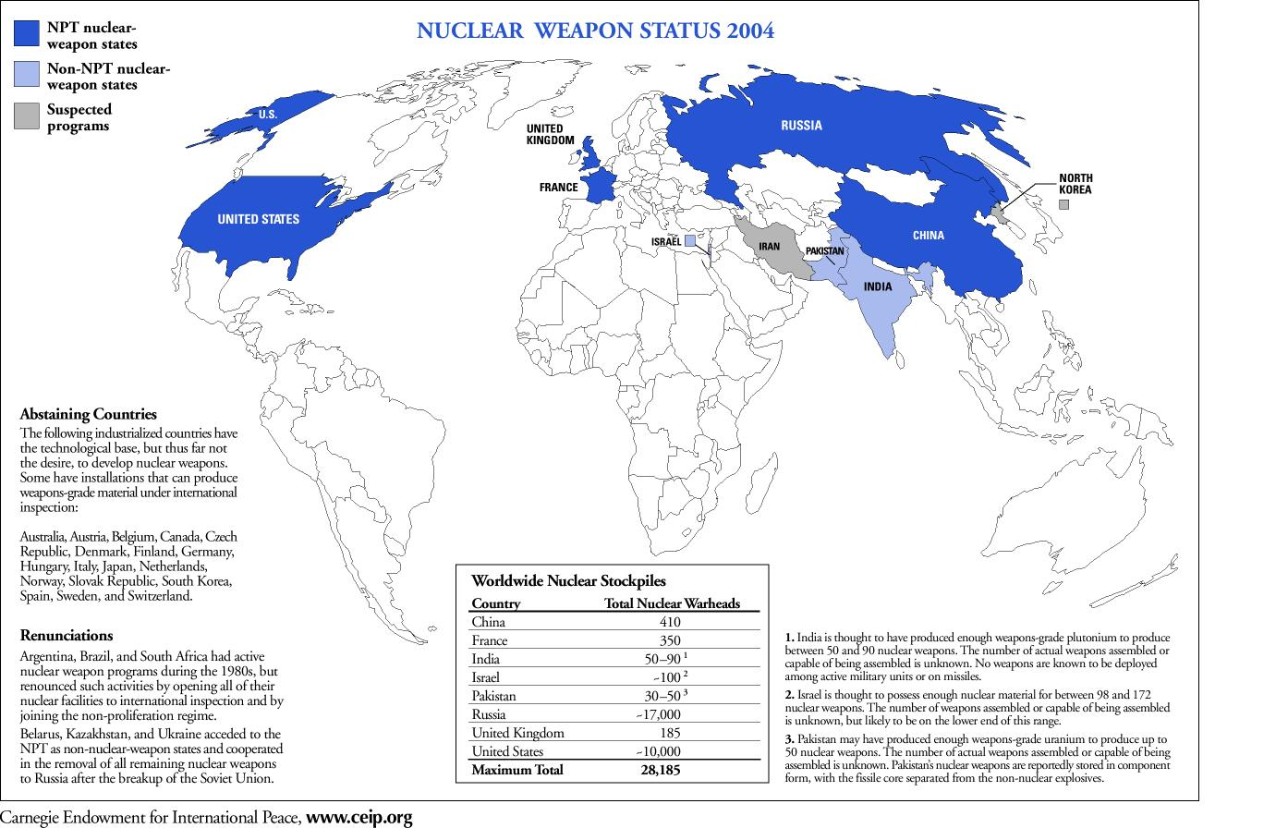
Nuclear Weapons 2004 Status Overhead

