What is Imperialism?

If you were to “Google” the term imperialism, you might come up with a definition stating imperialism is “a policy of extending a country’s power and influence through diplomacy or military force.” Another definition you might come across would state that imperialism occurs when “a strong nation takes over a weaker nation or region and dominates its economic, political, or cultural life.” The second definition might conjure up thoughts of colonization and that’s good, because a major aspect of imperialism involves the taking of colonies. In this assignment, you will explore the concept of imperialism and at the end I would like you to come up with your own definition of imperialism based on what it means to you and how it affects the world today.

I. Early 20th Century Maps
Directions: Study the maps below and answer questions 1-4 on the final page.

Map 1: The World of 1914

Map 2: Africa 1914

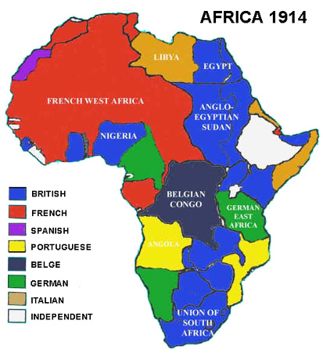
Map 3: China 1910

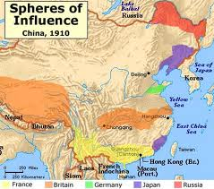

II. Rudyard Kipling’s “White Man’s Burden”
Directions: Read the poem below and answer question 5 on the final page.

Born in British India in 1865, Rudyard Kipling was educated in England before returning to India in 1882, where his father was a museum director and authority on Indian arts and crafts. Thus, Kipling was thoroughly immersed in Indian culture; by 1890 he had published in English about 80 stories and ballads previously unknown outside India. As a result of financial misfortune, from 1892-96 he and his wife, the daughter of an American publisher, lived in Vermont, where he wrote the two Jungle Books. After returning to England, he published "The White Man's Burden" in 1899, an appeal to the United States to assume the task of developing the Philippines, recently won in the Spanish-American War. As a writer, Kipling perhaps lived too long. By the time of his death in 1936, he had come to be reviled as the poet of British imperialism, though being regarded as a beloved children's book author. Below is an excerpt from “The White Man’s Burden.”
Take up the White Man's burden--
Send forth the best ye breed--
Go bind your sons to exile
To serve your captives' need;
To wait in heavy harness,
On fluttered folk and wild--
Your new-caught, sullen peoples,
Half-devil and half-child.
Take up the White Man's burden--
In patience to abide,
To veil the threat of terror
And check the show of pride;
By open speech and simple,
An hundred times made plain
To seek another's profit,
And work another's gain…

Take up the White Man's burden--
No tawdry rule of kings,
But toil of serf and sweeper--
The tale of common things.
The ports ye shall not enter,
The roads ye shall not tread,
Go mark them with your living,
And mark them with your dead.

III. Quotes on Imperialism
Directions: Read the quotes below and answer question 6 on the final page.

“What do nations care about the cost of war, if by spending a few hundred millions in steel and gunpowder they can gain a thousand millions in diamonds and cocoa?”
--W.E.B. Du Bois (American sociologist, civil rights activist and co-founder of the NAACP)

“I hate imperialism. I detest colonialism. And I fear the consequences of their last bitter struggle for life. We are determined, that our nation, and the world as a whole, shall not be the play thing of one small corner of the world.”
--Sukarno (First president of Indonesia; leader in his countries fight for independence from the Netherlands)

“Every empire, however, tells itself and the world that it is unlike all other empires, that its mission is not to plunder and control but to educate and liberate."
--Edward W. Said (20th century Palestinian-American author, English professor, and critic of imperialism)
IV. The World Today
Directions: Study the maps below and answer question 7 on the final page.

Map 4: Market Size by Gross Domestic Product (1995)
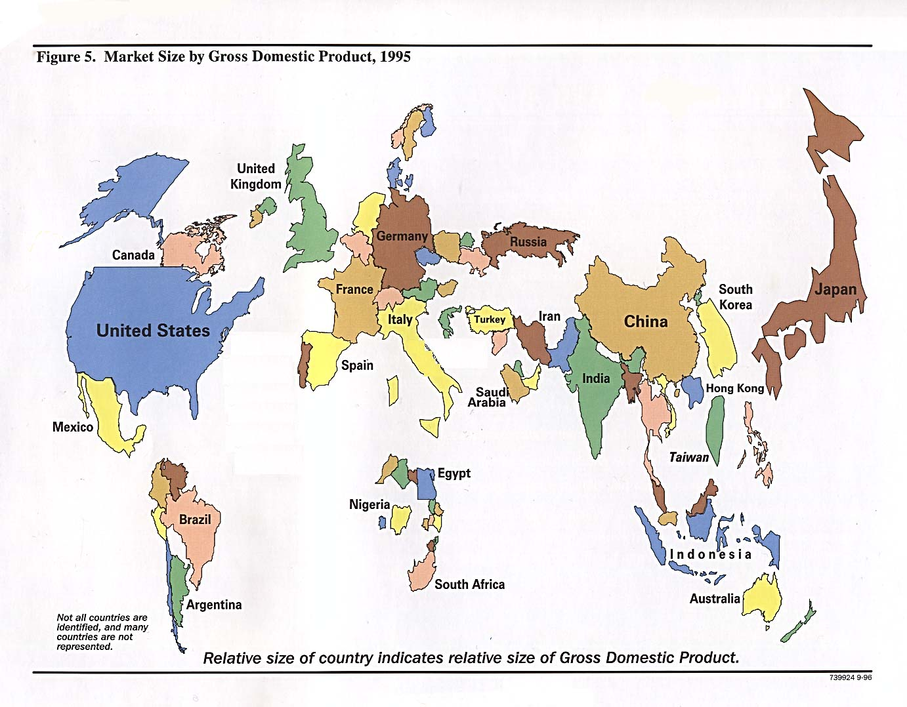

Map 5: Countries According to Their Gross Domestic Product (2007)
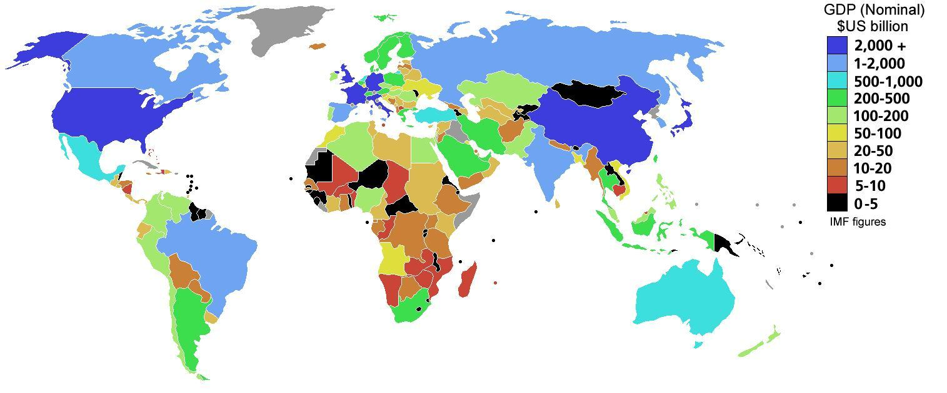
Map 6: World’s Economy Divided by Area (2015)

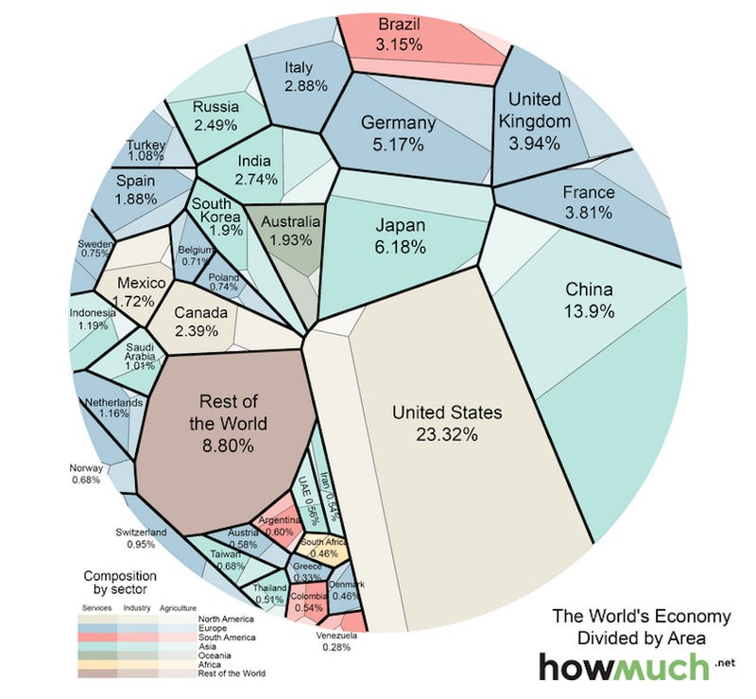

Questions on Imperialism

1. From what part of the world did imperial/colonial powers come from? (Europe, N. America, Asia, etc.)

2. What regions/continents of the world were being colonized?

3. Brainstorm: What advantages (think technology) did the imperial powers (the colonizers) have over those being colonized?

4. Do you see racism at work when countries practice imperialism?

5. What is the central message of Kipling’s poem? If you were a citizen of a colonized territory, how would you respond to Kipling?

6. How do the three quotes describe a similar reality regarding imperialism?

7. What countries have the largest GDPs today? Do you see a connection between the countries with the largest GDPs and those countries that practiced imperialism?

8. How would you define imperialism? In what ways does the practice of imperialism affect the world today?

