Tenth Grade: Economics

Unit 4: The Role of Government

Overarching Question:

How can the U.S. government influence the economic environment to achieve macroeconomic goals in a global economy?

Previous Unit:  Macroeconomics Challenges | This Unit:  The Role of Government |  | Next Unit:  The Global Economy
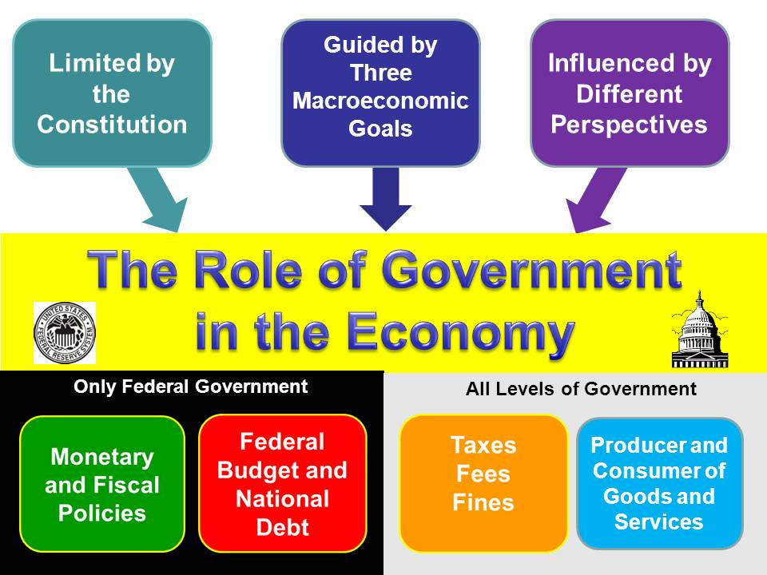
Questions To Focus Assessment and Instruction:  1. How can the US government influence the economic environment to achieve the macroeconomic goals?  2. How can government policies influence the interactions of buyers and sellers in a market economy?  3. How do fiscal and monetary policies affect individuals, businesses, and society? |  | Types of Thinking  - Cause and Effect  - Description  - Problem solving  - Identifying perspectives

Unit Abstract:
This unit focuses primarily on the federal government’s role in the economy. Students begin the unit with a brief review of the three macroeconomic goals of an economy. They are then introduced to the role of government in the economy by examining different government actions and/or regulation in the United States. After exploring how these actions and regulations may serve the purposes of government as set forth in the Preamble to the U.S. Constitution and account for externalities, students revisit the circular flow model and add government’s role. Students then examine a variety of examples of government policies and their influence on the circular flow. They then explore tax policies as both a revenue generator for the government and as an incentive/disincentive for specific economic behavior. In considering public goods and services, students consider why some are provided by the government, while others are not. After learning how all taxes have a base, a rate, and a system, students use criteria to evaluate taxes and apply those criteria in developing a tax code. Students then turn their attention to the federal budget, exploring revenue, expenditures (mandatory and discretionary), and the national debt. They analyze the budget and make recommendations for balancing the budget. Students then learn to distinguish between fiscal and monetary policy and their tools. The unit concludes with students comparing two contrasting views about the role of government in the economy that have been debated since early in the 20th century. Throughout the unit, students continue to write reflectively in their Perspectives on Decision Making Notebook in response to macroeconomic questions and deepen their understanding of economic terminology by completing their Essential Economic Terms handout.

Focus Questions
1. How can the US government influence the economic environment to achieve the macroeconomic goals?
2. How can government policies influence the interactions of buyers and sellers in a market economy?
3. How do fiscal and monetary policies affect individuals, businesses, and society?

Content Expectations
E1.4.1: Public Policy and the Market – Analyze the impact of a change in public policy (such as an increase in the minimum wage, a new tax policy, or a change in interest rates) on consumers, producers, workers, savers, and investors.

E1.4.2: Government and Consumers – Analyze the role of government in protecting consumers and enforcing contracts, (including property rights), and explain how this role influences the incentives (or disincentives) for people to produce and exchange goods and services.

E1.4.3: Government Revenue and Services – Analyze the ways in which local and state governments generate revenue (e.g., income, sales, and property taxes) and use that revenue for public services (e.g., parks and highways).

E1.4.4: Functions of Government – Explain the various functions of government in a market economy including the provision of public goods and services, the creation of currency, the establishment of property rights, the enforcement of contracts, correcting for externalities and market failures, the redistribution of income and wealth, regulation of labor (e.g., minimum wage, child labor, working conditions), and the promotion of economic growth and security.

E1.4.5: Economic Incentives and Government – Identify and explain how monetary and non-monetary incentives affect government officials and voters and explain how government policies affect the behavior of various people including consumers, savers, investors, workers, and producers.

E2.1.2: Circular Flow and the National Economy – Using the concept of circular flow, analyze the roles of and the relationships between households, business firms, financial institutions, and government and nongovernment agencies in the economy of the United States.

E2.1.3: Financial Institutions and Money Supply – Analyze how decisions by the Federal Reserve and actions by financial institutions (e.g., commercial banks, credit unions) regarding deposits and loans, impact the expansion and contraction of the money supply.

E2.1.8: Relationship Between Expenditures and Revenue (Circular Flow) – Using the circular flow model, explain how spending on consumption, investment, government and net exports determines national income; explain how a decrease in total expenditures affects the value of a nation’s output of final goods and services.

E2.2.1: Federal Government and Macroeconomic Goals – Identify the three macroeconomic goals of an economic system (stable prices, low unemployment, and economic growth).

E2.2.2: Macroeconomic Policy Alternatives – Compare and contrast differing policy recommendations for the role of the Federal government in achieving the macroeconomic goals of stable prices, low unemployment, and economic growth.

E2.2.3: Fiscal Policy and its Consequences – Analyze the consequences – intended and unintended –of using various tax and spending policies to achieve macroeconomic goals of stable prices, low unemployment, and economic growth.

E2.2.4: Federal Reserve and Monetary Policy – Explain the roles and responsibilities of the Federal Reserve System and compare and contrast the consequences – intended and unintended – of different monetary policy actions of the Federal Reserve Board as a means to achieve macroeconomic goals of stable prices, low unemployment, and economic growth.

E2.2.5: Government Revenue and Services – Analyze the ways in which governments generate revenue on consumption, income and wealth and use that revenue for public services (e.g., parks and highways) and social welfare (e.g., social security, Medicaid, Medicare).

C1.1.3: Identify and explain competing arguments about the necessity and purposes of government (such as to protect inalienable rights, promote the general welfare, resolve conflicts, promote equality, and establish justice for all).

Common Core Standards
RH.9-10.2: Determine the central ideas or information of a primary or secondary source; provide an accurate summary of how key events or ideas develop over the course of the text.

RH.9-10.4: Determine the meaning of words and phrases as they are used in a text, including vocabulary describing political, social, or economic aspects of history/social studies.

RH.9-10.6: Compare the point of view of two or more authors for how they treat the same or similar topics, including which details they include and emphasize in their respective accounts.

RH.9-10.9: Compare and contrast treatments of the same topic in several primary and secondary sources.

RH.9-10.10: By the end of grade 10, read and comprehend history/social studies texts in the grades 9-10 text complexity band independently and proficiently

WHST.9-10.4: Produce clear and coherent writing in which the development, organization, and style are appropriate to task, purpose, and audience.

WHST.9-10.8: Gather relevant information from multiple authoritative print and digital sources, using advanced searches effectively; assess the usefulness of each source in answering the research question; integrate information into the text selectively to maintain the flow of ideas, avoiding plagiarism and following a standard format for citation.

WHST.9-10.9: Draw evidence from informational texts to support analysis, reflection, and research.

WHST.9-10.10: Write routinely over extended time frames (time for reflection and revision) and shorter time frames (a single sitting or a day or two) for a range of discipline-specific tasks, purposes, and audiences.

Key Concepts
circular flow
externalities
fiscal policy
government budget
government expenditures
government revenue (taxes, fees, fines)
incentives
macroeconomic goals
market imperfections/failures
monetary policy
money supply
national debt
property rights
public goods and services
public policy
regulation (consumer and worker protections)
taxation
transfer payments (entitlements)

Duration
3 weeks

Lesson Sequence
Lesson 1: Government and the Economy
Lesson 2: Rounding out the Circular Flow
Lesson 3: Taxes, Fees, and Fines, Oh My!
Lesson 4: Understanding Government Budgets
Lesson 5: Fiscal Policy
Lesson 6: Monetary Policy
Lesson 7: Economic Perspectives

Assessment
Selected Response Items

Constructed Response Items

Performance Assessments

Resources
Equipment/Manipulative
Chart paper and Markers
Computer Internet Access
Overhead Projector or Document Camera
Poster Board
Sticky Notes

Student Resources
ABC News. 4 May 2011 <http://abcnews.go.com>.

Bloomberg News. 4 May 2011 <http://www.bloomberg.com>.

Budget Hero. American Public Media. 2008. 4 May 2011 <http://budgethero.publicradio.org/widget/widget.php>.

“Budget Puzzle: You Fix the Budget.” Week in Review. The New York Times. 13 November 2010. 4 May 2011 <http://www.nytimes.com/interactive/2010/11/13/weekinreview/deficits-graphic.html?ref=weekinreview>.

CNN. US Edition. 4 May 2011 <http://www.cnn.com>.

"Fear the Boom and Bust" A Hayek vs. Keynes Rap Anthem. Youtube. 4 May 2011 <http://www.youtube.com/watch?v=d0nERTFo-Sk> (For audio use only).

Forbes. 4 May 2011 <http://www.forbes.com>.

Fox News. 4 May 2011 <http://www.foxnews.com>.

“The Great Tax-Cut Debate: The Proposals. Bloomberg Business Week. 17 Sept. 2010. Updated Oct. 27, 2010. 23 April 2011 <http://www.businessweek.com/magazine/tax-cuts/>.

Hibbs, Jason. “Firefighters watch as home burns to the ground.” WPSD Local 6 - News, Sports, Weather - Paducah KY. 29 September 2010. 4 May 2011 <http://www.wpsdlocal6.com/internal?st=print&id=104052668&path=/news/local>.

“How Twitter Users Balanced the Budget.” Week in Review. The New York Times. 20 November 2010. 4 May 2011 <http://www.nytimes.com/interactive/2010/11/21/weekinreview/21leonhardt-graphic.html?ref=weekinreview>.

Leonhardt, David. “O.K., You Fix the Budget.” The New York Times. 13 November 2010.

Mankiw, N Gregory. Principles of Economics: Fourth Edition. Thomson South-Western. United States. 2007.

MSNBC News. 4 May 2011 <http://www.msnbc.msn.com>.

NBC News. 4 May 2011 <http://www.nbc.com>.

Papola, John and Russ Roberts. Fear the Boom and Bust Rap. 4 May 2011 <http://www.billyandadam.com>.

Tax Terms. Investopia. 4 May 2011 < http://www.investopedia.com/categories/taxes.asp

The Detroit Free Press. 4 May 2011 <http://www.freep.com>.

The New York Times. 4 May 2011 http://www.nytimes.com

The Oakland Press. 4 May 2011 <http://www.theoaklandpress.com>.

The Wall Street Journal. 4 May 2011 <http://www.wsj.com>.

Understanding Taxes, Student Glossary. IRS.com. 4 May 2011 <http://www.irs.gov/app/understandingTaxes/student/glossary.jsp>.

Von Hayek, Friedrich. The Road to Serfdom. Routledge, 1944. pp. 13-14, 36-37, 39-45.

Weisberg, Jacob. “Down with the People.” Washington Post. Newsweek Interactive Co. 6 Feb. 2010.
“Who Pays? A Distributional Analysis of the Tax Systems in All 50 States.” Institute of Taxation and Economic Policy. 3rd ed. Nov. 2009. 4 May 2011 <http://www.itepnet.org/whopays3.pdf> .

Yergin, Daniel and Joseph Stanislaw. Profile of John Maynard Keynes. Commanding Heights. PBS/WGBH, 1998.

Teacher Resources
“16 Ways to Cut the Deficit.” Room for Debate. The New York Times. 14 November 2010. 4 May 2011 <http://www.nytimes.com/roomfordebate/2010/11/14/16-ways-to-cut-the-deficit>.

“House Goes Up in Flames.” Youtube.com. 5 Oct. 2010. 4 May 2011 <http://www.youtube.com/watch?v=HHpNhvFPFG8>.

“Theme 3: Fairness in Taxes.” Understanding Taxes. IRS.gov. 4 May 2011 <http://www.irs.gov/app/understandingTaxes/student/whys_thm03_les04.jsp>.

Krugman, Paul R. and Robin Wells. Economics. New York: W.H.Freeman & Co., Ltd., 2009.

McEachern, William A. Contemporary Economics. Australia: Thomson, 2005.

Role of Government in the Economy. U.S. Department of State. 4 May 2011 <http://countrystudies.us/united-states/economy-6.htm>.

Siklos, Pierre L. “What is Deflation?” Wilfrid Laurier University. 1 Feb. 2010. 4 May 2011 <http://eh.net/encyclopedia/article/siklos.deflation>.

U.S. Bureau of Labor Statistics Occupational Outlook Handbook. 23 April 2011 <http://www.bls.gov>.

Resources for Further Professional Knowledge
Fishback, Price V. and Douglass C. North. Government and the American Economy. Chicago: University of Chicago Press, 2007.

Commanding Heights: Battle for the World Economy. PBS/WGBH. Heights Production, Inc. 2002. 4 May 2011 <http://www.pbs.org/wgbh/commandingheights/lo/index.html>.

Martinez, Mark A. The Myth of the Free Market: The Role of the State in a Capitalist Economy. Sterling, VA: Kumarian Press, 2009.

