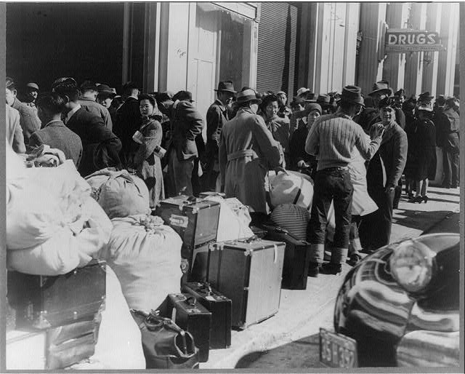
After the Bombing of Pearl Harbor, was the internment of Japanese Americans justified?
Lange Dorothea. Residents of Japanese ancestry awaiting the bus at the Wartime Civil Control sta., San Francisco, Apr. 1942, 1942 April. Library of Congress Prints and Photographs Division Washington, D.C. 20540 USA

Overview: On December 7, 1941 Pearl Harbor was attacked by Japanese fighter pilots. Most of the base was destroyed. Within the next few days the United States declared war on Japan. This act of aggression caused fear and suspicion of Japanese Americans across the United States. In February 1942 Present Roosevelt passed the Executive Order Act 9066 and the internment of Japanese Americans began. The question for this Mini-Q is was the internment of Japanese Americans after the bombing of Pearl Harbor justified.

The Documents
Document A Pearl Harbor naval base and U.S.S. Shaw aflame after the Japanese attack
Document B FDR's "Day of Infamy" Speech
Document C Salvage scrap to blast the Jap
Document D Executive Order 9066
Document E Tule Lake Segregation Camp. California State Library http://www.library.ca.gov/
Document F 89 Panel: Japanese American Citizens League Testimony of John Y Tateishi

Hook Exercise: Japanese American Internment:

Your neighbor is a Japanese American who was just given six days’ notice to pack all of his family’s belongings and move to an unknown place. He and his family are only allowed to take what they can carry. Everything else must be sold or left behind. For five days you watch your neighbor sell their things.

You watch other neighbors turn their backs and ignore the Japanese American family. Some of them even call them names and shout from across the street. Many seem sympathetic, but do nothing but look the other way.

Your task: With a partner talk through the situation. Do you think Japanese Americans being sent to internment camps is justified?

Justified Not Justified

Your Decision

Background Essay Questions

What Caused the Japanese American Internment?

On the morning of December 7, 1941, the Japanese launched a surprise air attack on Pearl Harbor, Hawaii. Much of the US Pacific Fleet was stationed there and the surprise attack caused many US losses. Four navy battle ships were sunk and another four damaged. The Japanese also sunk or damaged or destroyed smaller ships and aircraft. In total, about half of the pacific Fleet was damaged or destroyed. Along with the damage, 2,402 men killed and 1,282 wounded.

A day after the attack, President Franklin D. Roosevelt asked Congress to declare war on Japan. The resolution was approved, with only one representative voting against it. In the days immediately following the attack on Perl Harbor the FBI arrested approximately 1,200 Japanese aliens within the United States, and President Roosevelt came under increasing political and public pressure to do something about the Japanese population in California. Many newspaper articles called for action, stirring up public fear and creating anxiety among the general public.

There were however, those who urged the president to exercise restraint and argued that internment was unconstitutional. Despite protest of the Justice department on February 19, 1942 President Roosevelt signed Executive Order 9066 into law, granting the War Department broad powers to create military exclusion areas. By 1943, more than 110,000 Japanese Americans had been forced from their homes and moved to camps in remote inland areas of the US called internment camps.

Background Essay Questions

- What happened on December 7, 1941 at Pearl Harbor?

- How did President Roosevelt respond to the attack on Pearl Harbor?

- What happen on February 19, 1942?

- By 1943, how many Japanese Americans were forced to relocate to internment camps?

- Define or explain each of these terms:

Internment Camps

Executive Order 9066

Internment Camp

Document A
Source: Pearl Harbor naval base and U.S.S. Shaw aflame after the Japanese attack. 1941. Miscellaneous Items in High Demand. Library of Congress Prints and Photographs Division Washington, D.C. 20540 USA. 19 February 2013. http://www.loc.gov/pictures/item/98506923/

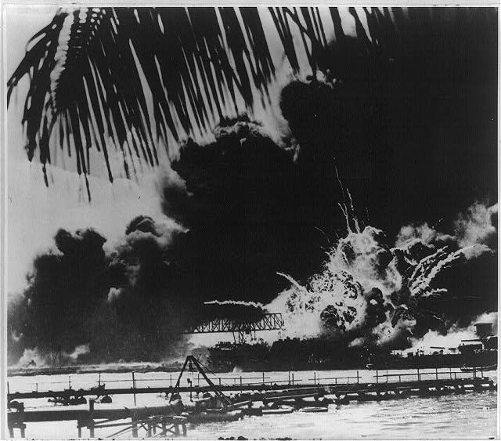

Document B
Source: FDR's "Day of Infamy" Speech: Crafting a Call to Arms. Our Heritage in Documents. Prolong Magazine. National Archives. Winter 2001, Vol. 33, No. 4. 18 February 2013. http://www.archives.gov/publications/prologue/2001/winter/crafting-day-of-infamy-speech.html

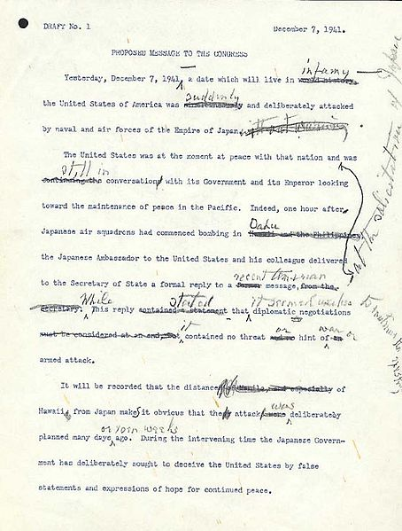

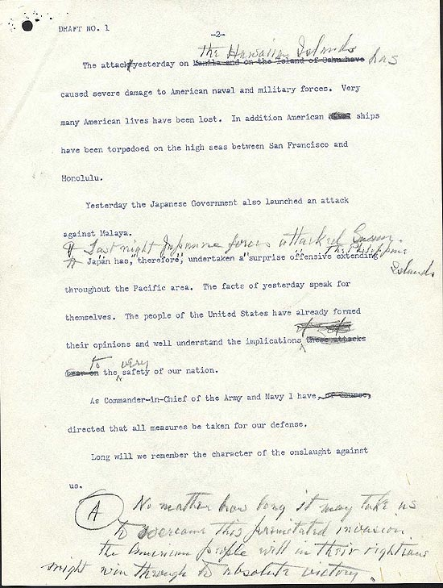

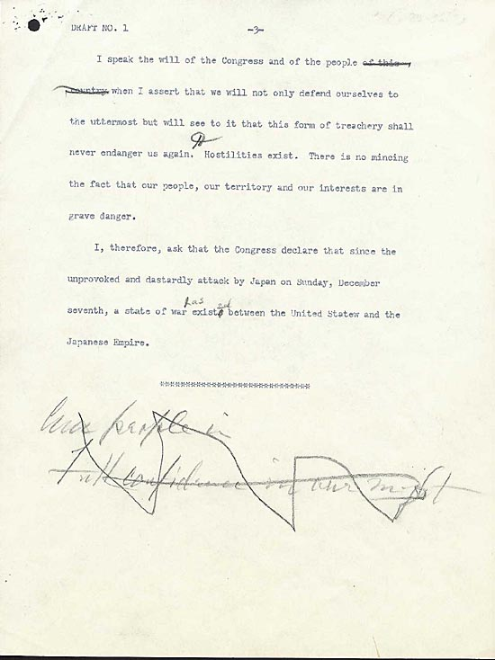

Document C

Source: Salvage scrap to blast the jap, Library of Congress, Prints and Photographs Division, WPA Poster Collection, LC-USZC2-1109 DLC (color film copy slide)

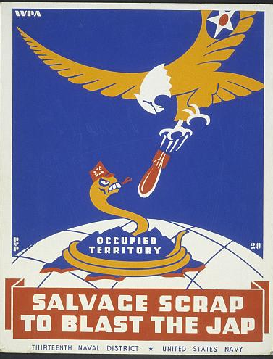

Document D
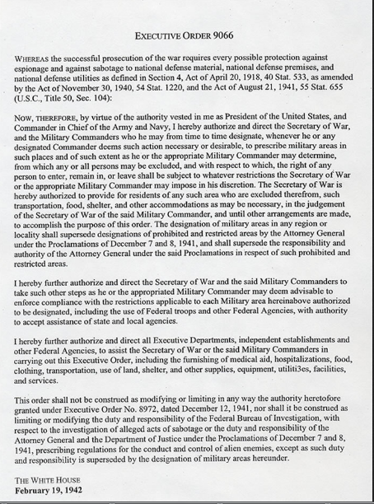
Source: Franklin D. Roosevelt: "Executive Order 9066 - Authorizing the Secretary of War To Prescribe Military Areas," February 19, 1942. Online by Gerhard Peters and John T. Woolley, The American Presidency Project. http://www.presidency.ucsb.edu/ws/?pid=61698.

Document E
Source: Tule Lake Segregation Camp. California State Library http://www.library.ca.gov/

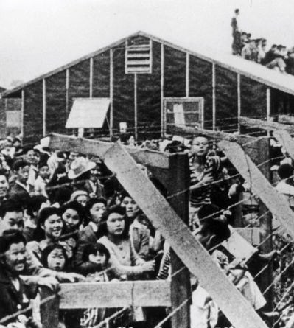

Document E
Source: 89 Panel: Japanese American Citizens League Testimony of John Y Tateishi. American Memory OCR. Library of Congress. 19 February 2013. http://memory.loc.gov/service/digsymlinks/000/000171/00017162/0001716223/00017162238/00000087.txt

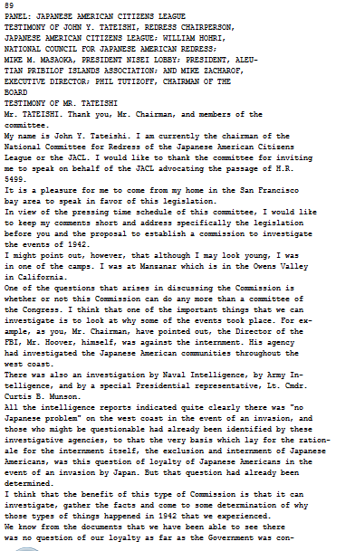

Bucketing – Getting Ready to Write

Bucketing

Look over all the documents and organize them into your final buckets. Write final bucket labels under each bucket and place the letters of the documents in the buckets where they belong. It is okay to put a document in more than one bucket. Remember, your buckets are going to become your body paragraphs.

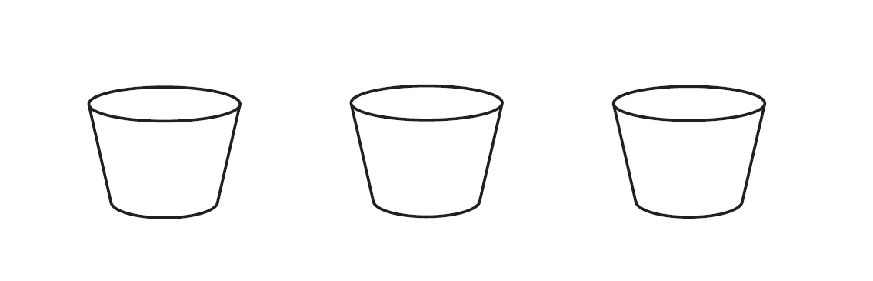

Thesis Development and Roadmap

On the chickenfoot below, write your thesis and your roadmap. Your thesis is always an opinion and answers the Mini-Q question. The road map is created from your bucket labels and lists the topic areas you will examine in order to prove your thesis.

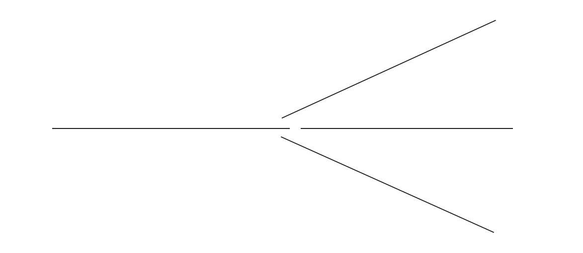
From Thesis to Essay Writing

Mini-Q Essay Outline Guide

Working Title

Paragraph #1
Grabber

Background

Stating the question with key terms defined

Thesis and roadmap

Paragraph #2
Baby Thesis for bucket one

Evidence: supporting detail from documents with document citation

Argument: connecting evidence to the thesis

Paragraph #3
Baby Thesis for bucket one

Evidence: supporting detail from documents with document citation

Argument: connecting evidence to the thesis

Paragraph #4
Baby Thesis for bucket one

Evidence: supporting detail from documents with document citation

Argument: connecting evidence to the thesis

Paragraph #5
Conclusion: Restatement of main idea along with possible insight or wrinkle

Rubric
Here are the standards for the DBQ essay scores from the highest score of a 5, to the lowest score a 0. You will earn one of these scores if the DBQ answer demonstrates the following:
5 | - A strong thesis statement. It directly answers the question.  - The essay thoroughly addresses all aspects of the task by accurately analyzing and interpreting at least 3 documents.  - Incorporates information from the documents in the body of the essay.  - Incorporates relevant outside information.  - Richly supports the theme or problem with relevant facts, examples, and details.  - Excellent organization; a well-written essay with proper spelling, grammar, and mechanics.
4 | - A thesis that answers the question.  - The essay addresses all aspects of the task by accurately analyzing and interpreting at least 3 documents.  - Incorporates information from the documents in the body of the essay.  - Incorporates some relevant outside information.  - Includes relevant facts, examples, and details, but discussion may be more  - descriptive than analytical  - Clear organization and good writing; only minor errors in spelling, grammar, and mechanics.
3 | - A weaker thesis that may not adequately answer the question.  - Addresses most aspects of the task or addresses all aspects of the task in a limited way, using some of the documents.  - Incorporates some information from the documents in the body of the essay.  - Incorporates limited or no relevant outside information.  - Includes some facts, examples, and details, but discussion is more descriptive than analytical.  - Weaker organization and writing; errors in spelling, grammar, and mechanics that detract from the essay’s quality.
2 | - A weak thesis that fails to adequately answer or even address the question.  - Attempts to address some aspects of the task, making limited use of the documents.  - Presents no relevant outside information.  - Includes few facts, examples, and details; discussion restates contents of the documents.  - Poorly organized essay and writing; many errors in spelling, grammar, and mechanics.

1 | - A confused and unfocused thesis that fails to address the question.  - Shows limited understanding of the task with vague, unclear references to the documents.  - Presents no relevant outside information.  - Includes little or no accurate or relevant facts, details, or examples.  - Disorganized and unfocused writing; many errors in spelling, grammar, and mechanics.
0 | No thesis statement; no attempt to address the question.  No understanding of the topic or question; fails to address the task.  No use or only misuse and misunderstanding of the documents.  No information from any learning beyond simply the documents used.  A lack of organization and structure. Little attempt made. Blank paper.

Resource Table

Image | Description | Citation | URL
 | Pearl Harbor naval base and U.S.S. Shaw aflame after the Japanese attack. 1941. | Pearl Harbor naval base and U.S.S. Shaw aflame after the Japanese attack. 1941. Miscellaneous Items in High Demand. Library of Congress Prints and Photographs Division Washington, D.C. 20540 USA. 19 February 2013. http://www.loc.gov/pictures/item/98506923/ | http://www.loc.gov/pictures/item/98506923/
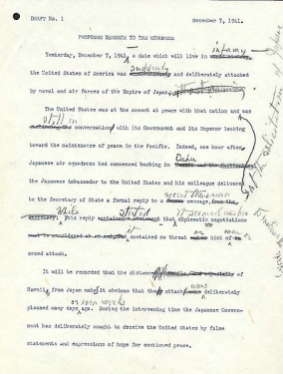 | FDR's "Day of Infamy" Speech: Crafting a Call to Arms. | FDR's "Day of Infamy" Speech: Crafting a Call to Arms. Our Heritage in Documents. Prolong Magazine. National Archives. Winter 2001, Vol. 33, No. 4. 18 February 2013. http://www.archives.gov/publications/prologue/2001/winter/crafting-day-of-infamy-speech.html | http://www.archives.gov/publications/prologue/2001/winter/crafting-day-of-infamy-speech.html
 | Salvage scrap to blast the jap, | Salvage scrap to blast the jap, Library of Congress, Prints and Photographs Division, WPA Poster Collection, LC-USZC2-1109 DLC (color film copy slide) | http://memory.loc.gov/cgi-bin/query/r?ammem/wpapos:@field(NUMBER+@band(cph+3b49009))
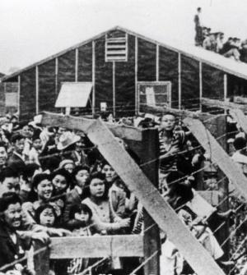 | Tule Lake Segregation Camp | Tule Lake Segregation Camp. California State Library http://www.library.ca.gov/ | http://lanternreview.com/blog/wp-content/uploads/2010/05/internment-image.jpg
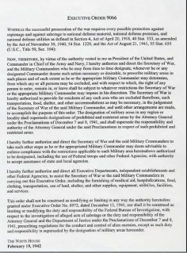 | Franklin D. Roosevelt: "Executive Order 9066 - Authorizing the Secretary of War To Prescribe Military Areas," | Franklin D. Roosevelt: "Executive Order 9066 - Authorizing the Secretary of War To Prescribe Military Areas," February 19, 1942. Online by Gerhard Peters and John T. Woolley, The American Presidency Project. http://www.presidency.ucsb.edu/ws/?pid=61698. | http://www.presidency.ucsb.edu/ws/?pid=61698.
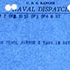 | Naval dispatch from the Commander in Chief Pacific (CINCPAC) announcing the Japanese attack on Pearl Harbor, 7 December 1941. | Library of Congress Manuscript Division | http://lcweb2.loc.gov/cgi-bin/query/r?ammem/mcc:@field(DOCID+@lit(mcc/002))
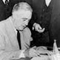 | President Roosevelt signing the declaration of war against Japan | Library of Congress, Prints and Photographs Division [reproduction number, LC-USZ62-15185 DLC | http://memory.loc.gov/cgi-bin/query/r?ammem/presp:@field(NUMBER+@band(cph+3a17434))
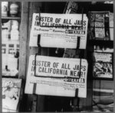 | Oakland, Calif., Feb. 1942 | Lange, Dorothea. Oakland, Calif., Feb. 1942. 1942 February. Farm Security Administration and Office of War Information Collection. Library of Congress Prints and Photographs Division. 15 February 2013.  http://www.loc.gov/pictures/item/2001705924/ | http://www.loc.gov/pictures/item/2001705924/
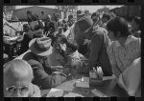 | Santa Anita reception center, Los Angeles, California. The evacuation of Japanese and Japanese-Americans from West Coast areas under U.S. Army war emergency order. Registering Japanese-Americans as they arrive | Lee, Russel. Santa Anita reception center, Los Angeles, California. 1942 April. Farm Security Administration and Office of War Information Collection. Library of Congress Prints and Photographs Division.  http://www.loc.gov/pictures/item/fsa1998003578/PP/ | http://www.loc.gov/pictures/item/fsa1998003578/PP/
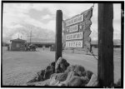 | Entrance to Manzanar, Manzanar Relocation Center | Adams, Ansel. Entrance to Manzanar, Manzanar Relocation Center. 1943. Adams, Ansel, 1902- Manzanar War Relocation Center photographsLibrary of Congress Prints and Photographs Division Washington. 19 February 2013. http://www.loc.gov/pictures/item/2002695960/ | http://www.loc.gov/pictures/item/2002695960/
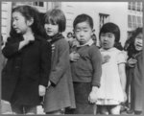 | San Francisco, Calif., April 1942. First-graders, some of Japanese ancestry, at the Weill public school pledging allegience to the United States flag. The evacuees of Japanese ancestry will be housed in War relocation authority centers for the duration of the war. | San Francisco, Calif., April 1942. First-graders, some of Japanese ancestry, at the Weill public school pledging allegience to the United States flag. April 1942. Farm Security Administration and Office of War Information Collection (Library of Congress).Library of Congress, Prints and Photographs Division. 19 February 2013. http://www.loc.gov/pictures/item/2001705948/ | http://www.loc.gov/pictures/item/2001705948/
Text of Munson report |  |  | http://memory.loc.gov/service/digsymlinks/000/000171/00017162/0001716223/00017162238/00000062.txt
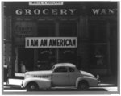 | Oakland, Calif., Mar. 1942. A large sign reading "I am an American" placed in the window of a store, at 13th and Franklin streets, on December 8, the day after Pearl Harbor. | Lange, Dorothea. Oakland, Calif., Mar. 1942. A large sign reading "I am an American" placed in the window of a store, at 13th and Franklin streets, on December 8, the day after Pearl Harbor. 1942 March. Farm Security Administration / Office of War Information Collection. Library of Congress Prints and Photographs Division. 18 February 2013. http://www.loc.gov/pictures/item/2004665381/ | http://www.loc.gov/pictures/item/2004665381/
Website: Presentations and Actiivites, Immigration  Library of Congress |  |  | http://www.loc.gov/teachers/classroommaterials/presentationsandactivities/presentations/immigration/japanese4.html
Teacher guide: Japanese American Internment during WW II  Library of Congress |  |  | http://www.loc.gov/teachers/classroommaterials/primarysourcesets/internment/pdf/teacher_guide.pdf
Primary source set:  Japanese American Internment during WW II  Library of Congress |  |  | http://www.loc.gov/teachers/classroommaterials/primarysourcesets/internment/
Map of America’s Relocation Camps |  |  | http://www.janm.org/projects/clasc/map.htm
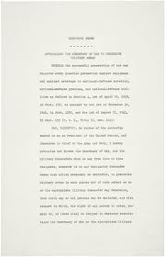 | Executive Order 9066: Resulting in the Relocation of Japanese | National Archives | http://www.archives.gov/historical-docs/todays-doc/index.html?dod-date=219
 | Korematsu v. United States: The U.S. Supreme Court Upholds Internment |  | http://historymatters.gmu.edu/d/5151
 | Milton Eisenhower Justifies the Internment of Japanese Americans |  | http://historymatters.gmu.edu/d/5153/
 | “Evacuation Was a Mistake”: Anger at Being Interned |  | http://historymatters.gmu.edu/d/5152
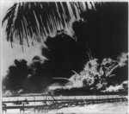 | [Pearl Harbor naval base and U.S.S. Shaw aflame after the Japanese attack] | Pearl Harbor naval base and U.S.S. Shaw aflame after the Japanese attack. 1941. Miscellaneous Items in High Demand. Library of Congress Prints and Photographs Division Washington, D.C. 20540 USA. 19 February 2013. http://www.loc.gov/pictures/item/98506923/ | http://www.loc.gov/pictures/item/98506923/

