OVERVIEW
At 12:30 p.m. on November 22nd of 1963 one of the biggest tragedies in American History occurred in Dallas, Texas. While in riding in a convertible in a motorcade, President John F. Kennedy was assassinated by an unknown assailant. Lee Harvey Oswald was arrested for the assassination, but he was killed two days later by Jack Ruby before he could be put on trial. Was the CIA behind the murder? Fidel Castro? The Mafia? The FBI? LBJ? The Russians? Martians?

Directions
Data Sets 1-5 explain specific theories on the JFK assassination. Data Set 6 contains a collection of theories, some of which reinforce the theories found in Data Sets 1-5. You will receive 2 pts extra credit for each theory that you analyze. You many analyze a maximum of three theories for a total of 6 pts. The extra credit will be applied to the Cold War Unit Test.

DATA SET 1

AN EXCERPT FROM:

"KENNEDY"

BY THEODORE C. SORENSEN
SPECIAL COUNSEL TO THE LATE PRESIDENT
Page 301:

With hindsight it is clear that what in fact he had approved was diplomatically unwise and militarily doomed from the outset. What he thought he was approving appeared at the time to have diplomatic acceptability and little chance of outright failure. That so great a gap between concept and actuality should exist at so high a level on so dangerous a matter reflected a shocking number of errors in the whole decision-making process-errors which permitted bureaucratic momentum to govern instead of policy leadership.

- The president thought he was approving a quiet, even though large-scale, reinfiltration of fourteen hundred Cuban exiles back into their homeland. He had been assured that the plan as revised to meet his criteria was an unspectacular and quiet landing of patriots plausibly Cuban in its essentials, of which the air strike was the only really noisy enterprise that remained. Their landing was, in fact, highly publicized in advance and deliberately trumpeted as an "invasion," and their numbers deliberately and grossly overstated-in part by exile groups and officials hoping to arouse the Cuban people to join them, in part by Castro to inflate first his danger and then his victory, and in part by headline writers to whom "invasion" sounded more exciting than a landing of fourteen hundred men. The CIA even dictated battle communiqués to a Madison Avenue public relations firm representing the exiles' political front. After all the military limitations accepted in order to keep this nation's role covert, that role was not only obvious but exaggerated.

The President thought he was approving a plan whereby the exiles, should they fail to hold and expand a beachhead, could take up guerilla warfare with other rebels in the mountains. They were, in fact, given contrary instructions to fall back on the beaches in case of failure; the immediate area was not suitable for guerrilla warfare, as the President had been assured; the vast majority of brigade members had not been given guerrilla training, as he had been assured; and the eighty-mile route to the Escambray Mountains, to which he had been assured they could escape, was so long, so swampy and so covered by Castro's troops that this was never a realistic alternative. It was never even planned by the CIA officers in charge of the operation, and they neither told the President they thought this option was out nor told the exiles that this was the President's plan.

- The President thought he was permitting the Cuban exiles, as represented by their Revolutionary Council and brigade leaders, to decide whether they wished to risk their own lives and liberty for the liberty of their country without any overt American support. Most members of the brigade were in fact under the mistaken impression, apparently from their CIA contacts, that American armed forces would openly and directly assist them, if necessary, to neutralize the air (presumably with jets), make certain of their ammunition and prevent their defeat. They also mistakenly assumed that a larger exile force would land with them, that the Cuban underground or guerillas would join them and that another landing elsewhere on the island would divert Castro's forces. (A small diversionary landing was, in fact, scheduled but called off after two tries.) Their assumptions were not made known to the President, just as his were not made known to them; and the Revolutionary Council was similarly kept largely uninformed on the landing and largely out of touch with the brigade. Its President, Dr. José Miró Cardona, who believed that only American armed might could overturn Castro, did not pass on the message he received from Kennedy's emissaries that no American military help would be forthcoming.

- President Kennedy thought he was approving a plan calculated to succeed with the help of the Cuban underground, military desertions and in time an uprising of a rebellious population. In fact, both Castro's popularity and his police state measures, aided by the mass arrests which promptly followed the bombings and landing, proved far stronger than the operation's planners had claimed. The planners, moreover, had no way to alert the underground without alerting Castro's forces. Cooperation was further impaired by the fact that some of the exiles' left-wing leaders were mistrusted by the CIA, just as some of their right-wing leaders and brigade members were mistrusted by the Cuban underground. As a result, although the brigade was aided after its landing by some defectors and villagers, no coordinated uprising or underground effort was really planned or possible, particularly in the brief time the brigade was carrying the fight. In short, the President had given his approval with the understanding that there were only two possible outcomes-a national revolt or a flight to the hills-and in fact neither was remotely possible.

- The President thought he was approving a plan rushed into execution on the grounds that Castro would later acquire the military capability to defeat it. Castro, in fact, already possessed that capability. Kennedy was told that Castro
had only an obsolete, ineffective air force not in combat condition, no communications in the Bay of Pigs-Zapata Swamp area and no forces nearby. All these reports were wrong: expected mass defections did not materialize; Castro's T-33 jet trainers were much more effective than predicted; and Castro's forces moved to the beachhead and crushed the exile force with far greater strength, equipment and speed than all the estimates had anticipated. Indeed, the jet trainers-which were largely responsible for the ammunition losses and other failures-had been largely overlooked by the planners.

The President, having approved the plan with assurances that it would be both clandestine and successful, thus found in fact that it was too large to be clandestine and too small to be successful. Ten thousand exiles might have done it-or twenty thousand-but not fourteen hundred, as bravely and brilliantly as they fought. General Taylor's subsequent review found the whole plan to have been militarily marginal: there were too few men in the brigade, too few pilots in the air arm, too few seconds-in-command to relieve fatigued leaders, too few reserves to replace battle losses and too many unforeseen obstacles. The brigade relied, for example, on a nighttime landing through uncharted reefs in boats with outboard motors. Even with ample ammunition and control of the air, even with two more air strikes twice as large, the brigade could not have broken out of its beachhead or survived much longer without substantial help from either American forces or the Cuban people. Neither was in the cards, and thus a brigade victory at the Bay of Pigs was never in the cards either.

http://www.historyofcuba.com/history/baypigs/jfk-2.htm
DATA SET 2

Article from the New York Times that has ‘evidence’ accusing Lyndon B. Johnson for plotting Kennedy’s assassination.
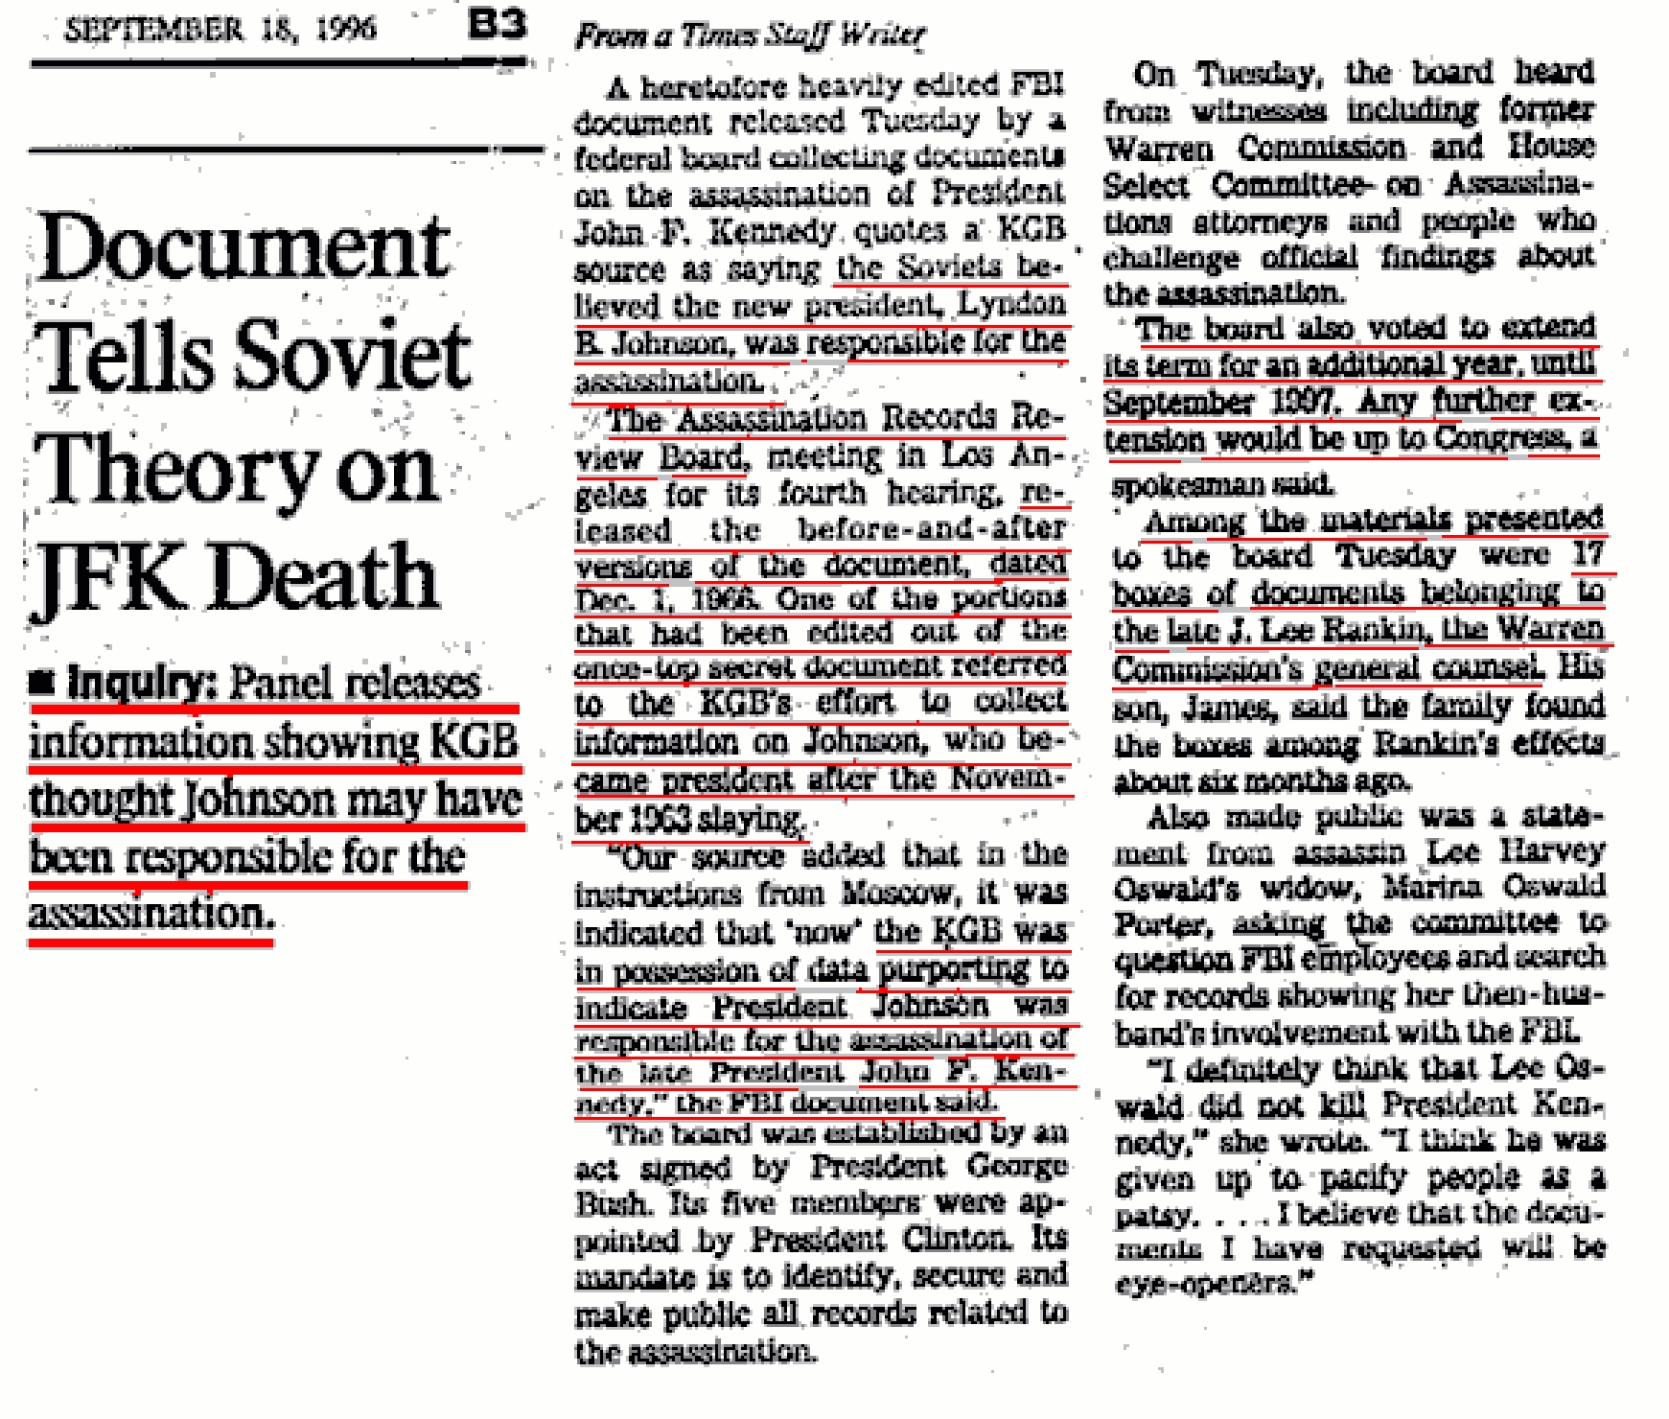
DATA SET 3

This data set tells about the Warren Commission and its findings. The Warren Commission was created to investigate the assassination.

The Warren Commission

After the death of John F. Kennedy, his deputy, Lyndon B. Johnson, was appointed president. He immediately set up a commission to "ascertain, evaluate and report upon the facts relating to the assassination of the late President John F. Kennedy." The seven man commission was headed by Chief Justice Earl Warren and included Gerald Ford, Allen W. Dulles, John J. McCloy, Richard B. Russell, John S. Cooper and Thomas H. Boggs.

Lyndon B. Johnson also commissioned a report on the assassination from J. Edgar Hoover. Two weeks later the Federal Bureau of Investigation produced a 500 page report claiming that Lee Harvey Oswald was the sole assassin and that there was no evidence of a conspiracy. The report was then passed to the Warren Commission. Rather than conduct its own independent investigation, the commission relied almost entirely on the FBI report.

The Warren Commission was published in October, 1964. It reached the following conclusions:

- The shots which killed President Kennedy and wounded Governor Connally were fired from the sixth floor window at the southeast corner of the Texas School Book Depository.

- The weight of the evidence indicates that there were three shots fired.

- Although it is not necessary to any essential findings of the Commission to determine just which shot hit Governor Connally, there is very persuasive evidence from the experts to indicate that the same bullet which pierced the President's throat also caused Governor Connally's wounds. However, Governor Connally's testimony and certain other factors have given rise to some difference of opinion as to this probability but there is no question in the mind of any member of the Commission that all the shots which caused the President's and Governor Connally's wounds were fired from the sixth floor window of the Texas School Book Depository.

- The shots which killed President Kennedy and wounded Governor Connally were fired by Lee Harvey Oswald.

- Oswald killed Dallas Police Patrolman J. D. Tippit approximately 45 minutes after the assassination.

- Within 80 minutes of the assassination and 35 minutes of the Tippit killing Oswald resisted arrest at the theater by attempting to shoot another Dallas police officer.

- The Commission has found no evidence that either Lee Harvey Oswald or Jack Ruby was part of any conspiracy, domestic or foreign, to assassinate President Kennedy.

- In its entire investigation the Commission has found no evidence of conspiracy, subversion, or disloyalty to the U.S. Government by any Federal, State, or local official.

- On the basis of the evidence before the Commission it concludes that, Oswald acted alone.
DATA SET 4

This Article lists the reasons the mafia wanted Kennedy dead thus making them the guilty party behind the assassination.

Mafia and John F. Kennedy

by Krysta Cardinale

“America’s First Family and the Kings of the Underworld”

One of the most popular topics of discussion for historians and conspiracy theorists alike is the connection between the Kennedy family and the Mafia. While most of the information available is based on word-of-mouth information passed down from people with questionable motives, a general thesis is plausible.

It is generally agreed that the association between the Kennedys and the mob goes back to the years before JFK took over the White House, back to when his father Joe Kennedy was becoming a very wealthy man in the bootlegging business. During Prohibition, Kennedy befriended Sam Giancana, the most powerful man in the Chicago underworld. Together, they made a fortune selling illegal booze and sparked a lifelong partnership and friendship.

Knowing that his past would never allow him to successfully run for office, Joe Kennedy satisfied his insatiable quest for power through his sons, insisting that they enter politics. The elder Kennedy used his significant monetary influence and enlisted his underworld connections to strong-arm support for his son in the media. Here he provided lucrative incentives to editors and journalists alike, in law enforcement, and in business. Joe Kennedy’s Mafia ties pulled through for him, and his efforts translated into John F.

Kennedy being elected president in November 1960. When broken down, the margin worked out to a single-vote victory in every poll in America. However, Joe Kennedy made sure there was no connection between the Mafia and John F. Kennedy’s presidential win.

The Mafia and John F. Kennedy

After JFK became president, he appointed his brother Robert to the post of attorney general. Bobby Kennedy immediately set out on a relentless pursuit of members of organized crime, arresting and jailing the very people who allegedly helped get him his job in the first place. His war on the underworld felt like a betrayal to mobsters like Sam Giancana. Especially since Giancana was rumored to have helped seal the election for JFK in Illinois, secure the West Virginia primary that got him the Democratic nomination, and had allegedly been assured by Joe Kennedy that the mob would be safe with his sons in office.

There was also the theory that the Kennedy brothers knew about and continued to support CIA-backed plans to use mobsters to assassinate Cuban leader Fidel Castro. Thus, they used and pursued mobsters and their resources at the same time.

Jimmy Hoffa, leader of the Teamsters and a well-known mob cohort, was closely watched by the government. Hoffa allegedly wanted Robert Kennedy eliminated. It had been rumored that he decided to get to Bobby by rubbing out his brother first.

The Mafia killed Kennedy

Jimmy Hoffa, leader of the Teamsters and a well-known mob cohort, was closely watched by the government. Hoffa allegedly wanted Robert Kennedy eliminated. This is because Robert Kennedy had uncovered and indicted Hoffa on several charges. Hoffa had a mistrial in his first trial for allegedly tampering with the jury. In the second trial, Hoffa was found guilty and sentenced to thirteen years in prison. It had been rumored that he decided to get to Bobby by rubbing out his brother first.

So in 1963, when John F. Kennedy was assassinated the stories began. The Kennedy assassination and the Mafia were rumored to be linked together by orders of Jimmy Hoffa. However, the evidence never proved that the Mafia killed Kennedy. In another tragic event, on June 6, 1968 Robert Kennedy was shot dead.

Once again, the Kennedy assassination and the Mafia were supposedly connected. And, once again, despite rumors there was no evidence that proved the Mafia killed Kennedy number two.

Though much of the “evidence” to this effect is circumstantial, and many “facts” arose years after the assassination, one thing is certain: America lost one of its most popular and beloved presidents on November 22, 1963. Though the events leading up to the assassination of John F. Kennedy and later, his brother Robert are still unknown, many people have their own theories, the legacy they left is undeniable.
DATA SET 5

This is an article from the NY Post that accuses Vice President Lyndon B. Johnson of being behind the assassination.

HUNT BLAMES JFK HIT ON LBJ

Last Updated: 5:00 AM, January 14, 2007

Posted: 5:00 AM, January 14, 2007

Richard Johnson with Paula Froelich, Bill Hoffmann, and Corynne Steindler

E. HOWARD Hunt - the shadowy former CIA man who organized the Watergate break-in and was once eyed in the assassination of President Kennedy - bizarrely says that Lyndon Johnson could be seen as a prime suspect in the rubout.

Only the most far-out conspiracy theorists believe in scenarios like Hunt's. But in a new memoir, "American Spy: My Secret History in the CIA, Watergate & Beyond," due out in April, Hunt, 88, writes: "Having Kennedy liquidated, thus elevating himself to the presidency without having to work for it himself, could have been a very tempting and logical move on Johnson's part.

"LBJ had the money and the connections to manipulate the scenario in Dallas and is on record as having convinced JFK to make the appearance in the first place. He further tried unsuccessfully to engineer the passengers of each vehicle, trying to get his good buddy, Gov. [John] Connolly, to ride with him instead of in JFK's car - where . . . he would have been out of danger."

Hunt says Johnson also had easy access to CIA man William Harvey, who'd been demoted when he tried to have Fidel Castro poisoned in defiance of orders to drop covert operations against Cuba. Harvey was "a ruthless man who was not satisfied with his position in the CIA and its government salary," Hunt writes.

"He definitely had dreams of becoming [CIA director] and LBJ could do that for him if he were president

. . . [LBJ] would have used Harvey because he was available and corrupt." Hunt denies any hand in the assassination, insisting he wasn't one of three mysterious hobos who were photographed at the scene.

On Watergate, Hunt says he saved G. Gordon Liddy from gagging on urine-tainted booze as they got ready to break into Democratic National Committee headquarters, telling him, "I know you like your scotch, but don't order it . . . Last night when we were hiding in the closet, I had to take a leak in the worst way, and when I couldn't bear it any longer, I found a fairly empty bottle of Johnnie Walker Red - and now let's just say it's quite full."
DATA SET 6

Whodunit

So who killed John Kennedy?

"The usual suspects are so numerous that whatever group you want to have a grudge against, you can pick your case based on the Kennedy assassination," says John McAdams, the Marquette professor. "Anything is possible to believe if you are willing to take the most unreliable evidence or most unreliable inferences and run with them."

Here is a short list of suspects and theories.

Lee Harvey Oswald, Lone Gunman

The best argument for the Warren Commission's controversial conclusion may be the serendipity through which Oswald landed a job at the Texas School Book Depository weeks before the murder—a second-hand referral. Simmering with anger about Cuba, Oswald learned that Kennedy's motorcade route would pass by his building. He secreted a rifle into the building, took a place at a sixth-floor window and fired the shots that killed the president and injured Gov. Connally, believers say.

Second Unidentified Assassin on the Grassy Knoll

The notion of a second assassin or an assassination team at Dealey Plaza has been fomented over the years by suspicious shadows, gunman-like silhouettes and puffs of smoke that turn up in moving and still pictures shot by witnesses on the day of the Kennedy murder. These photographic hieroglyphs have been deciphered since the day after the shooting, and figures such as "Black Dog Man" and "Umbrella Man" are totems among both doubters and believers. Oliver Stone used the mysterious Umbrella Man in "J.F.K." to signal the assassination team by pumping his umbrella up and down. The film left out one fact: the Umbrella Man had long ago been identified, questioned and cleared of having any part in the assassination.

The Cubans

The simplest Cuba theory is that Fidel Castro ordered Kennedy murdered because Kennedy had tried to have him murdered. In a variation, exiled Cubans who were angered at Kennedy's failure in the Bay of Pigs invasion arranged to have him killed. And in a second version of that variation, the same right-wing Cubans ordered the murder because Kennedy had resolved the Cuban missile crisis by promising the Soviets that he would keep his hands off Castro. Oswald served as a foil to the Cubans, and Ruby's job was to silence him.

The Kennedy-for-Castro postulate had a marquee believer: Lyndon Johnson. Six months before he died, Johnson told a journalist, "I never believed that Oswald acted alone, although I can accept that he pulled the trigger." He said he believed Castro ordered the retaliatory murder.

The Cuban conspiracy theories gained weight because Oswald adored Castro and had tried to travel to Cuba not long before the assassination, and because Jack Ruby had visited the island nation in 1959. Mere coincidences, say the lone-gunman believers. Impossible coincidences, say the doubters.
The KGB

Under this theory, Soviet agents—again, using Oswald as a foil—killed Kennedy because the president had embarrassed Premier Nikita Khrushchev in the missile crisis "staredown." Debunkers dismiss this scheme since Kennedy had promised a hands-off-Cuba policy and had made other concessions that cast Khrushchev as a clever negotiator, not a failure. Conspiracy theorists happily note that Oswald had lived in the Soviet Union during a defection dalliance, spoke a little Russian and was obsessed with Russian literature and music.

LBJ

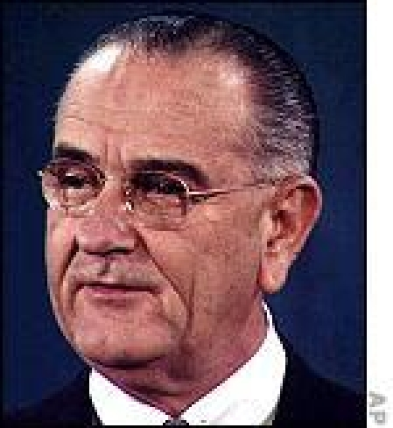

Lyndon Johnson

Lyndon Johnson is a seminal figure in any number of the conspiracy theories. As noted, he believed Oswald was a puppet for Castro. New Orleans DA Jim Garrison also fingered Johnson as a marionette pulling strings behind Garrison's personal conspiracy theory. He played a role in the KGB conspiracy theory, as well, by ordering the Warren Commission to "leave that stone unturned," according to adherents, when it learned of a Soviet connection to the murder.

In newly released telephone recordings made during his presidency, Johnson sounded flummoxed and frustrated as various aides, politicians and newsmen briefed him on conspiracy theories about the assassination. But the subject regularly came up in the Oval Office.

In a 1967 conversation with Attorney General Ramsey Clark, Johnson referred to the CIA's covert efforts to kill Castro.

He said, "It's incredible. I don't believe there's a thing in the world to it, and I don't think we oughta seriously consider it. But I think you oughta know about it."

Which proved, above all else, that even the president might not know everything the government is doing.
The Mafia
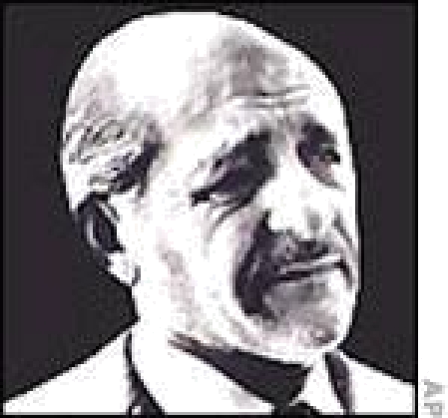

Sam Giancana

The Mafia liked Kennedy's religion but hated his politics.

The president and his brother, Attorney General Robert Kennedy, had pushed for probes of union racketeering, angering Teamsters boss Jimmy Hoffa. His appeasement deal with Nikita Khrushchev to keep U.S. hands off Cuba under Castro also stuck in the craw of the mob, which had financial interests in Havana's casinos, which were popular with Americans before the revolution. And then there was the bizarre plot arranged by the CIA to use Mafia hitmen to whack Castro. Some believe the Mafia got angry when the Kennedys became impatient and called off the mob goons. Lastly, there may have been a complicated romantic entanglement since mobster Sam Giancana and Jack Kennedy reportedly shared the same mistress.
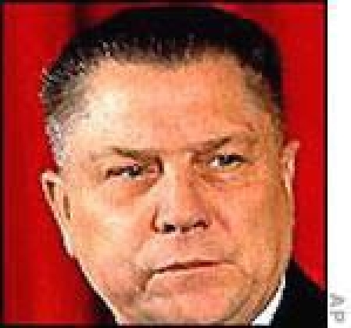

Jimmy Hoffa

Whatever a doubter's mob conspiracy theory of choice, Oswald served as a Mafia foil, and Jack Ruby, the Dallas nightclub owner who was on friendly terms with organized crime, was the wing man in the cover-up.

The FBI
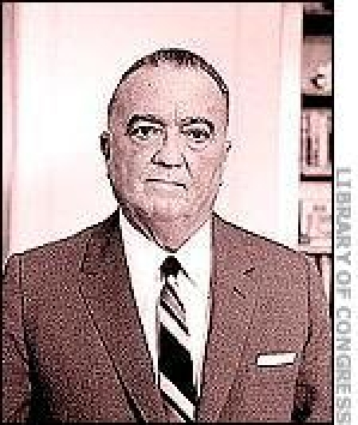

J. Edgar Hoover

J. Edgar Hoover had been kept informed of the whereabouts and activities of Lee Oswald. The agency knew he had subscribed to Commie publications, was active in the pro-Castro Fair Play for Cuba Committee and had traveled to Mexico in a failed attempt to gain access to Cuba. An FBI agent spoke with an Oswald acquaintance just two weeks before the assassination, and Oswald had written to the Soviet Embassy in Washington to complain of FBI harassment.

Why such interest in a small fry Red, doubters ask. Believers reply that the FBI had a remarkable ability to track a wide breadth of suspected "enemies" during the Cold War era, and Hoover took a personal interest in a mind-boggling number of those cases.

The Garrison/Stone Theory

Jim Garrison's wildcat theory of the JFK assassination was a mishmash of international and political intrigue. He fingered virulent anti-Communist, anti-Castro zealots in the Central Intelligence Agency for plotting the murder because the president was soft on Reds—as witnessed by his appeasement of Khrushchev during the Cuban missile crisis. The same zealots were soured that Kennedy was mulling a retreat from Vietnam.

Garrison, who enjoyed the limelight, asserted that Oswald had never fired a shot. He condemned the Warren Commission's lone-gunman conclusion as "totally false." He appeared on the "Tonight" show to discuss with Johnny Carson his allegations about an assassination team, shadowy figures on the Grassy Knoll, photographic evidence, and connivances involving Dallas police, the FBI, CIA, Secret Service and wealthy Texans.

But his showcase, the 1969 conspiracy trial of New Orleans businessman Clay Shaw, was a laugher, with bizarre testimony from oddball witnesses. A jury acquitted Shaw in less than an hour.

Nonetheless, some credit Garrison and the film "J.F.K." for prompting Congress in 1992 to release nearly a million previously secret Government documents regarding Kennedy's death.
The Government Super-Conspiracy

In this variation on Garrison/Stone, elements within the CIA wanted Kennedy punished for ordering a series of firings after the CIA's Bay of Pigs debacle. The CIA crew recruited trained assassins (Cubans, Mafia, Soviet spies, et al), then propped up Oswald to take the fall. The Secret Service and Dallas police were in on the planning, and the local cops helped trick Ruby into shooting Oswald. The killers were later killed, chopped to bits and buried in Mexico.

The truth was either (a) hidden from the law enforcement agency bosses or (b) revealed to the bosses, who hid the information from investigators to save a collapse of the entire American military-industrial complex.

Oswald and Other Undetermined Assassins

After a two-year investigation, the House Select Committee on Assassinations in 1979 concluded that a second gunman also fired at Kennedy, based upon "acoustical scientific evidence." The members wrote, "The committee believes, on the basis of the evidence available to it, that President John F. Kennedy was probably assassinated as a result of a conspiracy. The committee is unable to identify the other gunman or the extent of the conspiracy."

However, it rejected as suspects "on the basis of the evidence available" the Soviet government, the Cuban government and anti-Castro Cuban exiles. It added that it could not preclude "individual members" of anti-Castro groups or the mob from involvement. And it flatly exonerated the Secret Service, the FBI and CIA

