Big History Chemistry Study Guide Name__________________________
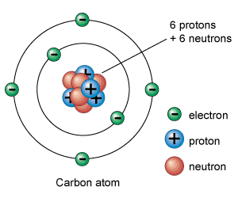
- Atom: smallest particle that still retains its chemical properties, (e.g. what it will react with)
- Molecule: two or more atoms bonded together ex: H₂0, CO₂
- Nucleus:
  - contains protons & neutrons
  - Held together by the strong nuclear force
  - Surrounded by cloud of electrons
- Protons:
  - Positive charge
  - Mass of 1 a.m.u. (“atomic mass unit”)
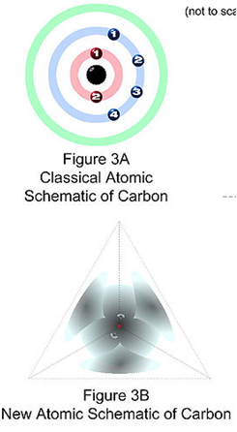
  - Found in the nucleus
- Neutrons:
  - Neutral (zero) charge
  - Mass of 1 a.m.u. (“atomic mass unit”)
  - Inside nucleus; attract protons with strong nuclear force
- Electrons:
  - Charge of -1 (attracted to protons); TINY mass (.0005 a.m.u.)
  - Are found in “shells”, “orbitals”, or “clouds” surrounding the nucleus. Terminology depends on which model you choose to use. (Are actually in oddly-shaped clouds, but shells are easier to think about and draw.)
- Ions: Atoms which become charged by gaining or losing electrons (e⁻)
  - PROTONS AND NEUTRONS STAY PUT unless there is a nuclear reaction, which affects the nucleus. Electrons, on the other hand, are frequently stripped from or added to atoms.
  - Gain electrons: become negative anion
  - Lose electrons: become positive cation
- Isotopes:
  - While there are usually a similar number of neutrons and protons, they definitely do not have to be equal. As you progress through the periodic table, the ratio changes from roughly 1:1 (Helium has 2 neutrons and 2 protons) up to roughly 1.5 : 1 (Mercury has 121 neutrons holding its 80 protons together)
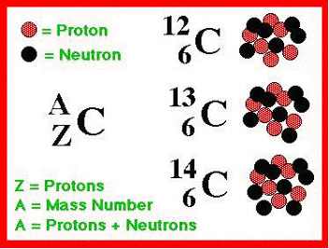
  - Too many neutrons or not enough neutrons will result in a nucleus not being stable. This means it will not survive in that form, and will split apart in a nuclear fission reaction, breaking into smaller elements. Elements that are unstable are called radioactive, because they actively release radiation (which can harm or kill you). Naturally radioactive elements include Radon, Uranium, and Plutonium
  - The various forms of one element with different numbers of neutrons are called isotopes.
The three isotopes of carbon: all isotopes of an element have the same number of protons and electrons. They vary in the number of neutrons present in the nucleus, and therefore they vary in mass. Isotopes are named based on their masses (“carbon-12, carbon-13, carbon-14”).
- A FEW Important Bits of History:
  - Democritus, 400 BCE: concept of indivisible little bits called “atoms”
  - Aristotle, ca. 350 BCE: Concept of all matter being combinations of just 4 elements (earth, air, water, fire)
  - John Dalton, 1804: First good atomic theory.
    - All atoms of a certain element are identical.
    - Atoms of different elements are different.
    - Chemical reactions just rearrange atoms, but do not create or destroy them.
  - Dmitri Mendeleev, 1869:
    - Noticed a repeating, periodic, pattern in the properties of elements as he arranged them by atomic mass.
    - Arranged these in a table. A periodic table!
  - Rutherford, 1910: Discovered the nucleus by beaming positive particles through extremely thin gold foil, and noticing that most of the particles went straight through (empty space, electron cloud) but a very few of them bounced back, because they had hit a tiny positive center (the nucleus)
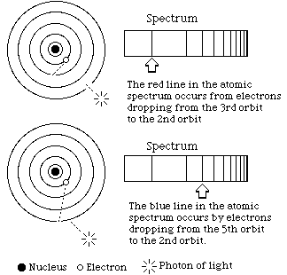
  - Niels Bohr, 1912:
    - Electrons can orbit only at certain allowed distances from the nucleus. (Quantum theory)
    - Atoms radiate energy (give off photon) when an electron jumps from a higher-energy orbit to a lower-energy orbit. Also, an atom absorbs energy when an electron gets boosted from a low-energy orbit to a high-energy orbit.
  - Henry Moseley, 1916:
    - Confirms experimentally that there are protons in the nucleus, and that the atomic number is equal to the number of protons.
    - Predicts new elements to be discovered, based on missing atomic numbers.

Name ____________________________________ Date _____________ Block _____
- Atoms are normally electrically neutral, because they have the same number of ______________ and _________________.
- If an atom loses an ____________________, it will be left with more ____________________ than ______________________, and will have a ___________________ charge. It will now be a ____________________ _______.
- The atom is composed mostly of empty ________________. Almost all of the mass of the atom (>99%) is located in the _____________________, made of _________________ and __________________.
- Atoms are placed in the periodic table in order of _____________ __________________, which equals the number of __________________. The person who gets credit for this concept, and the first version of the table, is ______________ ___________________.
- The atomic mass is equal to the ___________________ plus _____________________.
- Every atom of _________________ in the universe has 5 protons. The atomic mass of this element is listed as _________ amu, which means that its most common isotopes have masses of _____ and _____. These isotopes have _____ neutrons or ____ neutrons.
- In nuclear ________________, small atoms combine to make larger atoms, losing a tiny bit of mass and releasing energy in the process.
- In nuclear _____________, radioactive elements such as ________________ break apart into smaller elements (“decay products”), also releasing energy.
- The significance of Henry ___________________’s experiment with x-rays and atoms is that it found a numerical relationship between the ______________ of light produced by an atom and the _________________ number of an atom. He was able to predict certain ______________ which should be in the periodic table, based on the atomic number, but had not been discovered yet.
- A column in the periodic table consists of elements which have similar ____________________ ________________________. As you progress down a column in the periodic table, the atomic mass ____________________.
Short Answer:
- Why are the atomic masses in the periodic table not whole numbers?

- Why are would Carbon-8 be very unstable?

