Ninth Grade: United States History and Geography

Unit 2: Growth of Industrial and Urban America

Big Picture Graphic

Overarching Question:

How and why did the meaning of freedom and equality in the United States change as a result of industrialization?

Previous Unit:  Foundations of American History | This Unit:  Growth of Industrial and Urban America | Next Unit:  Progressivism and Reform

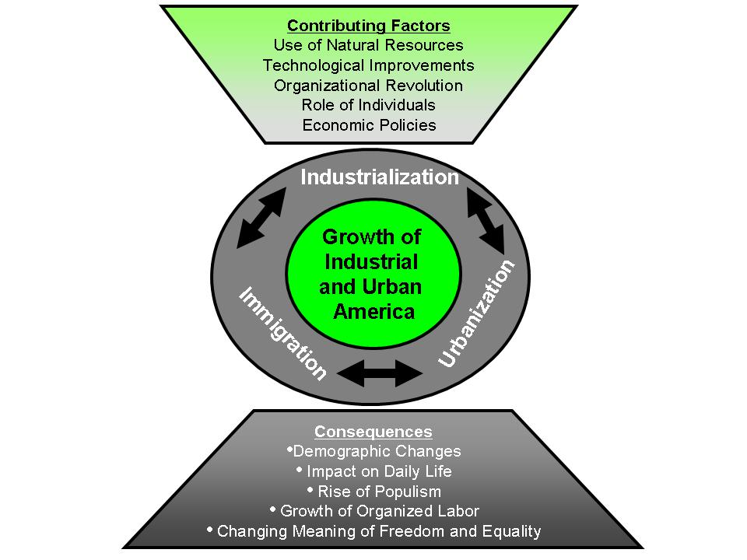
Questions To Focus Assessment and Instruction:

- How did geography, technology, people, and government cause the growth of industrial and urban America?
- How did industrialization transform life in late 19th and early 20th century America?
- How did the growth of an industrial and urban America help shape the meaning of freedom and equality?

Types of Thinking  - Cause and Effect  - Research  - Description  - Compare and contrast  - Identifying perspectives | Public Issues  - Balance of Power: Contemporary public policy issues related to the distribution of power among central government, state governments, and the people.  - Movement of People: Contemporary public policy issues related to the movement of people into and within the United States.

Unit Historical Overview
The period of American history from the end of Reconstruction to the dawning of a new century can be characterized by significant economic and social changes in America. In 1870, the United States was still predominately a rural nation, facing the challenges of reconstructing itself and forging a new post-Civil War national identity. Fueled by an interconnected railroad system, technical innovations and mechanization, and the ingenuity of inventors and entrepreneurs, the national economy exploded and became much more integrated than ever before. During the next several decades, cities and the industries that developed there became increasingly central to American life. The rapid expansion of big business, large-scale agriculture, and the rise of national labor unions generated new challenges involving industrial and social conflict. A few industrialists obtained tremendous wealth, the middle class began to expand, but many workers remained impoverished.

Opportunities in the cities spurred mass migrations throughout the country as people moved from south to north and from east to west, as well as from other lands. Migrating Americans and immigrants flooded urban centers with hopes of improving their lives. However, increasing ethnic diversity and growing poverty in these urban centers created significant social problems. As a result, workers banded together transforming social and economic challenges into political issues. Similarly, American farmers organized as never before in response to economic strife. As family farms sought to modernize, they assumed debt that eventually threatened their way of life. At the end of this period, the economic and social turmoil experienced by rural and urban Americans gave rise to third-party political movements. Yet, these same economic and social transformations helped forge a new national identity.

Unit Abstract:
Students ended the previous unit with an examination of economic and demographic data about the United States from Reconstruction to the turn of the century. In this unit, students focus on how technical and organizational innovations, entrepreneurs, migration and immigration led to the transformation of the national economy. They investigate entrepreneurs and engage in small group discussions evaluating whether these individuals were Captains of Industry or Robber Barons. Students also explore the immigrant experience, analyzing primary sources to determine how issues of freedom and equality affected the lives of immigrants. Using primary and secondary sources students analyze the consequences of industrialization, including its effects on both rural and urban America. In doing so, students explore the growth of Populism and the labor movement. After students examine and reflect upon how American concepts of freedom and equality were affected by industrialization, immigration, and urbanization, they record their thoughts in their Freedom Tracking Notebook. Students then compare the attributes of writing arguments and narratives, and consider the role of evidence in both. After analyzing a variety of sources related to industrialization, students use evidence to develop a historical narrative about the consequences of industrialization. Throughout the unit, students use their Freedom Tracking Notebook to reflect on how the ideas of freedom and equality shaped industrial and urban America during this period.

Focus Questions
- How did geography, technology, people, and government cause the growth of industrial and urban America?
- How did industrialization transform life in late 19th and early 20th century America?
- How did the growth of an industrial and urban America help shape the meaning of freedom and equality?

Content Expectations
USHG F1.1: Identify the core ideals of American society as reflected in the documents below and analyze the ways that American society moved toward and/or away from its core ideals
- Declaration of Independence
- the U.S. Constitution (including the Preamble)
- Bill of Rights
- the Gettysburg Address
- 13th, 14th, and 15th Amendments.

USHG 6.1.1: Factors in the American Industrial Revolution - Analyze the factors that enabled the United States to become a major industrial power, including
- gains from trade
- organizational “revolution” (e.g., development of corporations and labor organizations)
- advantages of physical geography
- increase in labor through immigration and migration
- economic policies of government and industrial leaders (including Andrew Carnegie and John D. Rockefeller)
- technological advances.

USHG 6.1.2: Labor’s Response to Industrial Growth - Evaluate the different responses of labor to industrial change including
- development of organized labor, including the Knights of Labor, American Federation of Labor, and the United Mine Workers
- southern and western farmers’ reactions, including the growth of populism and the populist movement (e.g., Farmers Alliance, Grange, Platform of the Populist Party, William Jennings Bryan’s “Cross of Gold” speech).

USHG 6.1.3: Urbanization - Analyze the changing urban and rural landscape by examining:
- the location and expansion of major urban centers
- the growth of cities linked by industry and trade
- the development of cities divided by race, ethnicity, and class
- resulting tensions among and within groups
- different perspectives about immigrant experiences in the urban setting

USGH 6.1.4: Population Changes - Use census data from 1790 -1940 to describe changes in the composition, distribution, and density of the American population and analyze their causes, including immigration, the Great Migration, and urbanization.

C6.1.2: Analyze and use various forms of evidence, information, and sources, including primary and secondary sources, legal documents (e.g., Constitutions, court decisions, state law), non-text based information (e.g., maps, charts, tables, graphs, and cartoons), and other forms of communication (e.g., political cartoons, campaign advertisements, political speeches, blogs).

Key Concepts
disparity of wealth
ethnicity
historical narrative
immigration
industrialization
labor movements
mechanization
migration
populism
Social Darwinism
urbanization

Duration
3 weeks

Lesson Sequence
Lesson 1: Industrialism in America
Lesson 2: Big Business and Captains of Industry
Lesson 3: Immigration and Migration
Lesson 4: Consequences of Industrialism
Lesson 5: Early Response to Industrialism: Populism
Lesson 6: Early Response to Industrialism: Labor Movement
Lesson 7: Exploring the Changing Meaning of Freedom and Equality
Lesson 8: Constructing a Historical Narrative about the Growth of Industrial and Urban America

Assessment
Selected Response Items

Constructed Response Items

Performance Assessments

USHG 6.1.1  USHG 6.1.4  C6.1.2 | Construct a historical narrative about the growth of industrial and urban America. The narrative should include a description of the causes and the use of graphic data.
USHG 6.1.2  USHG 6.1.3 | Create a political cartoon that depicts at least two consequences of the industrial revolution, including urbanization, population changes, the response of labor, or the response of rural America.
USHG 6.1.1  USHG 6.1.2  USHG 6.1.3  USHG 6.1.4 | Write an essay explaining how ideas of freedom and equality shaped the causes and consequences of the growth of industrial and urban America. The essay should include an explanation of how these ideas influenced or affected entrepreneurs, laborers, and immigrants. Support your thesis with historical evidence.

Resources
Equipment/Manipulative
Chart paper
Computer with Internet access for students
Highlighters for each student
Markers for chart paper
Overhead projector or document camera
Sticky notes

Student Resource
19th Century Inventors. About.com. 17 March 2009 <http://inventors.about.com/od/timelines/a/Nineteenth_3.htm>.

America on the Move. Smithsonian Institute. National Museum of American History. 17 March 2009 <http://americanhistory.si.edu/onthemove/exhibition/>.

American Federation of Labor. InfoPlease.com. 17 March 2009 <http://www.infoplease.com/ce6/bus/A0856583.html>.

American Federation of Labor. Ohio History Central. Ohio Historical Society. 17 March 2009 <http://www.ohiohistorycentral.org/entry.php?rec=835>.

Andrew Carnegie. The American Experience. PBS. 17 March 2009 http://www.pbs.org/wgbh/amex/carnegie/peopleevents/pande01.html

Arrival. A Nation of Immigrants. The City University of New York. 17 March 2009 <http://www1.cuny.edu/portal_ur/content/nationofimmigrants/arrival.php>.

∗Berliner, Uri. “Have and Have Nots: Income Inequality in America.” National Public Radio. 5 Feb. 2007. 17 March 2009 <http://www.npr.org/templates/story/story.php?storyId=7180618>.

Bill Moyers Interview with Nell Irvin Painter. Bill Moyers Journal. PBS. 17 March 2009 <http://www.pbs.org/moyers/journal/02292008/watch2.html>.

“Bryan’s ‘Cross of Gold Speech:’ Mesmerizing the Masses.” History Matters. 17 March 2009 <http://historymatters.gmu.edu/d/5354/ -cross of gold speech audio and transcript>.

“Building New York City.” World History: The Modern Era. United Streaming. 17 March 2009 <http://player.discoveryeducation.com/index.cfm?guidAssetId=8EF18FCE-F762-44B9-9EBD-74A51C245982&blnFromSearch=1&productcode=US>.

Carnegie and the Era of Steel. Outline of American History. From Revolution to Reconstruction. 17 March 2009 <http://odur.let.rug.nl/~usa/H/1994/ch7_p2.htm>.

Ethnic and Race Relations. The Encyclopedia of Cleveland History. 17 March 2009 <http://ech.cwru.edu/ech-cgi/article.pl?id=EARR>.

Eugene V. Debs, Union Leader. Debs Foundation. 2008. 17 March 2009 <http://www.eugenevdebs.com/pages/union.html>.

Foner, Eric. The Story of American Freedom. NY: W.W. Norton & Company, 1998. pp. 118-126.

“History of Steel.” Steel Manufacturing. Ball State University. 17 March 2009 <http://www.bsu.edu/web/acmaassel/steel.html#History_of_Steel>.

“The Homestead Strike.” American Experience. PBS/WGBH. 17 March 2009 <http://www.pbs.org/wgbh/amex/carnegie/peopleevents/pande04.html>.

“Immigration to the United States.” The Rise of Industrial America. The Learning Page, Library of Congress. 17 March 2009 <http://lcweb2.loc.gov/learn/features/timeline/riseind/immgnts/immgrnts.html>

Industrial Expansion 1865-1890. 17 March 2009 <http://www.emayzine.com/lectures/indust~1.htm>.

Industrial Revolution Inventors. About.com 17 March 2009 <http://americanhistory.about.com/library/charts/blchartindrev.htm>.

“Industrialization and Reform.” History of the United States. The USA Online.com. 17 March 2009 <http://www.theuaonline.com/history/industrilazation.htm>.

“An Introduction to the American Industrial Revolution.” Discovery Education, United Streaming. 17 March 2009 <http://streaming.discoveryeducation.com>.

Introduction to Oil Industry. Oil Industry. 17 March 2009 <http://www.petroleumhistory.org/OilHistory/pages/intro.html>.

A Journalistic Masterpiece. The Rockefellers. American Experience. PBS/WGBH. 17 March 2009 <http://www.pbs.org/wgbh/amex/rockefellers/sfeature/sf_7.html>.

Knights of Labor. US-History.com. 17 March 2009 <http://www.u-s-history.com/pages/h933.html>.

Knights of Labor. Ohio History Central. Ohio Historical Society. 17 March 2009 <http://www.ohiohistorycentral.org/entry.php?rec=910>.

The New Industrial Age. US History.com. 17 March 2009 <http://www.u-s-history.com/pages/h860.html>.

Overview: Immigration to the United States 1851-1900. Rise of Industrial America, 1876-1900. The Learning Page. Library of Congress. 17 March 2009 <http://lcweb2.loc.gov/learn/features/timeline/riseind/immgnts/immgrnts.html>.

The Peopling of America. 1880-1930. Ellis Island Foundation, Inc. 17 March 2009 <http://www.ellisislandrecords.org/immexp/wseix_5_3.asp>.

Population Distribution by Age, Race, Nativity, and Sex Ratio, 1860–2005. InfoPlease.com. 17 March 2009 <http://www.infoplease.com/ipa/A0110384.html>, citing the US Census Bureau.

Party Platform, 1892. 17 March 2009 <http://www.pinzler.com/ushistory/popparplatsupp.html>.

The Populist Party. 1896. Vassar College. 17 March 2009 <http://projects.vassar.edu/1896/populists.html>.

“Railroads in the Late 19th Century.” The Rise of Industrial America. The Learning Page, Library of Congress. 17 March 2009 <http://lcweb2.loc.gov/learn/features/timeline/riseind/railroad/rail.html>.

Rich as Rockefeller. Freedom: History of US. PSB. 17 March 2009 <http://www.pbs.org/wnet/historyofus/web09/segment4.html>.

Sound Recording Analysis Sheet. National Archives and Records Administration. 17 March 2009 <http://www.archives.gov/education/lessons/worksheets/sound_recording_analysis_worksheet.pdf>.

Tarr, Joel A. The City and the Natural Environment. Carnegie Mellon University. 17 March 2009 <http://www.gdrc.org/uem/doc-tarr.html>.

Textile Industry History. 17 March 2009 <http://www.textilehistory.org/>.

The Triangle Factory Fire. Cornell University. 17 March 2009 <http://www.ilr.cornell.edu/trianglefire/>.

United Mine Workers. Ohio History Central. Ohio Historical Society. 17 March 2009 <http://ohiohistorycentral.org/entry.php?rec=995&nm=United-Mine-Workers-of-America>.

United Mine Workers. 17 March 2009 <http://www.umwa.org/index.php?q=content/brief-history-umwa>.

Wake Up, America! Freedom: A History of US. Webisode 4. PBS. 17 March 2009 <http://www.pbs.org/wnet/historyofus/web04/index.html>.

Teacher Resource
Acuña-Alfaro,Jairo. US Industrialization Process in the Late XIX Century. The Natural Resource Endowment. 17 March 2009 <http://www.geocities.com/jaacun/USAIndustrialization.PDF>.

Argument. The Writing Center. University of North Carolina. 17 March 2009 <http://www.unc.edu/depts/wcweb/handouts/argument.html>.

Barton, Keith C. and Linda S. Levstik. Teaching History for the Common Good. Routledge Publishing, 2004. pp. 131. <http://books.google.com/books?id=DtJF3QvhT5gC&pg=PA195&lpg=PA195&dq=%22Use+of+evidence%22+history&source=web&ots=NZ6m2-IAy_&sig=lDUYTfXqsu30wDih8gkRos3MmSs&hl=en&ei=zbiYSeSbOYTYNK7dpIkM&sa=X&oi=book_result&resnum=8&ct=result#PPA131,M1>.

Brinkley, Alan. The Unfinished Nation PowerPoint. Chapter 18. Pearson Education. 17 March 2009 <http://www.vbhssocialstudies.com/apus/powerpoint/chapter18.ppt>.

City Life in the Late 19th Century. Rise of Industrial America. Library of Congress. The Learning Page. 17 March 2009 <http://lcweb2.loc.gov/learn/features/timeline/riseind/city/city.html>.

The Corporate Revolution. Digital History. 17 March 2009 <http://www.digitalhistory.uh.edu/database/article_display.cfm?HHID=196>.

Ethnic and Race Relations. The Encyclopedia of Cleveland History. 17 March 2009 <http://ech.cwru.edu/ech-cgi/article.pl?id=EARR>.

Historical Topic: A New Industrial America: Freedom and the Rights of Workers. TAHPDX: Great Decisions in U.S. History. 17 March 2009 <http://www.upa.pdx.edu/IMS/currentprojects/TAHv3/TAH2_Content/Industrial_America.html>.

Klumpp, James F. Writing Narrative History. University of Maryland. 17 March 2009 <http://terpconnect.umd.edu/~jklumpp/spch711/narrative.htm>.

Littlefield, Henry M. The Wonderful Wizard of Oz: Parable on Populism. 17 March 2009 <http://www.amphigory.com/oz.htm>.

Millions of Acres. American Memory. Library of Congress. 17 March 2009 <http://memory.loc.gov/cgi-bin/ampage?collId=rbpe&fileName=rbpe13/rbpe134/13401300/rbpe13401300page.db&recNum=0>.

∗Outman, James L. and Elisabeth M. Outman. Industrial Revolution Almanac (2003), pp. 145-153.

Parker, David B. “The Rise and Fall of the Wonderful Wizard of Oz as a “Parable on Populism.” As published in the Journal of the Georgia Association of Historians. vol. 15 (1994), pp. 49-63. 17 March 2009 <http://www.halcyon.com/piglet/Populism.htm>.

*Pennock, Pamela E. Industrialization: Part 1 – The Rise of Big Business. University of Michigan, Dearborn. 17 March 2009 <http://www-personal.umd.umich.edu/~ppennock/L-BigBusiness.htm>.

People and Events: Ida Tarbell, 1857-1944. The Rockefellers. American Experience. PBS/WGBH. 17 March 2009 <http://www.pbs.org/wgbh/amex/rockefellers/peopleevents/p_tarbell.html>.

∗Populism. Missouri State University. 17 March 2009 <http://history.missouristate.edu/wrmiller/Populism/texts/populism.htm>.

“The Populist Party.” 1896. Vassar College. 17 March 2009 <http://projects.vassar.edu/1896/populists.html>.

*The Populist Movement and the Struggle for Reform in America. Ethnic Studies, University of Colorado. 17 March 2009 <http://www.colorado.edu/AmStudies/lewis/2010/populism.htm>.

Railroad Land Grants. American Memory. Library of Congress. 17 March 2009 <http://memory.loc.gov/award/mhsdalad/120000//120033v.jpg>.

∗Schultz, Stanley K. Lecture 10: How Ya’ G onna’ Keep ‘Em Down on the Farm?: The Rise of Populism. History Department. University of Wisconsin- Madison. 17 March 2009 <http://us.history.wisc.edu/hist102/lectures/lecture10.html>.

*“What Went Wrong.” The Economist. March 19, 2008. 17 March 2009 <http://www.economist.com/finance/displaystory.cfm?story_id=10881318>.

The Wizard of Oz: Populism and the 1896 Election. Turn Me on Dead Man. 17 March 2009 <http://www.turnmeondeadman.net/OZ/Populism.php>.

“Writing Guide.” Boston University, Department of History. 17 March 2009 <http://www.bu.edu/history/writing_guide.html>.

Resources for Further Professional Knowledge
Chicago: The City of the Century. American Experience. PBS Film. 17 March 2009 <http://www.pbs.org/wgbh/amex/chicago/filmmore/index.html#>.

Campbell, Ballard C. Understanding Economic Change in the Gilded Age. Organization of American Historians. 17 March 2009 <http://www.oah.org/pubs/magazine/gilded/campbell.html>.

Drake, Frederick D. and Sarah Drake Brown. A Systematic Approach to Improve Students’ Historical Thinking. The History Teacher. 17 March 2009 <http://www.historycooperative.org/journals/ht/36.4/drake.html>.

Foner, Eric. The Story of American Freedom. NY: W.W. Norton & Company, 1998.

Jacobson, Matthew Frye. Whiteness of a Different Color: European Immigrants and the Alchemy of Race. Cambridge, MA: Harvard University Press, 1998.

Green, James. Death in the Haymarket: A Story of Chicago, the First Labor Movement and the Bombing that Divided Gilded Age America. NY: Random House Publishing Group, 2007.

Painter, Nell Irvin. Standing at Armageddon. NY: W.W. Norton & Company, 1987.

Peiss, Kathy. Cheap Amusements: Working Women and Leisure in Turn-of-the-Century New York. Philadelphia: Temple University Press, 1986.

Rosenzweig, Roy. Eight Hours for What we Will: Workers and Leisure in an Industrial City, 1870-1920. NY: Cambridge University Press, 1999.

Wineburg, Sam. Historical Thinking and Other Unnatural Acts. Philadelphia: Temple University Press, 2001.

Amended to include Bryan’s full name.
This civics expectation has been modified to reflect its use in this unit of United States History and Geography.
 Although the resources denoted with an asterisk are not cited in the lessons for this unit, they are included here to provide meaningful options for teachers.
 Although the resources denoted with an asterisk are not cited in the lessons for this unit, they are included here to provide meaningful options for teachers.
 Although the resources denoted with an asterisk are not cited in the lessons for this unit, they are included here to provide meaningful options for teachers.


