U.S. Western Railway Land Grants

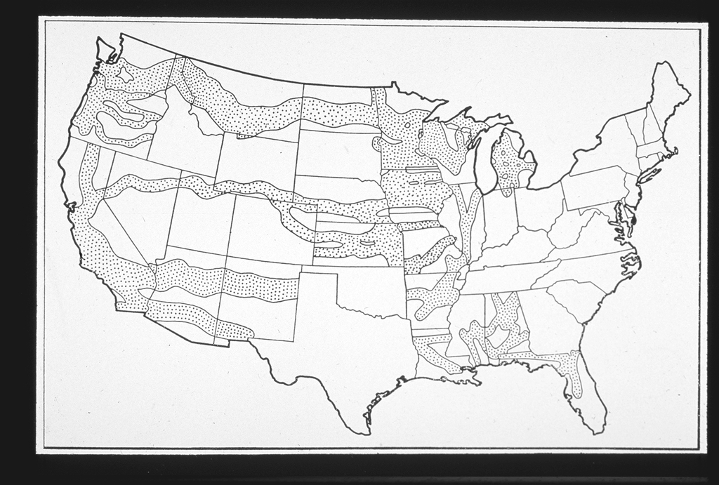

Source: Railroad Land Grants. American Memory. Library of Congress. 13 February 2009 <http://memory.loc.gov/award/mhsdalad/120000//120033v.jpg>.

