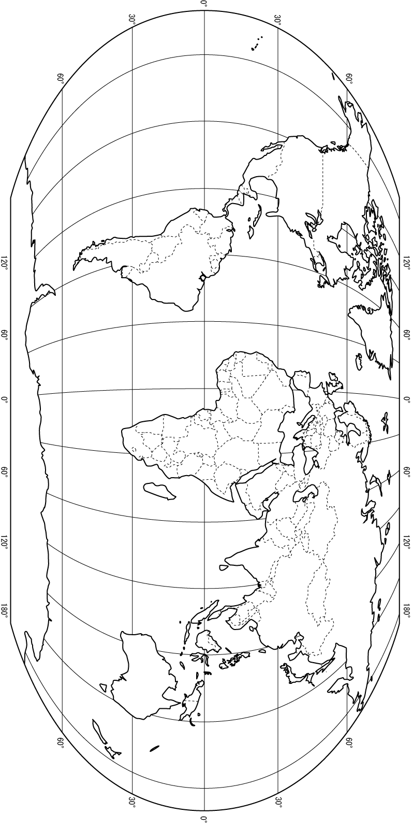
GeoHistogram Activity:

You will need:

- A map of the world
- A blank GeoHistogram
- Timelines for malaria, cholera, smallpox, bubonic plague.
- Four colored pencils (Use one color per disease)
i.e.) Red=Smallpox, Yellow=Malaria, Green=Bubonic Plague, Blue= Cholera

Directions for Activity

- Get four crayons/colored pencils. Designate a color per disease.
- Start with the traditional world map and chart disease on there.
- Then do the same on your GeoHistogram
- Geographers label and use symbols, so be creative how you express the story on both the traditional map and GeoHistogram.
- In the end, answer the questions on the last page.
- Staple the following and turn in to the bin:
- Traditional World Map
- GeoHistogram
- Questions

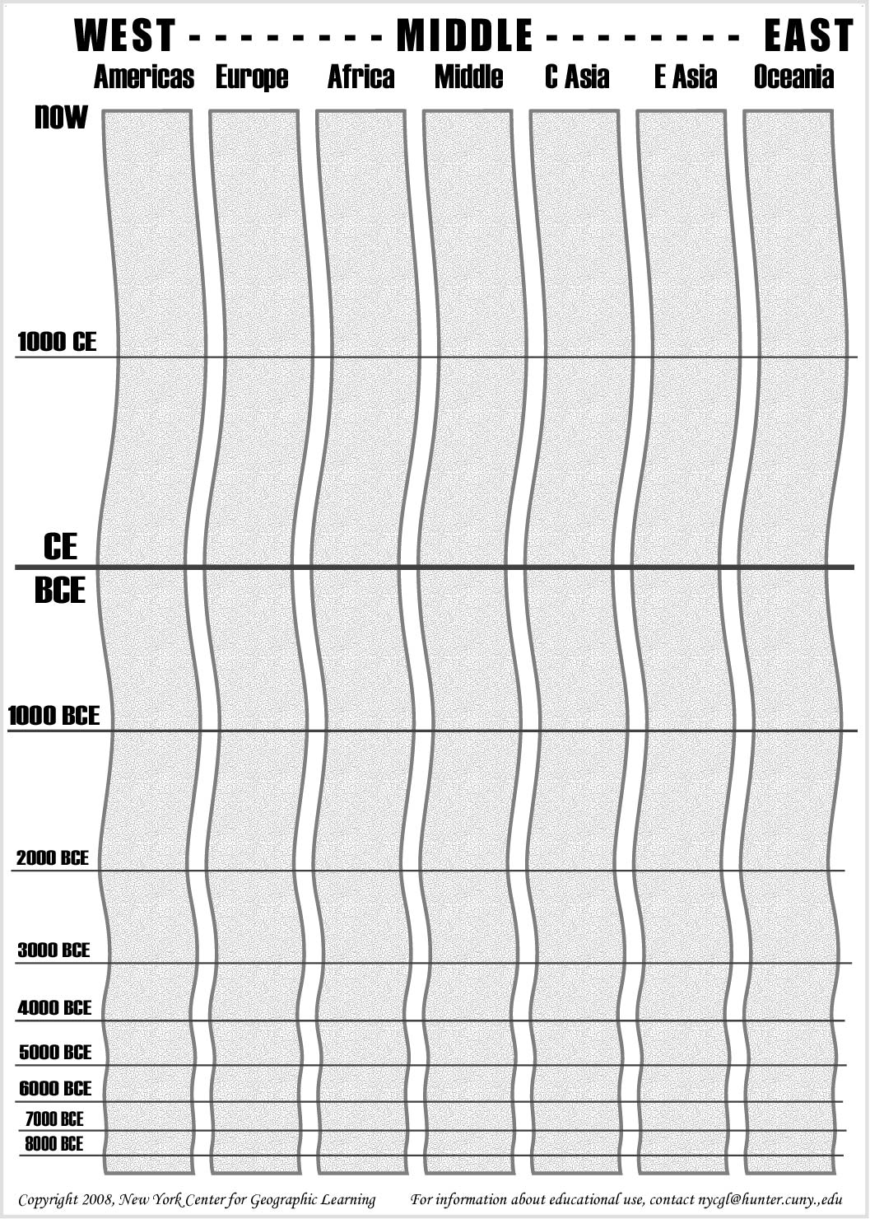

Smallpox Dates:

- Smallpox outbreaks in Nile River Valley and Mesopotamia, 10,000 BCE
- Smallpox epidemics in China and India, 3,000 BCE
- Smallpox documented in Athens, Greece, 490 BCE
- Smallpox documented in Korea, 583 CE
- Smallpox documented in Japan, 585 CE
- Smallpox spreads throughout Africa and Europe, 700-1000 CE
- First recorded smallpox outbreak in New World, Hispaniola (Dominican Republic), brought by ill Spanish sailor, half indigenous population dies, 1518 CE
- Cortes conquers Aztecs in Mexico, one of his soldiers passes smallpox to Aztec population, one third die, 1520 CE
- Inca emperor Huayna Capac dies of smallpox, 1525 CE
- King of Siam (Thailand) dies of smallpox, 1534 CE
- 400,000 Europeans die yearly from smallpox, 1700’s CE
- British troops distribute smallpox infected blankets to Native Americans in an attempt a biological warfare during the French and Indian War, 1763 CE
- Smallpox introduced to Australia killing over half the indigenous Aborigine population, 1789 CE
- British physician, Edward Jenner, tries first vaccination on boy using cowpox, 1796 CE
- Vaccination begins to overcome resistance in Europe, Asia although epidemics still occur world wide, 1800’s CE
- Last naturally occurring case of smallpox in United States, 1949 CE
- World Health Organization (WHO) launches worldwide campaign to vaccinate against smallpox, two million die this year from the disease, 1967 CE
- Last naturally occurring case of smallpox, worldwide, occurs in Somalia, 1977 CE
- Laboratory case of smallpox resulted in death in United Kingdom, 1978 CE
- WHO declare smallpox eradicated, only left in two labs in U.S. and Russian (USSR), 1979 CE

http://encarta.msn.com/media_701508643/smallpox_through_history.html

Malaria Dates:

- Malaria throughout African continent, 8,000 BCE
- Malaria in Mesopotamia, Indian peninsula, southeast Asia, 3,000-8,000 BCE
- Malaria in China, 3,000 BCE
- Malaria reaches the shores of the Mediterranean Sea, 500 BCE - 1CE
- Malaria reaches northern Europe, 1000-1500 CE
- 1100 CE, Valencia (Spain) - farmers sentenced to death if they planted rice too close to villages and cities
- Malaria reaches New World (North America), end 1500 CE
- Malaria spreads throughout North America, mid1700’s CE
- Malaria reaches peak around globe, mid 1800’s CE
- Malaria almost disappears from Europe, North America, 1950’s
- Malaria continues to be endemic in tropical tropics with most deaths occurring in Africa, present time

http://www.malariasite.com/MALARIA/History.htm
Bubonic Plague Dates :

- Believed outbreak of Bubonic Plague beginning in Ethiopia, traveling to Egypt, Libya, and Greece, killing 1/3 the population of Athens (some believe this might have been smallpox), 430 BCE
- Plague spreads from Egypt to Constantinople (Modern Turkey), 540’s CE
- Plague again breaks out in Constantinople and spreads towards Europe, 1334 CE
- Plague outbreak occurs in Constantinople and moves into Alexandria (Egypt), Cyprus, Sicily, Italy, France, Germany, England, Norway, Eastern Europe, Scotland, Wales, Ireland, Russia, 1347-1351 CE
- The Great Plague of London, 1665 CE
- Plague outbreak in central Europe, small outbreak in London, 1679 CE
- Austria has outbreak of plague, 1711 CE
- Balkans (Eastern Europe) have plague outbreak lasting two years, 1770’s
- Third Plague Pandemic - worldwide although China, India hardest hit, 1855-1889 CE
- Working independently, bacteriologists Alexandre Yersin and Shibasaburo Kitasato isolated the bacterium that causes bubonic Plague. Yersin discovers that rodents are the mode of infection. The bacterium is named Yersinia pestis after Yersin, 1894 CE
- Outbreak of plague in Australia and Portugal, 1900 CE
- Outbreak of plague in Manchuria (Eastern China), 1910 and 1920 CE
- Outbreak of plague in Surat, India, 1994
- Three mice infected with plague disappear from a lab in New Jersey, 2005 CE
- According to the World Health Organization, there are 1,000 to 3,000 cases of bubonic plague worldwide each year. There are no known cases in Australia or Europe. Areas where cases occur are in Russia, the Middle East, China, Southwest and Southeast Asia, Madagascar, southern and eastern Africa, the Andes mountains and Brazil, western United States, present day

http://www.twoop.com/medicine/archives/2005/10/bubonic_plague.html
Cholera Dates

- 1817 - 1823: first known pandemic of Cholera; Ganges River delta in India. By the early 1820s, colonization and trade had carried the disease to Southeast Asia, central Asia, the Middle East, eastern Africa, and the Mediterranean coast.
- 1829 - 1849: The second pandemic started in India and reached Russia by 1830 before continuing into Finland and Poland. A two-year outbreak began in England in October 183. Irish immigrants carried the disease from Europe to North America. The disease then entered the U.S. through Detroit and New York, and reached Latin America by 1833. Another outbreak across England and Wales began in 1848
- 1852 - 1859: The third pandemic; generally considered the most deadly, originated in India. It devastated large swaths of Asia, Europe, North America and Africa. In 1854, British physician John Snow succeeded in identifying contaminated water as the transmitter of the disease, a breakthrough in eventually bringing it under control. Snow carefully mapped the cases of cholera in the Soho area in London and traced the source to a water pump. After convincing officials to remove the pump handle, the number of cholera cases in the area immediately declined.
- 1863 - 1879: The fourth pandemic began in the Bengal region of India (Eastern part of India) from which Indian Muslim pilgrims visiting Mecca spread the disease to the Middle East. From there it migrated to Europe, Africa and North America.
- 1881 - 1896: The fifth pandemic originated in the Bengal region of India and swept through Asia, Africa, South America and parts of France and Germany. Cholera swept into Russia between 1893 and 1894; and Japan between 1887 and 1889. Quarantine measures based on the findings of John Snow kept cholera out of Britain and the United States. In 1892, Waldemar Haffkine, a Ukrainian bacteriologist who worked mostly in India, developed a human vaccine for cholera.
- 1899 - 1923: the sixth pandemic killed more than 800,000 in India before moving into the Middle East, northern Africa, Russia and parts of Europe. By 1923, cholera had receded from most of the world, although many cases were still present in India.
- 1961 - Present: the seventh pandemic originated in Indonesia. It spread across Asia and the Middle East, eventually reaching Africa by 1971. In 1991, 100 years after being vanquished from South America, cholera appeared in Peru. An outbreak among Rwandan refugee camps in the Democratic Republic of Congo occurred in 1994.The World Health Organization reported that nearly 500 people had died in an outbreak in Zimbabwe in the last few months of 2008. The outbreak is blamed on deteriorating infrastructure as the country's political crisis continues. The discovery of a new species of the cholera bacteria (O139) in Bangladesh in 1992, which has since been detected in 11 countries, has raised the possibility and fear of an eighth pandemic.
http://www.cbc.ca/health/story/2008/05/09/f-cholera-outbreaks.html
FINAL QUESTIONS:

- Choose one of the diseases mapped/charted. Recreate the GeoHistogram as if air travel had been introduced in 1000 CE. Describe the changes in the GeoHistogram. Did the current state of the disease change? Why or why not? How might this have impacted human populations?

- How did the patterns of disease change after time was introduced as a factor?

- What historical events might explain the differences in diffusion of the diseases?

- What technological innovations might explain the differences of the diffusion of the diseases?

- What else might explain the differences in the diffusion/occurrences of a particular disease?

- How might these diseases have affected the human populations based on their diffusion across area and time?

