WWI OUTCOMES

Background
World War I killed more people--9 million combatants and 5 million civilians--and cost more money--$186 billion in direct costs and another $151 billion in indirect costs--than any previous war in history. Politically, it resulted in the downfall of four empires and contributed to the Bolshevik rise to power in Russia in 1917 and the triumph of fascism in Italy in 1922. The war allowed the United States to become the world's leading creditor and industrial power. Its consequences included the mass murder of Armenians
in Turkey and an influenza epidemic that killed over 25 million people worldwide.

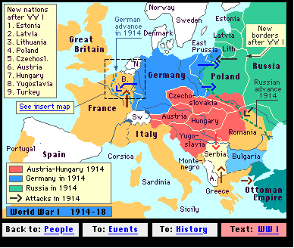
Consequences
1. Nearly 10 million soldiers died and about 21 million were wounded. U.S. deaths totaled 116,516.
2. Four empires collapsed: the Russian Empire in 1917, the German and the Austro-Hungarian in 1918, and the Ottoman in 1922.
3. Independent republics were formed in Austria, Czechoslovakia, Estonia, Hungary, Latvia, Lithuania, and Turkey.
4. Most Arab lands that had been part of the Ottoman Empire came under the control of Britain and France.
5. The Bolsheviks took power in Russia.
6. Under the peace settlement, Germany was required to pay reparations eventually set at $33 billion; accept responsibility for the war; cede territory to Belgium, Czechoslovakia, Denmark, France, and Poland; give up its overseas colonies; and accept an allied military force on the west bank of the Rhine River for 15 years.

