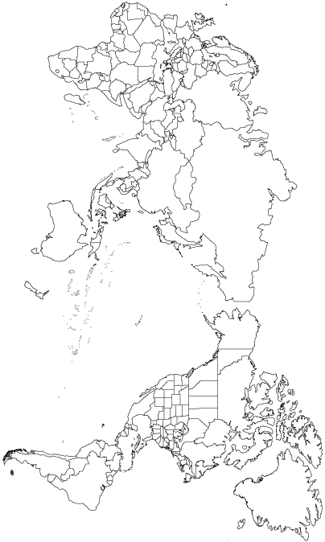

 | Hawaii | Cuba | Puerto Rico | Philippines
When? | 1898 | 1898 | 1898 | 1898
How? (Details) | In 1893, pineapple planter Sanford B. Dole removed Queen Liliuokalani from power (w/ the help of the U.S. Marines) and requested the U.S. be annexed. Congress approved the annexation in 1898. | Spanish-American War…U.S. passed Platt Amendment (P. 361) | Spanish-American War…U.S. paid Spain $20 million (P. 361) | Spanish-American War…U.S. paid Spain $20 million…U.S. has to put down Filipino resistance to U.S. takeover…fighting ends in 1902 (P.361)
Why? | Economic and military interests (P. 363) | Establish naval base…use for protection of Panama Canal (if built) | Establish naval base…use for protection of Panama Canal (if built) | Establish naval base…expand influence in Asia, economic motives
 | Guam | Midway | Samoa | Wake
When? | 1898 | 1867 | 1889 | 1899
How? (Details) | Spanish-American War…U.S. paid Spain $20 million (P. 361) | Annexed it as a U.S. territory…was uninhabited (P. 354) | The U.S., Great Britain and Germany began competing for control of the Samoan Islands in the 1880s…they nearly went to war. Negotiations were made and the U.S. acquired “American” Samoa in 1889. | Was annexed as an uninhabited territory.
Why? | Use as a naval/merchant refueling station | Use as a naval/merchant refueling station (P. 354) | Pago Pago had a perfect harbor for installing a U.S. naval base. (P. 364) | Built an airfield to service U.S. to Asia (China) flights.

