Late 19th and Early 20th Century U.S. Territorial Acquisitions

 | Hawaii (P. 363) | Cuba and Puerto Rico(P. 361/362) | Philippines (P. 361) | Guam (P. 361)
When? (Year)
How Did We Get It? (Details)
Why Did We Want It? |  | Establish naval bases…use for protection of Panama Canal (if built) | 1. Establish naval base 2. Economic Motive: Control of the Philippines would give the U.S. more influence in Asia; Philippines are close to China so they would make for a nice island to open factories and the goods could be sold in China, Japan, etc. | Use as a naval/merchant refueling station
 | Midway (P. 354) | American Samoa (P. 364) | Wake Island | Panama Canal
When? (Year)
How Did We Get It? (Details)
Why Did We Want It?

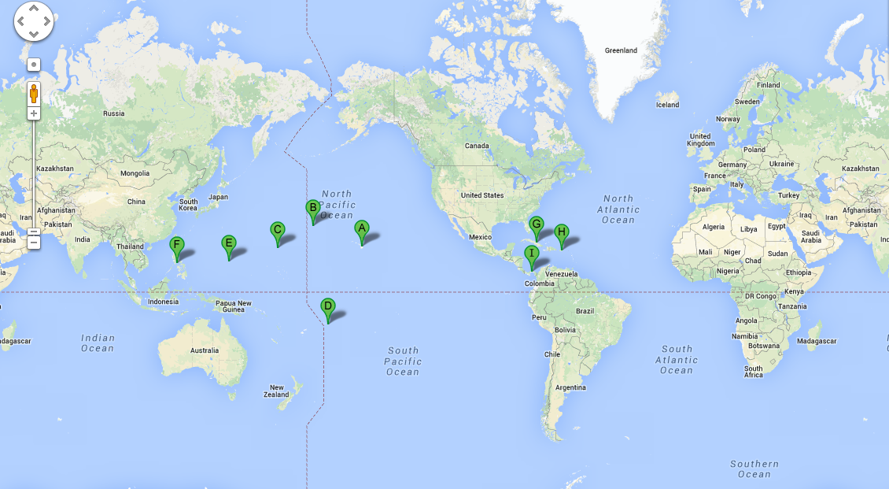

Key

A:_________________________ B: _________________________ C: _________________________ D: _________________________

E: _________________________ F: _________________________ G: _________________________ H: _________________________

I: _________________________

