Unit 4: Becoming a World Power

Big Picture Graphic

Overarching Question:

How did tension between isolationism and interventionism influence and reflect the changing meaning of freedom and equality?

Previous Unit:  Progressivism and Reform | This Unit:  Becoming a World Power | Next Unit:  The Crisis of Capitalism and Responses
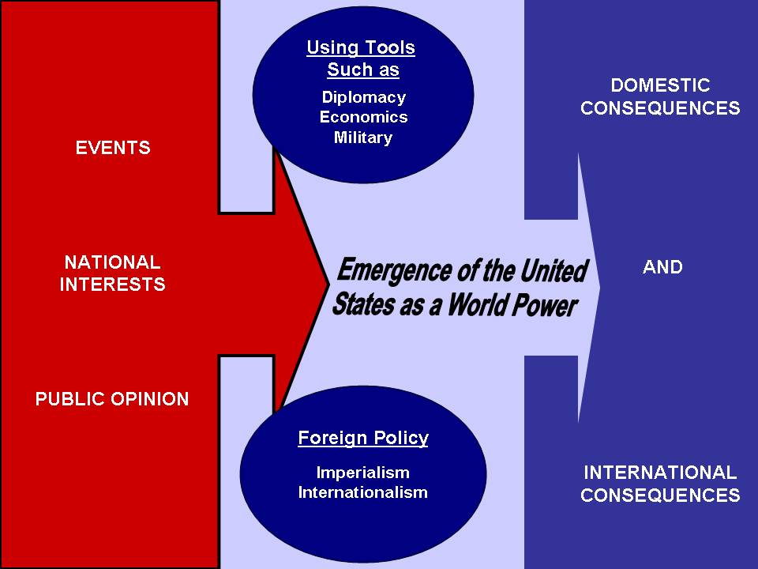
Questions To Focus Assessment and Instruction:

- How and why did America’s role on the international stage change?
- How did imperialism and World War I affect the United States domestically?
- How did responses to President Wilson’s Fourteen Points illustrate tensions between interventionism and isolationism, as well as instability in the world?

