Resource 1: US Industrialization Process in the Late 19th Century
Adapted from: Acuña-Alfaro,Jairo. US Industrialization Process in the Late XIX Century.
The Natural Resource Endowment.

“At the beginning the combination of the land, a great natural resource to be exploited, together with a rapidly growing, able population, gave Americans a history of unprecedented overall economic growth”.
--- Hughes, Jonathan & Cain, Louis P. (1998). American Economic History. Fifth Edition. Addison-Wesley. United States. p.602.

INTRODUCTION
In what ways did the available natural resource base influence American economic growth in the nineteenth century? . . . .

AMERICAN ECONOMIC GROWTH IN THE 19th CENTURY
The exceptional rate of growth of the United States in the XIX century, which leads it to catch-up with the Europeans leaders, especially the United Kingdom, and subsequently, to position as a world leader, may be related with the rapid assimilation of modern machines and tools of production. American economic growth was first devoted to the so-called ‘light industry’, as textiles, leather and foodstuff-producing. Later on, with the advancement of transportation and communication, came the development of ‘heavy industry’, with the construction of railroads, steam-boats, and the parallel coal, iron and steel-making industries. The distribution and commercialization of goods soon followed.

The direction of change in American manufacture is demonstrated by statistics. By 1913 the United States made 31.9 million metric tons of crude steel, compared with 35.5 for all Western Europe. The US also mined 517 million metric tons of coal, compared with Europe’s 493 million. And, by the 1880s businessmen and politicians in Britain were already acutely aware that the economic prosperity and political status the first industrial nation had enjoyed for almost a century was being challenged with steadily increasing effect.

In this case the United States was catching-up and forging ahead in the industrial lead, turning economic and political activities towards the new huge economy that emerged from the other side of the Atlantic. For example, Edison’s invention of the lamp was accompanied by the development and promotion of an entire system of generating, distributing, consuming and measuring electric power. In that sense, Edison “directed a team effort that produced a working lamp in one year and an entire commercial electric system in four”. It is an example of complete innovative process of research, development, manufacturing, finance, promotion, publicity and politics, to lay conduits in the first generating station in New York in 1882. Edison’s innovation was vital in the American and world-wide industrialization process. It provided a source of lighting and power that “altered urban living and transportation; changed the ways of the workplace; and gave rise to new industrial methods such as electrolytic processes for producing copper and other materials.”

INFLUENCE OF ABUNDANT NATURAL RESOURCES ON US GROWTH
There is no doubt the American economy had a privileged endowment of natural resources. If we compare the size of the country, it becomes clear. While the US territory covers 9,629,091 square kilometers, together, the UK, France, Sweden and Germany hold just 1,594,808 square kilometers. In addition, in comparing the US with other countries, relative to population, the US had a usually rich resource base. Indeed, it was short on labor and long on raw material. In that sense, the US industrialization process, especially, in the late 19th century, was confined mainly to its large access to natural resources and to the world’s largest domestic market.

Another fact that explains the growth of the US in late nineteenth century is what has been called ‘the logic of managerial enterprise’. The technologically advanced and capital-intensive American industries were characterized by a dual economic principle. They operated as economies of scale and economies of scope. Economies of scales refer to the economics principle that large plants can produce at a lower cost than smaller competitors, because the cost per unit falls as the volume of outputs rises. Meanwhile, economies of scope, refers when large plants can use many of the same raw and semi-finished materials and intermediate production processes to make a variety of different products.

The abundant natural resources of the country and the development of communication means, such as railroads, the telegraph and steamboats “made possible to speed goods and messages through an entire economy for the first time”. Furthermore, once precious metals were found they tended to dominate mineral extraction at the expense of everything else.

Finally, when thinking about American natural resource endowment, it is important to consider the ability of its citizens to innovate. Besides the large resources at their disposal, they chose industrial processes of scope, adding more value to the resources they inherited. For example, to make a technology like steel production work, Americans got useful insights into seeing exactly how Europeans did it, but successful steel production required that European methods be altered to fit local American conditions (e.g. the precise chemical composition of local ores and coal, etc.).

Early in the nineteenth century, Europeans knew what worked for their particular local resources, but did not know why. In contrast, by the end of the 19th century, the chemistry of steel making had been largely worked out and tacit knowledge of local conditions became less important. Thus Americans could know why things worked and could therefore tell what they could expect from any given inputs of coal and ore and how they could change production methods to suit what they had on hand. In addition, it is important to note that in the case of wood (particularly abundant compared with other materials, for example) it was widely used for houses, tools, furniture and transport equipment. As a matter of fact, “in 1860 American per capita wood consumption was five times that of England and Wales”. In 1860, the lumber industry was second only to cotton textiles in creation of value added and market value, as figure below shows.

Source: Adapted from: Acuña-Alfaro, Jairo. US Industrialization Process in the Late XIX Century. The Natural Resource Endowment. 12 Feb. 2009 <http://www.geocities.com/jaacun/USAIndustrialization.PDF> (citations to quotes omitted in adapted version).

Industrial Revolution Research Sheet

Topic of Research: ___________________________________________

Discoveries, Improvements, or Changes:

Impact on American Industrialization:
Research Websites

- General (For All)
- The New Industrial Age. US History.com. 13 Feb. 2009 <http://www.u-s-history.com/pages/h860.html>.
- “Industrialization and Reform.” History of the United States. The USA Online.com. 13 Feb. 2009 <http://www.theuaonline.com/history/industrilazation.htm>.

- Geography and Natural Resources
  - “History of Steel.” Steel Manufacturing. Ball State University. 13 Feb. 2009 <http://www.bsu.edu/web/acmaassel/steel.html#History_of_Steel>.
  - Introduction to Oil Industry. Oil Industry. 13 Feb. 2009 <http://www.petroleumhistory.org/OilHistory/pages/intro.html>.
  - Textile Industry History. 13 Feb. 2009 <http://www.textilehistory.org/>.

- Post-Reconstruction technological innovations or inventions
  - Industrial Expansion 1865-1890. 13 Feb. 2009 <http://www.emayzine.com/lectures/indust~1.htm>.
  - Carnegie and the Era of Steel. Outline of American History. From Revolution to Reconstruction. 13 Feb. 2009 <http://odur.let.rug.nl/~usa/H/1994/ch7_p2.htm>.
  - 19th Century Inventors. About.com. 13 Feb. 2009 <http://inventors.about.com/od/timelines/a/Nineteenth_3.htm>.

- Changes in Transportation
  - “Railroads in the Late 19th Century.” The Rise of Industrial America. The Learning Page, Library of Congress. 13 Feb. 2009 <http://lcweb2.loc.gov/learn/features/timeline/riseind/railroad/rail.html>.
  - America on the Move. Smithsonian Institute. National Museum of American History. 13 Feb. 2009 <http://americanhistory.si.edu/onthemove/exhibition/>.

- Immigration and Labor
  - “Immigration to the United States.” The Rise of Industrial America. The Learning Page, Library of Congress. 13 Feb. 2009 <http://lcweb2.loc.gov/learn/features/timeline/riseind/immgnts/immgrnts.html>
  - Eugene V. Debs, Union Leader. Debs Foundation. 2008. 13 Feb. 2009 <http://www.eugenevdebs.com/pages/union.html>.
  - The Triangle Factory Fire. Cornell University. 13 Feb. 2009 <http://www.ilr.cornell.edu/trianglefire/>.

Industrial Revolution Graphic Organizer

Topic of Research | Discoveries, Improvements, or Changes | Impact on American Industrialization
Geography and Natural Resources

Post-Reconstruction Technological Innovations or Inventions

Changes in Transportation

Immigration and Labor

Industrial Revolution Graphic Organizer
Reference Guide

Topic of Research | Discoveries, Improvements, or Changes | Impact on American Industrialization
Geography and Natural Resources | Iron ore  Coal  Oil  Lumber | Iron Ore: Used to create steel and pig iron. Also used for rails and spikes for the railroads, bridges, buildings, etc.  Coal: Replaced wood in fueling the steam engine and machinery; Used in various industries including the steel industry.  Oil: The ability to use a steam engine for oil drilling started an oil boom in the US. It also helped with the creation of the petroleum-refining industry. Transformed oil into kerosene and later gasoline for automobiles.  Lumber: Used to fuel the steam engines that were used on trains, steamboats, and in industry for the new machines being invented that ran on steam.  Impact: Created pollution in the atmosphere and the water system.
Post-Reconstruction Technological Innovations or Inventions | Incandescent light bulb  Electrical Power Distribution System  Telephone  Typewriter | Incandescent light bulb Perfected by Thomas Alva Edison in 1878  Electrical power distribution system in 1882  This led to electric power to run machines in industry,  community, and homes such as electric street cars, fans, and printing press  Telephone - Invented by Alexander Graham Bell. It opened a new and more efficient form of communication that affected businesses and office work. Also created new jobs for women  Typewriter - Developed by Christopher Sholes.
Changes in Transportation | Transcontinental Railroad | Creation of the Transcontinental Railroad provided quick  transportation from the east to the west coast. This allowed for expansion of farm land available due  to the railroad being able to get goods to market in a  reasonable time. It also lead to the creation of time  zones so travel time would be uniform (adopted by  Congress in 1918). It influenced business and industry  because of the need for natural resources including iron,  coal, steel, lumber, and glass. Government assisted in development of railroad system through a system of land  grants to the railroads.
Industrial Revolution Graphic Organizer
Reference Guide (continued)

Topic of Research | Discoveries, Improvements, or Changes | Impact on American Industrialization
Changes in Transportation  (continued) | Airplanes  Early Automobiles | Airplanes - Wright brothers, pioneers in flight  Early automobiles by Duryea brothers  Impact - Changes in transportation stimulated growth of  new businesses, created new markets, and resulted in the growth of towns. Food and manufactured goods could be distributed nationally. Railroads created new social, political,  and economic ties among people spread across thousands  of miles. To many Americans, a railroad connection promised new prosperity and new opportunities.
Immigration and Labor | Increased Immigration  Growth of Labor Force | Increased Immigration - Many immigrants came to the US in search of economic opportunities, facing crop failure, land and job shortages, rising taxes, and famine in their country of origin. Others sought personal freedom or relief from political and religious persecution. Nearly 12 million immigrants arrived in the United States between 1870 and 1900. During the 1870s and 1880s, the vast majority of these people were from Germany, Ireland, and England. The last two decades of the 19th century, however, saw increasing numbers of people coming from Italy and eastern Europe. Some 70% of immigrants arriving from Europe entered America through the port of New York City alone. Asian immigrants, primarily from Japan and China, arrived through west coast ports. Many immigrants settled near the ports of entry but others moved farther inland. They frequently had difficulty finding jobs and usually worked for less money than most other Americans. Perceived as “different” they were often viewed with distrust if not outright resentment by their native born neighbors.  Labor Force – Increased immigration greatly expanded the number of skilled and unskilled laborers available. Immigration also resulted in increased urbanization as these workers tended to cluster in cities where work was available.

Business Attitudes, Practices, and Governmental Efforts
Enabling Industrialists to Thrive

Laissez-faire philosophy

Social Darwinism

Government assistance for railroads

New forms of business organization

Corporations

Trusts

Vertical Integration

Horizontal Integration

Economies of scale

U.S. Western Railway Land Grants

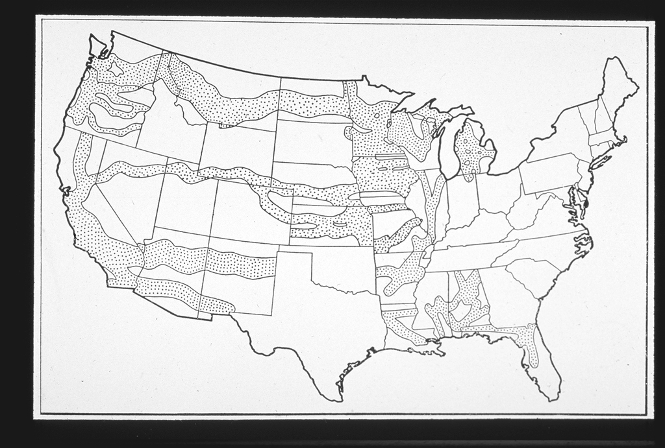

Source: Railroad Land Grants. American Memory. Library of Congress. 13 February 2009 <http://memory.loc.gov/award/mhsdalad/120000//120033v.jpg>.

Millions of Acres

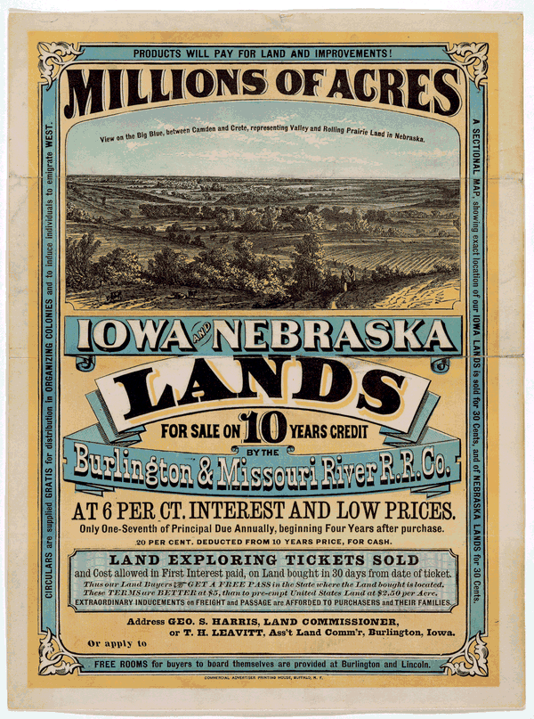

Source: Millions of Acres. American Memory. Library of Congress. 13 February 2009 <http://memory.loc.gov/cgi-bin/ampage?collId=rbpe&fileName=rbpe13/rbpe134/13401300/rbpe13401300page.db&recNum=0>.
Dual Column Notes: Rockefeller and Carnegie

Information on Rockefeller | What I Think About Rockefeller
Information on Carnegie | What I Think About Carnegie

Ida Tarbell’s Writings on Standard Oil and Rockefeller
Below are a few excerpts from the nineteen installments published by "McClure’s Magazine":
Rockefeller’s rise:
The strides the firm of Rockefeller & Andrews made after the former went into it were attributed, for three or four years, mainly to [his] extraordinary capacity for bargaining and borrowing. Then its chief competitors began to suspect something. Rockefeller might get his oil cheaper now and then, they said, but he could not do it often. He might make close contracts for which they had neither the patience nor the stomach. He might have an unusual mechanical and practical genius in his partner. But these things could not explain all. They believed they bought, on the whole, almost as cheaply as he, and they knew they made as good oil and with as great, or nearly as great, economy. He could sell at no better price than they. Where was his advantage? There was but one place where it could be, and that was in transportation.
The South Improvement Company scheme:
For several days an uneasy rumor had been running up and down the Oil Regions. Freights were going up. Now an advance in a man's freight bill may ruin his business; more, it may mean the ruin of a region. …
On the morning of February 26, 1872, the oil men read in their morning papers that the rise which had been threatening had come; moreover, that all members of the South Improvement Company were exempt from the advance. At the news all Oildom rushed into the streets. Nobody waited to find out his neighbor's opinion. On every lip there was but one word, and that was "conspiracy."…
For weeks the whole body of oil men abandoned regular business and surged from town to town intent on destroying the "Monster," the "Forty Thieves," the "great Anaconda," as they called the mysterious South Improvement Company. Curiously enough, it was chiefly against the combination which had secured the discrimination from the railroads--not the railroads which had granted it--that their fury was directed. They expected nothing but robbery from the railroads, they said. They were used to that; but they would not endure it from men in their own business.
The aftermath of South Improvement Company scheme:
No number of resolutions could wipe out the memory of the forty days of terrible excitement and loss which the region had suffered. No triumph could stifle the suspicion and bitterness which had been sown broadcast through the region. Every particle of independent manhood in these men whose very life was independent action had been outraged. Their sense of fair play, the saving force of the region in the days before law and order had been established, had been violated. These were things which could not be forgotten. There henceforth could be no trust in those who had devised a scheme which, the producers believed, was intended to rob them of their business.
The oil boom:
The oil men as a class had been brought up to enormous profits, and held an entirely false standard of values. As the "Derrick" told them once in a sensible editorial, "their business was born in a balloon going up, and spent all its early years in the sky." They had seen nothing but the extreme of fortune. One hundred per cent per annum on an investment was in their judgment only a fair profit. If their oil property had not paid for itself entirely in six months, and begun to yield a good percentage, they were inclined to think it a failure. They were notoriously extravagant in the management of their business. Rarely did an oil man write a letter if he could help it. He used the telegraph instead. Whole sets of drilling tools were sometimes sent by express. It was no uncommon thing to see near a derrick broken tools which could easily have been mended, but which the owner had replaced by new ones. It was anything to save bother with him. Frequently wells were abandoned which might have been pumped on a small but sure profit. The simple fact was that the profits which men in trades all over the country were glad enough to get, the oil producers despised. The one great thing which the Oil Regions did not understand in 1872 was economy.
The hushing of the Oil Regions:
The great human tragedies of the Oil Regions lie in the individual compromises which followed the public settlement of 1880. For then it was that man after man, from hopelessness, from disgust, from ambition, from love of money, gave up the fight for principle which he had waged for seven years. "The Union has surrendered," they said, "why fight on?" This man took a position with the Standard and became henceforth active in its business; that man took a salary and dropped out of sight; this one went his independent way, but with closed lips; that one shook the dust of the Oil Regions from his feet and went out to seek ‘God’s Country,’ asking only that he should never again hear the word ‘oil.’ The newspapers bowed to the victor. A sudden hush came over the region, the hush of defeat, of cowardice, of hopelessness.
Rockefeller’s genius:
With Mr. Rockefeller’s genius for detail there went a sense of the big and vital factors in the oil business and a daring in laying hold of them which was very like military genius. He saw strategic points like a Napoleon and he swooped on them with the suddenness of a Napoleon. Mr. Rockefeller’s capture of the Cleveland refineries in 1872 was as dazzling an achievement as it was a hateful one. The campaign … viewed simply as a piece of brigandage, was admirable. The man saw what was necessary to his purpose and he never hesitated before it. His courage was steady--and his faith in his ideas unwavering. He simply knew what was the thing to do, and he went ahead with the serenity of the man who knows.

Source: A Journalistic Masterpiece. The Rockefellers. American Experience. PBS/WGBH. 13 February 2009 <http://www.pbs.org/wgbh/amex/rockefellers/sfeature/sf_7.html>.
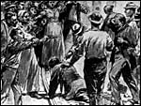
The Homestead Strike

One of the most difficult episodes Andrew Carnegie's life -- and one that revealed the steel magnate's conflicting beliefs regarding the rights of labor -- was the bitter conflict in 1892 at his steel plant in Homestead, Pennsylvania. Carnegie's involvement in the union-breaking action left many men dead or wounded and forever tarnished Carnegie's reputation as a benevolent employer and a champion of labor.
The conflict at Homestead arose at a time when the fast-changing American economy had stumbled and conflicts between labor and management had flared up all over the country. In 1892, labor declared a general strike in New Orleans. Coal miners struck in Tennessee, as did railroad switchmen in Buffalo, New York and copper miners in Idaho.
Carnegie's mighty steel industry was not immune to the downturn. In 1890, the price of rolled-steel products started to decline, dropping from $35 a gross ton to $22 early in 1892. In the face of depressed steel prices, Henry C. Frick, general manager of the Homestead plant that Carnegie largely owned, was determined to cut wages and break the Amalgamated Association of Iron and Steel Workers, one of the strongest craft unions in the country.
Behind the scenes, Carnegie supported Frick's plans. In the spring of 1892, Carnegie had Frick produce as much armor plate as possible before the union's contract expired at the end of June. If the union failed to accept Frick's terms, Carnegie instructed him to shut down the plant and wait until the workers buckled. "We... approve of anything you do," Carnegie wrote from England in words he would later come to regret. "We are with you to the end."
With Carnegie's carte blanche support, Frick moved to slash wages. Plant workers responded by hanging Frick in effigy. At the end of June, Frick began closing down his open hearth and armor-plate mills, locking out 1,100 men. On June 25th, Frick announced he would no longer negotiate with the union; now he would only deal with workers individually. Leaders of Amalgamated were willing to concede on almost every level -- except on the dissolution of their union. Workers tried to reach the Carnegie who had strongly defended labor's right to unionize. He had departed on his annual and lengthy vacation, traveling to a remote Scottish castle on Loch Rannoch. He proved inaccessible to all -- including the press and to Homestead's workers -- except for Frick.
"This is your chance to re-organize the whole affair," Carnegie wrote his manager. "Far too many men required by Amalgamated rules." Carnegie believed workers would agree to relinquish their union to hold on to their jobs.
It was a severe miscalculation. Although only 750 of the 3,800 workers at Homestead belonged to the union, 3,000 of them met and voted overwhelmingly to strike. Frick responded by building a fence three miles long and 12 feet high around the steelworks plant, adding peepholes for rifles and topping it with barbed wire. Workers named the fence "Fort Frick."
Deputy sheriffs were sworn in to guard the property, but the workers ordered them out of town. Workers then took to guarding the plant that Frick had closed to keep them out. This action signified a very different attitude that labor and management shared toward the plant.
"Workers believed because they had worked in the mill, they had mixed their labor with the property in the mill," explains historian Paul Krause. "They believed that in some way the property had become theirs. Not that it wasn't Andrew Carnegie's, not that they were the sole proprietors of the mill, but that they had an entitlement in the mill. And I think in a fundamental way the conflict at Homestead in 1892 was about these two conflicting views of property."
Frick turned to the enforcers he had employed previously: the Pinkerton Detective Agency's private army, often used by industrialists of the era. At midnight on July 5, tugboats pulled barges carrying hundreds of Pinkerton detectives armed with Winchester rifles up the Monongahela River. But workers stationed along the river spotted the private army. A Pittsburgh journalist wrote that at about 3 A.M. a "horseman riding at breakneck speed dashed into the streets of Homestead giving the alarm as he sped along." Thousands of strikers and their sympathizers rose from their sleep and went down to the riverbank in Homestead.
When the private armies of business arrived, the crowd warned the Pinkertons not to step off the barge. But they did. No one knows which side shot first, but under a barrage of fire, the Pinkertons retreated back to their barges. For 14 hours, gunfire was exchanged. Strikers rolled a flaming freight train car at the barges. They tossed dynamite to sink the boats and pumped oil into the river and tried to set it on fire. By the time the Pinkertons surrendered in the afternoon three detectives and nine workers were dead or dying. The workers declared victory in the bloody battle, but it was a short-lived celebration.
The governor of Pennsylvania ordered state militia into Homestead. Armed with the latest in rifles and Gatling guns, they took over the plant. Strikebreakers who arrived on locked trains, often unaware of their destination or the presence of a strike, took over the steel mills. Four months after the strike was declared, the men's resources were gone and they returned to work. Authorities charged the strike leaders with murder and 160 other strikers with lesser crimes. The workers' entire Strike Committee also was arrested for treason. However, sympathetic juries would convict none of the men.
All the strikers’ leaders were blacklisted. The Carnegie Company successfully swept unions out of Homestead and reduced it to a negligible factor in the steel mills throughout the Pittsburgh area.
Carnegie found the upheaval and its aftermath a devastating experience. When British statesman William E. Gladstone wrote him a sympathetic note, Carnegie replied:

This is the trial of my life (death's hand excepted). Such a foolish step -- contrary to my ideals, repugnant to every feeling of my nature. Our firm offered all it could offer, even generous terms. Our other men had gratefully accepted them. They went as far as I could have wished, but the false step was made in trying to run the Homestead Works with new men. It is a test to which workingmen should not be subjected. It is expecting too much of poor men to stand by and see their work taken by others. . . The pain I suffer increases daily. The Works are not worth one drop of human blood. I wish they had sunk.

Carnegie would come back to Homestead six years later to dedicate a building that would house a library, a concert hall, a swimming pool, bowling alleys, and a gymnasium. However, the man who saw himself as a progressive businessman would always carry pain regarding the incident. "Nothing. . . in all my life, before or since, wounded me so deeply," he wrote in his autobiography. "No pangs remain of any wound received in my business career save that of Homestead."
"It's easy to say that Carnegie was a hypocrite," states historian Joseph Frazier Wall. "And there is an element of hypocrisy clearly in between what he said and what was done. But it's a little too easy to simply dismiss the whole incident on Carnegie's part as an act of hypocrisy. There is this curious reason as to why Carnegie felt it necessary to even enunciate the rights of labor. Frick was the norm, not Carnegie, in management's relationship with labor at that time. And, one can only answer that, once again, it's being torn between wanting to pose as a great democrat and liberal and at the same time wanting to make sure Carnegie Steel came out on top."

Source: “The Homestead Strike.” American Experience. PBS/WGBH. 13 February 2009 <http://www.pbs.org/wgbh/amex/carnegie/peopleevents/pande04.html>.

Rockefeller and Carnegie: Captains of Industry or Robber Barons?

Captains of Industry: Usually held to imply that the person so described was intelligent, innovative, hardworking and mainly a decent person whose works and methods were mostly honorable and caused far greater good than harm.

Robber Barons: Usually held to imply that the person so described was also intelligent, hardworking and innovative but used methods and caused changes which overall were far more destructive than beneficial.

Short Essay: On a single sheet of paper, write a response to the following two questions. (3-4 sentences each)

How did the activities of Rockefeller and Carnegie enhance or promote freedom? How did they restrict or limit freedom?

Could or should government have done more than it did to protect the freedom of the American people? Why or why not?

Arrivals

There isn’t one immigrant story: famines, wars, persecution, but also economic opportunity and adventure encouraged individuals to leave their homeland. In Ireland, families fled the Great Famine of 1845-51, Jews escaped the Russian pogroms beginning in 1881, and Southern Italians came hoping to earn enough money to return to Italy and buy land. More recently, Haitians have left due to the political/economic collapse of their country. It should be remembered that Africans were forcibly take from their homelands and enslaved in the United States and the colonies that preceded it.
Those who made the journey were not the poorest of the poor, but the ones who could afford to leave, who often had greater job skills or education than those who remained behind. Whatever the reasons for leaving, immigrants came as part of networks of family and communities, whether Poles settling in Polish Hill in Pittsburgh in the late 19th century or Dominicans moving to Washington Heights today. The networks give people an address – a place to go and a friend or family to take them in for a while.
Immigration reached its peak at the turn of the 20th century and Ellis Island – organized in 1892 to replace Castle Garden in Manhattan – processed the largest number of immigrants. More than 12 million people came through its doors, most having traveled steerage in a not very sanitary ship. On arrival, they faced a physical examination to ensure they carried no communicable diseases and an interview to determine that they were not illegal contract laborers and would not become a public charge. Two percent of immigrants failed and were sent back.
The passage of the National Origins Act in 1924 slashed the number of immigrants, especially those from Southern and Eastern Europe. The Hart-Celler Act of 1965 changed that by allowing entrance from countries earlier excluded, especially in Asia. But the era of the steamship had ended. Immigrants from overseas now arrive in airports – still drawn by a network of family and community connected between the homeland and the United States.

Source: Arrival. A Nation of Immigrants. The City University of New York. 13 February 2009 <http://www1.cuny.edu/portal_ur/content/nationofimmigrants/arrival.php>.

Sources: Simon Kuznets and Ernest Rubin, Immigration and the Foreign Born (1954), p. 95, and Gavin Wright, Old South, New South: Revolutions in the Southern Economy Since the Civil War (1986), p. 73; Thernstrom, op. cit., p. 1036.
Immigration Handout: The Peopling of America, 1880-1930

By the 1880's, steam power had shortened the journey to America dramatically. Immigrants poured in from around the world: from the Middle East, the Mediterranean, Southern and Eastern Europe, and down from Canada.
The door was wide open for Europeans - In the 1880s alone, 9% of the total population of Norway emigrated to America. After 1892 nearly all immigrants came in through the newly opened Ellis Island.
One immigrant recalled arriving at Ellis Island: "The boat anchored at mid-bay and then they tendered us on the ship to Ellis Island… We got off the boat…you got your bag in your hand and went right into the building Ah, that day must have been about five to six thousand people. Jammed, I remember it was August. Hot as a pistol, and I'm wearing my long johns, and my heavy Irish tweed suit."
Families often immigrated together during this era, although young men frequently came first to find work. Some of these then sent for their wives, children, and siblings; others returned to their families in Europe with their saved wages.
The experience for Asian immigrants in this period was quite different. In 1882 Congress passed the Chinese Exclusion Act, severely restricting immigration from China. Since earlier laws made it difficult for those Chinese immigrants who were already here to bring over their wives and families, most Chinese communities remained "bachelor societies."
The 1907 "Gentlemen's Agreement" with Japan extended the government's hostility towards Asian workers and families. For thousands, the Angel Island Immigration Station in San Francisco Bay would be as close as they would ever get to the American mainland.
For Mexicans victimized by the Revolution, Jews fleeing the pogroms in Eastern Europe and Russia, and Armenians escaping the massacres in Turkey, America provided refuge.
And for millions of immigrants, New York provided opportunity. In Lower New York, one could find the whole world in a single neighborhood.
Between 1880 and 1930 over 27 million people entered the United States - about 20 million through Ellis Island. But after outbreak of World War I in 1914, American attitudes toward immigration began to shift. Nationalism and suspicion of foreigners were on the rise, and immigrants' loyalties were often called into question. Through the early 20s, a series of laws was passed to limit the flow of immigrants.

Source: The Peopling of America. 1880-1930. Ellis Island Foundation, Inc. 13 February 2009 <http://www.ellisislandrecords.org/immexp/wseix_5_3.asp>.

Immigration Handout: Immigration to the United States: 1851 – 1900

In the late 1800s, people in many parts of the world decided to leave their homes and immigrate to the United States. Fleeing crop failure, land and job shortages, rising taxes, and famine, many came to the U. S. because it was perceived as the land of economic opportunity. Others came seeking personal freedom or relief from political and religious persecution. With hope for a brighter future, nearly 12 million immigrants arrived in the United States between 1870 and 1900. During the 1870s and 1880s, the vast majority of these people were from Germany, Ireland, and England--the principal sources of immigration before the Civil War. That would change drastically in the next three decades.

Immigrants entered the United States through several ports. Those from Europe generally came through East Coast facilities, while those from Asia generally entered through West Coast centers. More than 70 percent of all immigrants, however, entered through New York City, which came to be known as the "Golden Door." Throughout the late 1800s, most immigrants arriving in New York entered at the Castle Garden depot near the tip of Manhattan. In 1892, the federal government opened a new immigration processing center on Ellis Island in New York harbor.

Although immigrants often settled near ports of entry, a large number did find their way inland. Many states, especially those with sparse populations, actively sought to attract immigrants by offering jobs or land for farming. Many immigrants wanted to move to communities established by previous settlers from their homelands.

Once settled, immigrants looked for work. There were never enough jobs, and employers often took advantage of the immigrants. Men were generally paid less than other workers, and women less than men. Social tensions were also part of the immigrant experience. Often stereotyped and discriminated against, many immigrants suffered verbal and physical abuse because they were "different." While large-scale immigration created many social tensions, it also produced a new vitality in the cities and states in which the immigrants settled. The newcomers helped transform American society and culture, demonstrating that diversity, as well as unity, is a source of national strength.

Source: Overview: Immigration to the United States 1851-1900. Rise of Industrial America, 1876-1900. The Learning Page. Library of Congress. 13 February 2009 <http://lcweb2.loc.gov/learn/features/timeline/riseind/immgnts/immgrnts.html>.
Demographic Changes

Immigration Data: 1850-1920
 | 1920 | 1910 | 1900 | 1890
Total | 13,920,692 | 13,515,886 | 10,341,276 | 9,249,547
Region | 13,911,767 | 13,506,272 | 10,330,534 | 9,243,535
Europe | 11,916,048 | 11,810,115 | 8,881,548 | 8,030,347
Northern and Western Europe | 6,241,916 | 7,306,325 | 7,204,649 | 7,288,917
Southern and Eastern Europe | 5,670,927 | 4,500,932 | 1,674,648 | 728,851
Asia | 237,950 | 191,484 | 120,248 | 113,383
Africa | 16,126 | 3,992 | 2,538 | 2,207
Oceania | 14,626 | 11,450 | 8,820 | 9,353
Latin America | 588,843 | 279,514 | 137,458 | 107,307
Northern America | 1,138,174 | 1,209,717 | 1,179,922 | 980,938
Region or country not reported | 8,925 | 9,614 | 10,742 | 6,012
Born at sea | 5,336 | 6,927 | 8,196 | 5,533
Not reported | 3,589 | 2,687 | 2,546 | 479
 | 1880 | 1870 | 1860 | 1850
Total | 6,679,943 | 5,567,229 | 4,138,697 | 2,244,602
Region | 6,675,875 | 5,563,637 | 4,134,809 | 2,202,625
Europe | 5,751,823 | 4,941,049 | 3,807,062 | 2,031,867
Northern and Western Europe | 5,499,889 | 4,845,679 | 3,773,347 | 2,022,195
Southern and Eastern Europe | 248,620 | 93,824 | 32,312 | 9,672
Asia | 107,630 | 64,565 | 36,796 | 1,135
Africa | 2,204 | 2,657 | 526 | 551
Oceania | 6,859 | 4,028 | 2,140 | 588
Latin America | 90,073 | 57,871 | 38,315 | 20,773
Northern America | 717,286 | 493,467 | 249,970 | 147,711
Region or country not reported | 4,068 | 3,592 | 3,888 | 41,977
Born at sea | 4,068 | 2,638 | 2,522 | (NA)
Not reported | - | 954 | 1,366 | 41,977
1. From where did most immigrants come -- northern/western Europe, eastern/southern Europe, Latin America, Asia, other?
2. Looking at Europe only, what do you notice about the immigration rate for norther/western v. eastern/southern? Which group had the heaviest immigration before 1880? After 1880?

Ethnic and Class Groupings in Milwaukee, 1850-1890

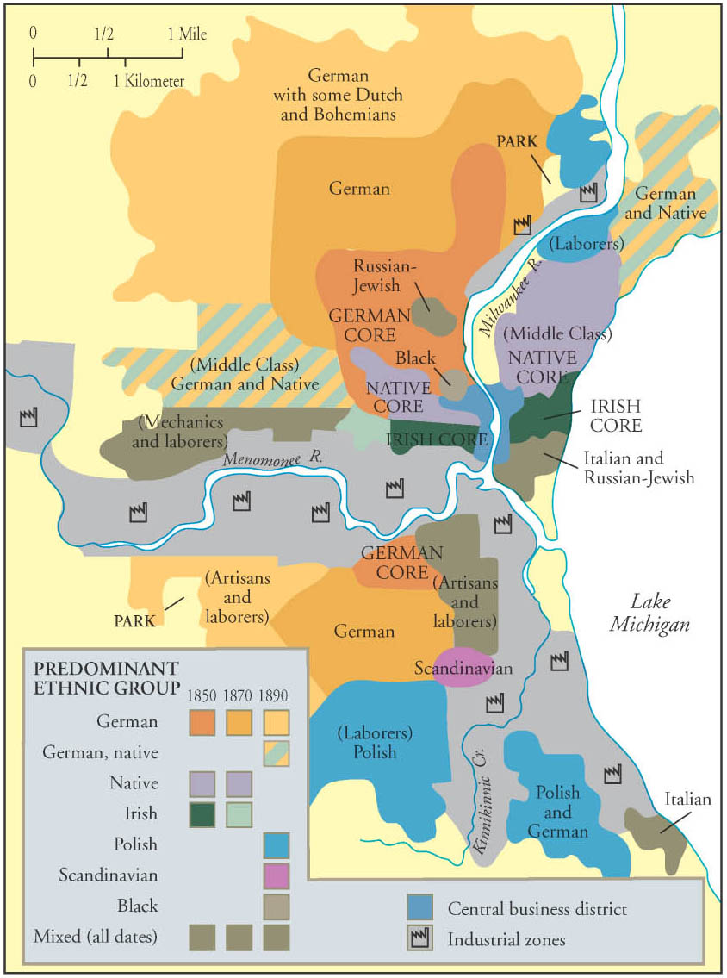
Source: McGraw Hill PowerPoint , slide 5, 2004. <http://www.vbhssocialstudies.com/apus/powerpoint/chapter18.ppt>.
Industrial Revolution Inventors

Person | Invention | Date
James Watt | First reliable Steam Engine | 1775
Eli Whitney | Cotton Gin, Interchangeable parts for muskets | 1793, 1798
Robert Fulton | Regular Steamboat service on the Hudson River | 1807
Samuel F. B. Morse | Telegraph | 1836
Elias Howe | Sewing Machine | 1844
Isaac Singer | Improves and markets Howe's Sewing Machine | 1851
Cyrus Field | Transatlantic Cable | 1866
Alexander Graham Bell | Telephone | 1876
Thomas Edison | Phonograph, Incandescent Light Bulb | 1877, 1879
Nikola Tesla | Induction Electric Motor | 1888
Rudolf Diesel | Diesel Engine | 1892
Orville and Wilbur Wright | First Airplane | 1903
Henry Ford | Model T Ford, Assembly Line | 1908, 1913

Source: Industrial Revolution Inventors. About.com. 13 February 2009 <http://americanhistory.about.com/library/charts/blchartindrev.htm>.

Timed Reading (ACT Prep)

DIRECTIONS: The passage in this test is followed by several questions. After reading the passage, choose the best answer to each question and fill in the corresponding oval on your answer document. You may refer to the passage as often as necessary.

Cities have always placed demands on their sites and their hinterlands. In order to extend their usable territory, urban developers often reshaped natural landscapes, leveling hills, filling valleys and wetlands, and creating huge areas of made land. On this new land, they constructed a built environment of paved streets, malls, houses, factories, office buildings, and churches. In the process they altered urban biological ecosystems for their own purposes, killing off animal populations, eliminating native species of flora and fauna, and introducing new and foreign species. Thus urbanites, as Ann Spirin has written, constructed a built environment that replaced the natural environment and created a local micro-climate, with different temperature gradients and rainfall and wind patterns than those of the surrounding countryside.
1

City populations require food, water, fuel, and construction materials, while urban industries need natural materials for production purposes. In order to fulfill these needs, as William Cronon has brilliantly shown in Nature's Metropolis, urbanites increasingly had to reach far beyond their boundaries. In the nineteenth century, for instance, the demands of city dwellers for food produced rings of garden farms around cities and drove the transformation of distant prairies into cattle ranches and wheat farms. The many horses quartered in cities required feed, consuming the products produced by thousands of acres. In the twentieth century, as urban population increased, the demand for food drove the rise of large factory farms.
2
3
Cities also require fresh water supplies in order to exist -- engineers, acting at the behest of urban elites and politicians, built waterworks, thrust water intake pipes ever further into neighboring lakes, dug wells deeper and deeper into the earth looking for groundwater, and dammed and diverted rivers and streams to obtain water supplies for domestic and industrial uses and for fire-fighting. In the process of obtaining water from distant locales, cities often transformed them, making deserts where there had been fertile agricultural areas..

City entrepreneurs and industrialists were actively involved in the commodification of natural systems, putting them to use for purposes of urban consumption. The exploitation of water power from rivers and streams in New England, for instance, provided power for manufacturing cities. . . It also sharply altered river dynamics, destroying fish populations and depriving downstream users of adequate and unpolluted supplies. For materials to build and to heat the city, loggers stripped millions of acres of forests, quarrymen tore granite and other stone from the earth, and miners dug coal to provide fuel for commercial, industrial and domestic uses.
4

Urbanites had to seek locations to dispose of the wastes produced by their construction, manufacturing, and consumption. . . .Initially, they placed wastes on sites within the city, polluting the air, land, and water with industrial and domestic [pollutants] and modifying and even destroying natural biological systems. In the post-Civil War period, as cities grew larger, they disposed of their wastes by transporting them to more distant locations.
5

Thus, cities constructed sewerage systems for domestic wastes to replace cesspools and privy vaults and to improve local health conditions. They usually discharged the sewage into neighboring waterways, often polluting the water supply of downstream cities. In order to avoid epidemics of waterborne disease such as typhoid and cholera, downstream cities sought new sources of supply or used technological fixes, such as water filtration (1890s) or chlorination (1912), but the choices were not simple. Industrial wastes also added to stream and lake pollution, and urban rivers often became little more than open sewers.
6

. . . . In the late-nineteenth century, bituminous (or soft) coal became the preferred fuel for industrial, transportation, and domestic use in cities such as Chicago, Pittsburgh and St. Louis. But while providing an inexpensive and plentiful energy supply, bituminous coal was also very dirty. The cities that used it suffered from air contamination and reduced sunlight, while the cleaning tasks of householders were greatly increased. . . . Industry also used land surfaces for disposal of domestic and industrial wastes. Open areas in and around cities were marked with heaps of garbage, horse manure, ashes, and industrial byproducts such as slag from iron and steel-making or copper smelting. Such materials were often used to fill-in "swamps" (wetlands) along waterfronts.
7

In the late-nineteenth and early twentieth centuries, reformers began campaigning for urban environmental cleanups and public health improvements. Women's groups . . . often took the lead in agitating for clean air, clean water, and improved urban "housekeeping," showing a greater concern than men with such quality of life and health-related issues. Many progressive reformers. . . believed that the moral qualities of good citizenship were related to environmental improvements and to exposure to nature.
8

Questions for Timed Reading (ACT Prep)

1. The author’s primary aim in the first paragraph is to:
a. make a case for replacing urban based societies with rural based ones
b. demonstrate the interconnectedness of all things
c. summarize the nature and extent of the impact of cities on the environment
d. demonstrate the need for a new science

2. In paragraph 4 the word “entrepreneur” most nearly means:
a. communal leader
b. chief
c. politician
d. businessman or women

3. The 4th paragraph primarily asserts that:
a. of all resources water is most important
b. cities have a varied and destructive impact on the environment
c. adversity promotes the development of problem solving skills
d. city life was in harmony with the environment

4. It can be reasonably inferred from paragraph 5 that:
- as cities grew larger people traveled farther to dispose of waste
- human capability improved over time
- the antebellum period in America was a Golden Age
- there is no such thing as progress

5. The author’s primary aim in paragraph 6 is to:
a. illustrate how people solve problems
b. focus on the interdependence of cities
c. summarize the impact of cities on water systems
d. list diseases associated with water pollution

6. The 7th paragraph implies that:
a. coal was an environmentally-friendly source of energy
b. coal was cheap, plentiful and a major contaminant
c. fuel sources should be based solely on cost and availability
d. clean coal technology was widely available

7. As it is used on paragraph 8, the word “agitating” most nearly means:
a. organizing
b. protesting
c. voting
d. providing

8. The best title for this piece is:
- No Place Like Home
- Rugged Individualism
- Benefits of Capitalism
- The City and the Natural Environment

Answers for Timed Reading (ACT Prep)

1. c

2. d

3. b

4. a

5. c

6. b

7. b

8. d

Source: Tarr, Joel A. The City and the Natural Environment. Carnegie Mellon University. 13 February 2009 <http://www.gdrc.org/uem/doc-tarr.html>.
Excerpt from: ETHNIC AND RACE RELATIONS IN THE CITY OF CLEVELAND
Between the 1850s and 1930, a constant, shifting struggle emerged as the city's Anglo-American middle- and upper-classes struggled to enforce and maintain moral and social discipline in a city populated by growing numbers of European immigrants, many of whom were Catholics and Jews. Religion and ethnicity were thus tied together, and anti-Catholicism and anti-Semitism were important aspects of nativism in Cleveland and the rest of America. For example, EDWIN W. COWLES, Cleveland's most notorious anti-Catholic during the last half of the 19th century, railed against both the church and the drunken Irish from his position as editor of the CLEVELAND LEADER. Tensions within and between ethnic groups also intensified as communities developed and as older immigrants sought to influence the behavior and facilitate the assimilation of more recent arrivals.

Education was the first tool that Anglo-Americans used to try to inculcate the habits of "proper" behavior and good citizenship. In 1870, for example, bilingual education was adopted in the public schools in the hopes that offering some classes in German would attract into the schools the 2,000 German students who attended private schools. This policy, the superintendent explained, did "not tend to Germanize America as it [did] to Americanize the Germans." Within a decade, the number of German children attending private schools had dropped to 200. By 1887 the evening adult education program was attracting 2,000 immigrants to its classes in English and in civics in preparation for the naturalization exam. Public school programs for both immigrant children and adults were expanded repeatedly between 1870 and 1920, but the number of parochial schools also increased, making it possible for large numbers of ethnic students to escape the Americanizing influence of the public schools. The development of settlement houses such as HIRAM HOUSE provided new avenues for Americanization and educational efforts, as well as for other urban social reform work.

Source: Ethnic and Race Relations. The Encyclopedia of Cleveland History. 13 February 2009 <http://ech.cwru.edu/ech-cgi/article.pl?id=EARR>.
What is Populism?

- What caused the Populist Movement? (Why were people unhappy?)

From Reading | From Lesson

- What did Populists want? (What did they try to accomplish?)

From Reading | From Lesson

3. What did Populists achieve?

From Reading | From Lesson

4. What brought about the demise of the Populist Party?

From Reading | From Lesson

5. Was the Populist Movement ultimately successful? Explain.

Views on Populism

I say it fearlessly, and it can not be denied, that reforms for which the masses have been clamoring for years--whether it be silver or labor or income tax or popular rights or resistance to government by injunction--had never been written, and might never have been written, into a Democratic platform, until the Populist party, 1,800,000 strong, thundered in the ears of Democratic leaders the announcement that a mighty multitude demanded these reforms.

--John Temple Graves (Democrat), Atlanta Constitution, 27 August 1896.

The Populist gathering of this year lacked the drill and distinction and wealth of the Republican convention held the month before in the same building. It had not the ebullient aggressiveness of the revolutionary Democratic assembly at Chicago, nor the brilliant drivers who rode the storm there. Every one commented on the number of gray heads--heads many of them grown white in previous independent party movements. The delegates were poor men.... Cases are well known of delegates who walked because too poor to pay their railroad fare. It was one day discovered that certain members of one of the most important delegations were actually suffering for food. They had no regular sleeping place, having had to save what money they had for their nickel meals at the lunch counter.

--Henry Demorest Lloyd, Review of Reviews, September 1896

The Populist platform is almost too absurd to merit serious discussion.

--The Detroit Tribune, in Public Opinion, 6 August 1896

Source: “The Populist Party.” 1896. Vassar College. 17 February 2009 <http://projects.vassar.edu/1896/populists.html>.
Populist Party Platform, 1892 (July 4, 1892)

PREAMBLE

The conditions which surround us best justify our co-operation; we meet in the midst of a nation brought to the verge of moral, political and material ruin. Corruption dominates the ballot-box.... The people are demoralized;... public opinion silenced.... homes covered with mortgages, labor impoverished, and the land concentrating in the hands of capitalists. The urban workman are denied the right to organize for self-protection, imported pauperized labor beats down their wages... and [we] are rapidly degenerating into European conditions. The fruits of the toils of millions are boldly stolen to build up colossal fortunes for a few, unprecedented in the history of mankind.... From the same prolific womb of governmental injustice we breed the two great classes tramps and millionaires.

The national power to create money is appropriated to enrich bond-holders....

Silver, which has been accepted as coin since the dawn of history, has been demonitized to add to the purchasing power of gold.... the supply of currency is purposely [limited] to fatten [creditors].... A vast conspiracy against mankind has been organized... if not met and overthrown at once it forebodes terrible social convulsions, the destruction of civilization....

Controlling influences dominating both... parties have permitted the existing dreadful conditions to develop without serious effort to prevent or restrain them. Neither do they now promise any substantial reform.... They propose to sacrifice our homes, lives, and children on the alter of mammon; to destroy the multitude in order to secure corruption funds from the millionaires....

We seek to restore the government of the Republic to the hands of the "plain people."

Our country finds itself confronted by conditions for which there is no precedence in the history of the world; our annual agricultural productions amount to billions of dollars in value, which must, within a few weeks or months, be exchanged for billions of dollars worth of commodities consumed in their production; the existing currency supply is wholly inadequate to make this exchange; the results are falling prices, the formation of combines and rings, the impoverishment of the producing class. We pledge ourselves that if given power we will labor to correct these evils....

We believe that the power of government in other words, of the people should be expanded... to the end that oppression, injustice, and poverty shall eventually cease in the land.

[We] will never cease to move forward until every wrong is righted and equal rights and equal privileges securely established for all the men and women of this country....

PLATFORM
We declare, therefore

First: That the union of the labor forces of the United States... shall be permanent and perpetual....

Second: Wealth belongs to him who creates it, and every dollar taken from industry without an equivalent is robbery.... The interests of rural and civil labor are the same; their enemies identical....

Third: We believe the time has come when the railroad corporations will either own the people or the people must own the railroads.... The government [should] enter upon the work of owning and managing all the railroads....
FINANCE: We demand a national currency, safe, sound, and flexible issued by the general government....

1. We demand free and unlimited coinage of silver and gold at the present legal ratio of 16 to 1.
2. We demand that the amount of circulating medium be speedily increased....

3. We demand a graduated income tax.

4. We believe that the money of the country should be kept as much as possible in the hands of the people, and hence we believe that all State and national revenues shall be limited to the necessary expenses of the government, economically and honestly administered....

5. We demand that postal savings banks be established by the government for the safe deposit of the earnings of the people and to facilitate exchange....
TRANSPORTATION: Transportation being a means of exchange and a public necessity, the government should own and operate the railroads in the interest of the people. The telegraph and telephone... should be owned and operated by the government in the interest of the people.
LAND: The land, including all the natural sources of wealth, is the heritage of the people, and should not be monopolized for speculative purposes, and alien ownership of land should be prohibited. All land now held by railroads and other corporations in excess of their actual needs, and all lands now owned by aliens should be reclaimed by the government and held for actual settlers only.

EXPRESSION OF SENTIMENTS
1. Resolved, That we demand a free ballot, and a fair count in all elections... without Federal intervention, through the adoption by the states of the... secret ballot system.

2. Resolved, That the revenue derived from a graduated income tax should be applied to the reduction of the burden of taxation now levied upon the domestic industries of this country.

3. Resolved, That we pledge our support to fair and liberal pensions to ex-Union soldiers and sailors.

4. Resolved, That we condemn the fallacy of protecting American labor under the present system which opens our ports to [immigrants including] the pauper and the criminal classes of the world and crowds out our [American] wage-earners... and [we] demand the further restriction of undesirable immigration

5. Resolved, That we cordially sympathize with the efforts of organized workingmen to shorten the hours of labor....

6. Resolved, That we regard the maintenance of a large standing army of mercenaries, known as the Pinkerton system as a menace to our liberties and we demand its abolition....

7. Resolved, That we commend to the favorable consideration of the people... the initiative and referendum.

8. Resolved, That we favor a constitutional provision limiting the office of President and Vice President to one term, and providing for the election of Senators of the United States by a direct vote of the people.

9. Resolved, That we oppose any subsidy or national aid to any private corporation for any purpose.

Source: Populist Party Platform, 1892. 17 February 2009 <http://www.pinzler.com/ushistory/popparplatsupp.html>.

The 19th Century Context for Workers’ Struggles and the Rise of Organized Labor
Some historians have characterized the outcome of the Civil War as a victory as much for northern capitalists as for anti-slavery forces. Whether or not this was the essence of the Union’s triumph, the last quarter of the nineteenth century--the Gilded Age as it is generally known--was a period of social and economic turmoil, caused largely by the growth of big business in the nation’s life. The forces of urbanization and industrialization expanded under the idea of a laissez faire philosophy. Since Congress and the court system were sympathetic to business, the economy grew to unprecedented proportions. But American society paid a painful price as farmers, the middle class, and urban workers were exploited. From the 1870s onward, there were several intense reformist responses to the abuses of the new industrial system. These included Grange Movement and populism in the agrarian sector. The urban middle class responded with Progressivism and the development of a vigorous labor movement in the nation’s urban centers and on its industrial frontier. In short, workers were part of a pervasive dissatisfaction with the development of the society and economy, which was marked by low wages, long hours, unsafe conditions, and harsh measures to keep workers in line.
The American labor movement which arose in reaction to the harsh realities of industrialism, came directly out of the experience of the European immigrants who flooded the nation’s cities at the end of the nineteenth century and beginning of the twentieth century. In contrast to American workers who believed that social mobility was their birthright and resisted the idea that they would be workers forever, immigrant laborers reared in rigidly classed societies. Thus immigrant laborers felt their class and economic status was permanent and wished to improve it through collective action. Their determination to advance their position in life led them to form a number of national unions and a key labor central organization (an alliance of individual unions) called the American Federation of Labor.
The first of these unions was the National Labor Union (founded in 1866) under the leadership of William Sylvis. The NLU was short lived because it was indistinguishable from the social reform impulse taking shape in America. The next important union was the Knights of Labor founded in 1869 by Philadelphia tailors under Uriah Stevens, and later led by Terrence V. Powderly. The Knights were not effective because they did not want to use the strike as a weapon, which weakened their bargaining position in negotiations with employers, and failed to focus exclusively on labor issues. Instead, they campaigned for women’s suffrage and temperance. These ideals were consistent with the moral values of employers in the factory system of the first industrial age, but they were out of phase with the pressing need for workplace reform that characterized the last quarter of the century.
The ultimate ineffectiveness of the NLU and the Knights, growing abuses in factories, and the daily struggle of working class families caused workers to continue to push for change through collective action. The 1870s, 80s, and 90s saw the rise of a number of major unions, including the United Brotherhood of Carpenters and Joiners of America, founded in 1881, along with the labor central organization, the AFL. Many of the newly formed unions were by independent craftsmen like the carpenters who considered themselves skilled craftsmen. The unions they formed were exclusive to members of the craft and operated in some sense as guilds in that they restricted membership to a few. These unions were called craft unions and followed a philosophy of “business unionism,” in which the main issue was higher pay for the special commodity the members sold, their skill in the trade.
The AFL unions embraced the strike as a tool of bargaining, but they were basically pragmatic and conservative. They had lofty goals that they pressed for relentlessly. Samuel Gompers, the cigar maker who was the AFL leader for nearly 40 years, put it eloquently: "What does labor want? We want more schoolhouses and less jails [sic], more books and less arsenals, more learning and less vice, more constant work and less crime, more leisure and less greed, more justice and less revenge.” In practice, AFL unions remained pragmatic. As Gompers’ chief lieutenant Adolph Strasser said, “We are all practical men, we go from day to day.”
This pragmatism meant that rather than pursue aggressive tactics to produce immediate and revolutionary results, progress would be slow. In fact, AFL unions settled for modestly higher wages, somewhat shorter hours (for most trades, the 8-hour day didn’t take effect until the 20th century), and safer working conditions, which they gained only after waging rigorous campaigns in their respective trades. They militated also for limitations on woman, child, and convict labor, not from altruistic motives, but as a way to protect their own wage scales and jobs. They were, ironically, anti-immigrant for the same reason, especially if the immigrant competitors were Asians, who tended to work tirelessly for low pay. Indeed, the threat of Asian labor on the West Coast in the 1880s and 90s was so serious that up and down its length, the Knights of Labor enjoyed a serious, if brief, revival, based on the organization’s intense, often violent, and certainly racist, challenge to the employment of Chinese and Japanese.

Adapted from: Historical Topic: A New Industrial America: Freedom and the Rights of Workers. TAHPDX: Great Decisions in U.S. History. 27 Dec. 2008 <http://www.upa.pdx.edu/IMS/currentprojects/TAHv3/TAH2_Content/Industrial_America.html>.
Labor Movements of the Late 19th and Early 20th Century

ORGANIZATION | GOALS | METHODS | OBSTACLES | SUCCESSES AND FAILURES
Knights of Labor

American Federation of Labor

United Mine Workers

Source: “The Homestead Strike.” American Experience. PBS/WGBH. 24 November 2008 <http://www.pbs.org/wgbh/amex/carnegie/peopleevents/pande04.html

Labor Movements of the Late 19th and Early 20th Century

ORGANIZATION | GOALS | METHODS | OBSTACLES | SUCCESSES AND FAILURES
Knights of Labor | - United the “producers”  - 8hr. work day  - Improved work conditions  - Termination of child labor  - Termination of convict contract labor system  - Establishment of cooperatives to replace wage system  - Equal pay for equal work  - Govt. ownership of RRs and Telegraph  - Public land policy designed to aid settlers and not speculators  - Graduated income tax | - Early years of KOL did not strike…used boycotts and peaceful negotiations  - Strikes (won victories against the Union Pacific RR and Wabash RR) | - Their ideas were considered too radical for the time (8hr work day)  - Haymarket Square Riot eroded the KOL influence  - Mismanagement/internal divisions…skilled v unskilled laborers  - Rise of the AFL | - KOL of Ohio…1880 there were 800 members; 1887 there were 17,000 members  - Strikes proved successful  - Overall opposition to strikes caused decline in membership  - People joined the AFL
American Federation of Labor | - Higher wages  - Shorter Hours  - Workmen’s compensation (if injured at work you get paid for missed time)  - Anti child labor  - 8hr work day  - Exemption from anti-trust legislation | - Preferred peaceful negotiations but strikes were used  - Organize workers into local unions as part of the larger national union…organized skilled workers only by craft(painter, electrician, carpenter) unions  - Stayed out of politics | - Did not allow women, African Americans or other minorities (reduces to potential strength of the union)  - Split with the CIO in the 1930s | - Achieved most goals during the 20th century
United Mine Workers | - 8hr work day  - Collective bargaining rights  - Health/retirement benefits  - Health and safety protections  - Anti child labor  - Payment in U.S. currency instead of scrip (company issued money only redeemable at company owned stores)  - Pensions for retired mine workers | - Hard bargaining  - Strikes (Didn’t strike during WWI, but did during WWII) | - Strike during WWII painted them as traitors | - Achieved most of their aims gradually throughout the 20th century

