Source 1
Evidence
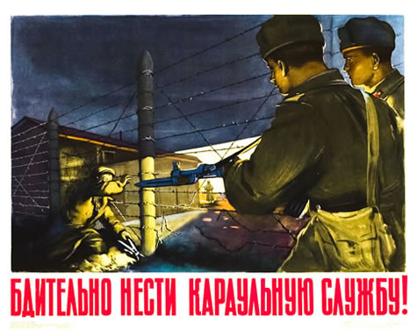
Source 2
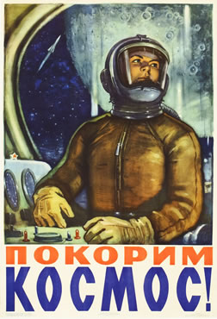
Source: <http://www.internationalposter.com/search-results.aspx?defaultview=browse&title=RU%20-%20WWII%20to%20Present&country=RU^WWII,40,50,60,70,80,90,2000http://englishrussia.com/?p=312>.
Source 3
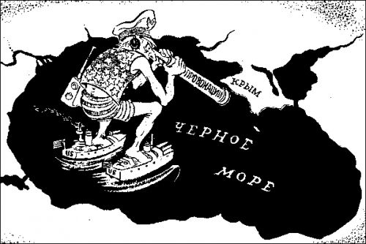
This is a Black Sea and Uncle Sam is looking thru spyglass on USSR with a sign “Provocation” on it.
Source 4
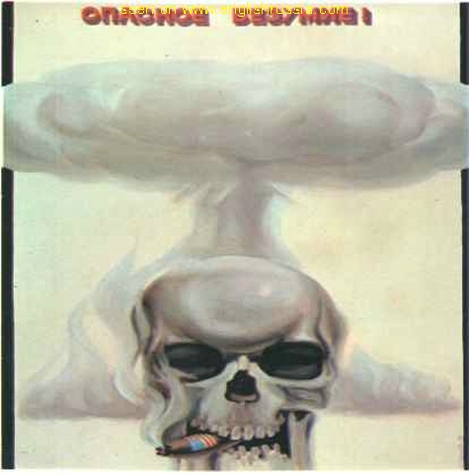
“What a Dangerous Madness”
Source 5
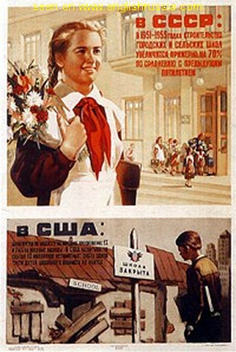
In USSR there are many new schools, in USA - schools are being closed all the time.
Source 6
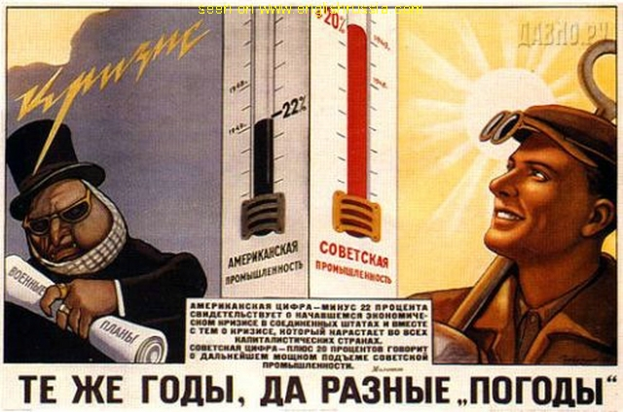
“Same years but different weathers”, red bar on the thermometer is “Soviet Industry rate”, black one is “American Industry rate”, small text tells us that there has began an economic crisis and dislocation in USA.
Source 7
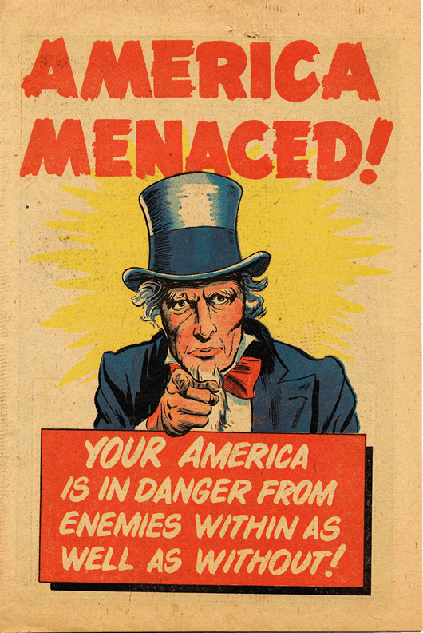

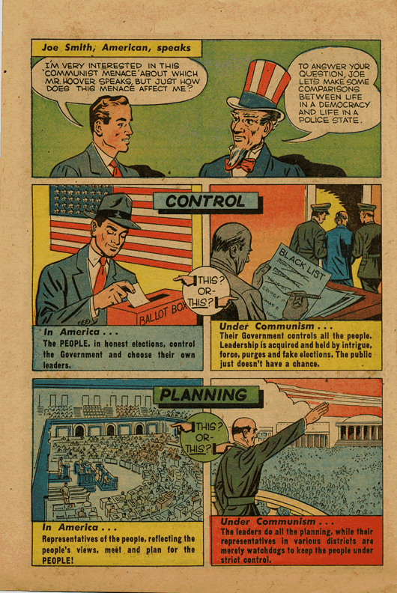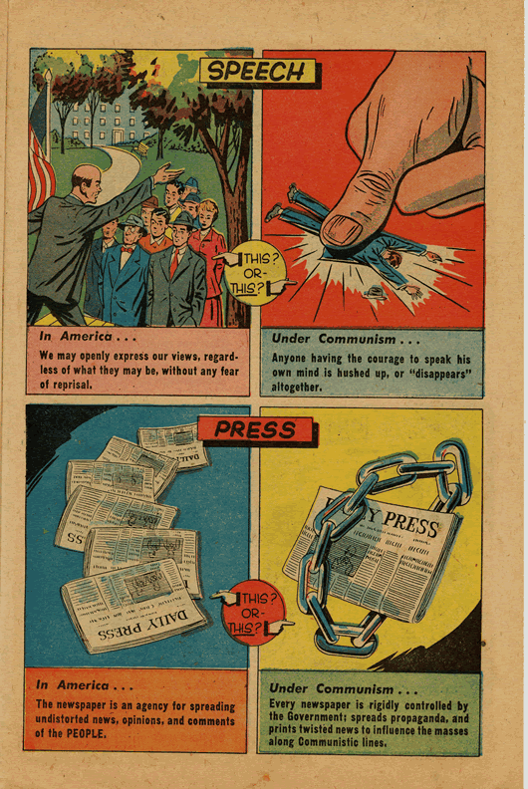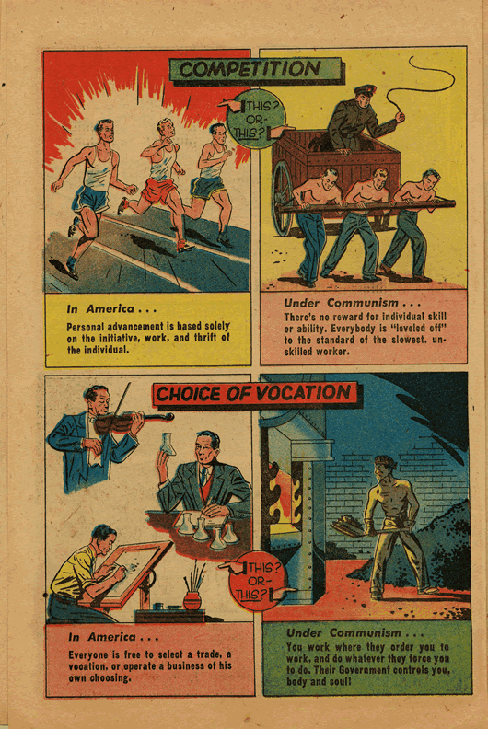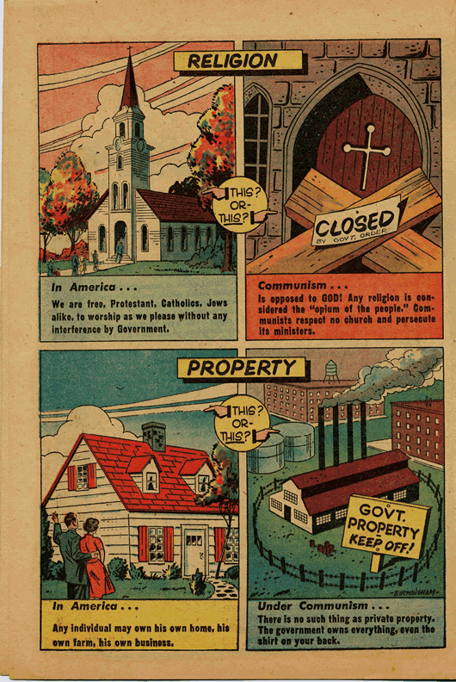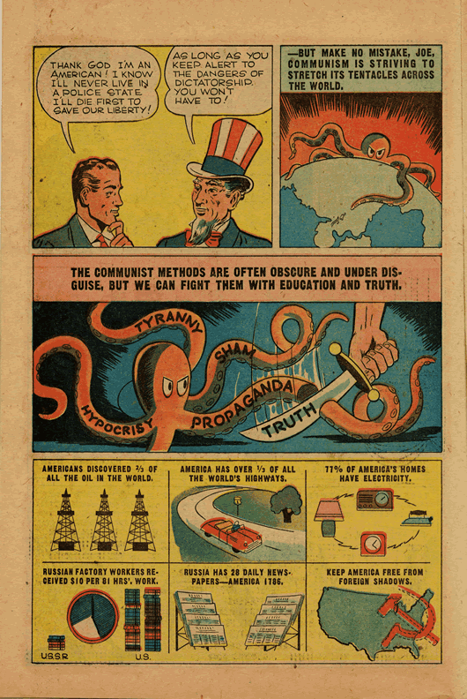
Source 8
Source 9
Source 10
Source 11
Source 12

Source: “Introduction to Anti-Communism in America.” Rutgers University. 17 April 2010 <http://www2.scc.rutgers.edu/njh/cold_war/academic_freedom/anti.php>.

