- Billy rides his sled down a frictionless slope 8 meters high, across a street 5 meters wide with a coefficient of kinetic friction equal to 0.3. Billy and his sled have a combined mass of 50 kg.
2 m
8 m
µ_{k} = 0.3
B
5 m
A
8 m

  - Billy starts at rest at point A. How fast is Billy going at point B?
Use conservation of energy:
U_{g-i} + K_{i} = U_{g-f} + K_{f}
(50kg)(10m/s²)(8m) + 0 = (50kg)(10m/s²)(2m) + ½(50kg)v_{B}²
4000 J = 1000 J + (25kg)v_{B}²
3000 J = (25kg)v_{B}²

v_{B} = 10.95 m/s

  - How much work is done on Billy and his sled as he crosses the street?

W = F_{x} ∙ Δx
W = f_{k} ∙ Δx
W = µ_{k} F_{N} ∙ Δx
W = µ_{k} m g ∙ Δx
W = (0.3)(50kg)(10m/s²)(5m)

W = 750 J technically it’s -750 J because energy is transferred out or lost

  - How high up the opposite slope does Billy go?
Use Conservation of Energy: Subtract the work done by friction from the initial energy and then convert that final energy into gravitational potential to find the final height.

E_{i} + W = E_{f}
4000 J – 750 J = m g h_{f}
3250 J = (50kg)(10m/s²) h_{f}

h_{f} = 6.5 m

- Spring 1 stores 500 J of energy. When released, it transfers this energy to Cart 1, which then flies off to the right and collides inelastically with Cart 2. The two connect together and continue moving to the right towards Spring 2. The table of information below details the important properties of the carts and springs.

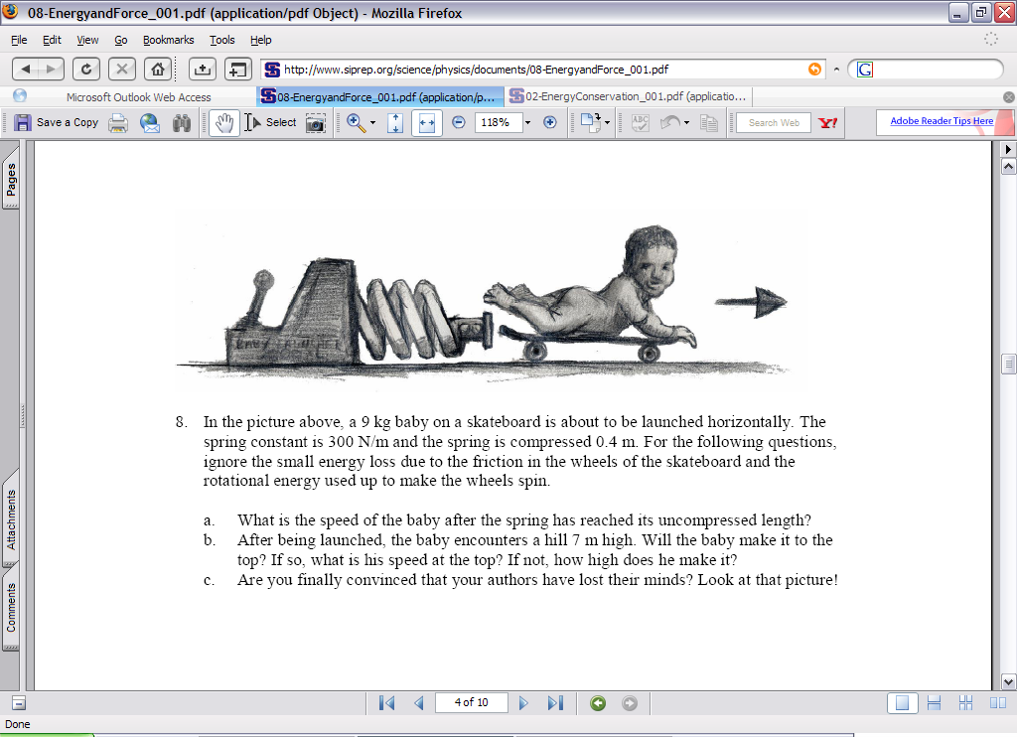
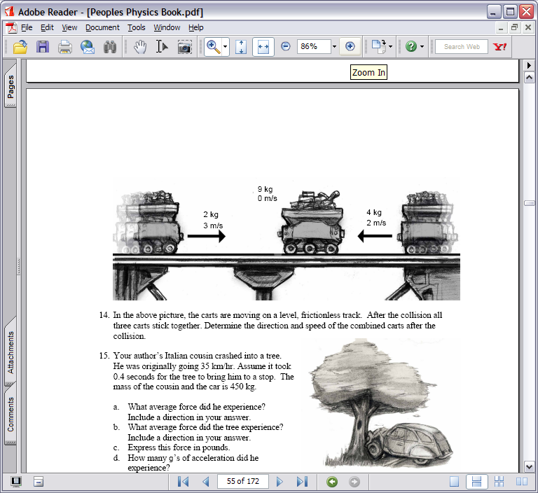
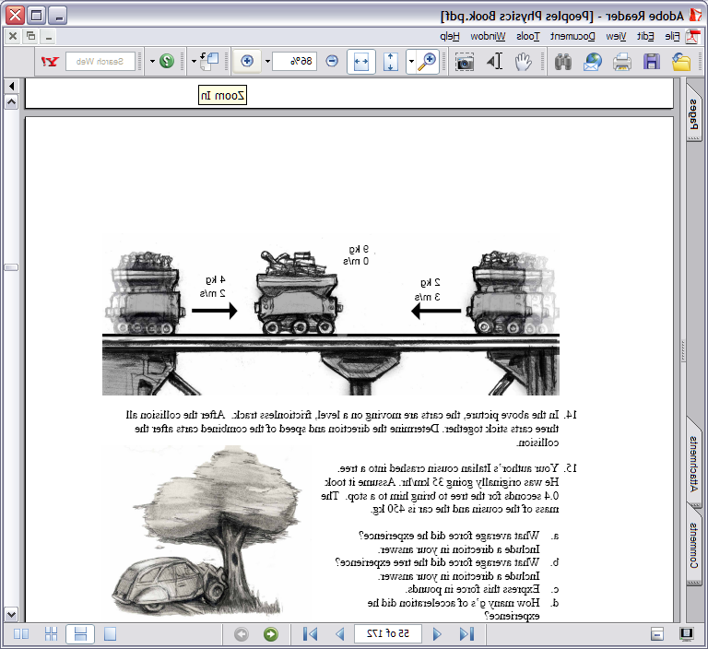
Cart 1
Cart 2
Spring 1
Spring 2

a. What is the speed of Cart 1 before it runs into Cart 2?
Cart 1 mass | 20 kg
Cart 2 mass | 40 kg
Spring 1 constant | 400 N/m
Spring 2 constant | 200 N/m
Use conservation of energy. The potential energy in spring 1 is converted into the kinetic energy of cart 1.
E_{tot-i}= E_{tot-f}
U_{sp} = K_{cart-1}
500 J = ½ (20kg) v_{i}²
v_{i} = 7 m/s

b. What is the speed of the two carts when they are attached together?
Use Conservation of Momentum for the collision of the carts

p_{i} = p_{f}
m₁v_{1i} + m₂v_{2i} = m₁v_{1f} + m₂v_{2f}
(20kg)(7m/s) + (40kg)(0) = (20kg + 40kg)v_{f}
140 kg m/s = 60kg v_{f}

v_{f} = 2.33 m/s

c. By how much does the second spring compress when it brings the two carts to a stop?
Use Conservation of Energy. The kinetic energy of the two carts is converted into potential spring energy in spring 2.
E_{tot-i}= E_{tot-f}
K = U_{sp}
½ (60kg)(2.33m/s)² = ½ (200 N/m) Δx²

Δx = 1.27 m

For the following problem, ignore any energy lost to friction or air resistance.

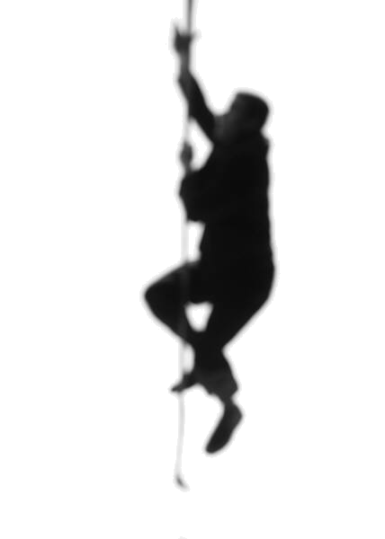
3. James Bond intends to save a woman being chased by a car of bad guys. The car is going fairly slowly because Bond already shot out the tires. Having studied physics during his training, he decides he will swing down on a rope, grab her, and bring them both to safety on a far away ledge. James has a mass of 75 kg and starts out from rest on a ledge that is 8 m above the ground. The woman has a mass of 55 kg and is running at a constant speed of 2.5 m/s.

a. Calculate James’ initial energy.
E_{i-Bond} = U_{g-i-Bond}
E_{i-Bond} = m_{Bond} g h_{i-Bond}
E_{i-Bond} = (75 kg)(9.8 m/s²)(8 m) E_{i-Bond} = 5880 J

b. Calculate the woman’s initial momentum.
p_{i-woman} = m_{woman} v_{i-woman}
p_{i-woman} = (55 kg)(2.5 m/s)
p_{i-woman} = 137.5 kg·m/s rightward

c. How much momentum does James have just before he grabs the woman?
Solve for speed using conservation of energy
E_{Bond} = U_{g} + K
5880 J = 0 + ½ (75kg) v_{Bond}²
v_{Bond} = 12.52 m/s
p_{Bond} = m_{Bond} v_{Bond}
p_{Bond} = (75kg) (12.52m/s)

p_{Bond} = 939.1 kg m/s rightward

d. What impulse does James deliver to the woman when he grabs her?

Impulse is change in momentum, but to get her final momentum we need to use conservation of momentum
p_{i} = p_{f}
p_{i woman} + p_{i James} = p_{f woman} + p_{f James}
137.5 kg·m/s + 939.1 kg·m/s = (75kg + 55kg) v_{f-Bond&Woman}
v_{f-Bond&Woman} = 8.28 m/s

Now solve for impulse:
J_{woman} = ∆p = p_{f-woman} – p_{i-woman}
J_{woman} = (55kg)(8.28m/s) – 137.5kg·m/s

J_{woman} = 317.9 kg·m/s rightward

e. Will they make it to the ledge on the right? Its height is 4.5 m.
Use Conservation of Energy
E_{tot-i}= E_{tot-f}
U_{g-i} + K_{i} = U_{g-f} + K_{f}
0 + ½(130kg)(8.28m/s)² = (130kg)(9.8m/s²) h_{f} + 0

h_{f} = 3.5 m

Nope…can’t win ‘em all

4. A 350 kg rocket-car is attempting to beat the land-speed record by breaking the sound barrier (reaching a velocity of 343 m/s). The rocket applies a constant horizontal thrust of 10,000 N. For the purposes of this problem, we can neglect air resistance and friction.

a. Calculate the work done to the rocket by the thrust force over a distance of 100 m.
W = F Δx
W = (10000 N)(100 m)

W = 1,000,000 Joules.

b. Use your answer to part (a) to determine the speed of the rocket-car after it has traveled a distance of 100 m. Assume it began at rest.
The energy of the rocket-car has increased by a million Joules. Since it is traveling horizontally, none of this went into potential energy: it all went into the kinetic energy of the car.

E_{tot} = ½ m v²
1,000,000 J = ½ (350 kg) v²

v = 75.6 m/s

c. What horizontal distance would the rocket-car need to get up to the speed of sound starting from rest?
K_{at speed of Sound} = W

½ m v_{sound}² = F Δx
½ (350 kg) (343 m/s)² = (10000 N) Δx

Δx = 2058 m … just over 2 kilometers. Better get a bigger rocket.

