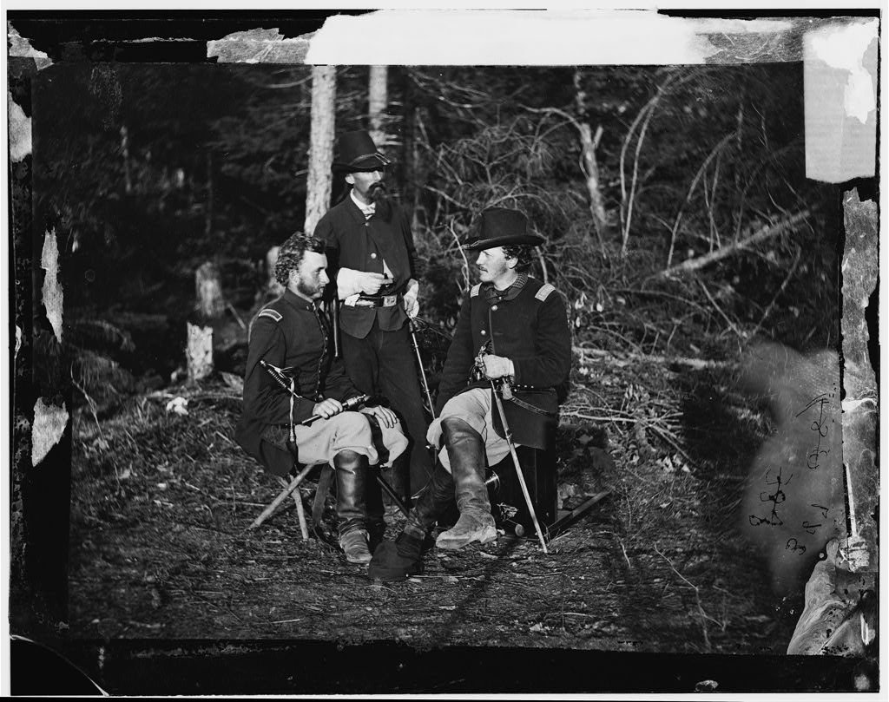

Journal 24

George A Custer, VA May 1862

