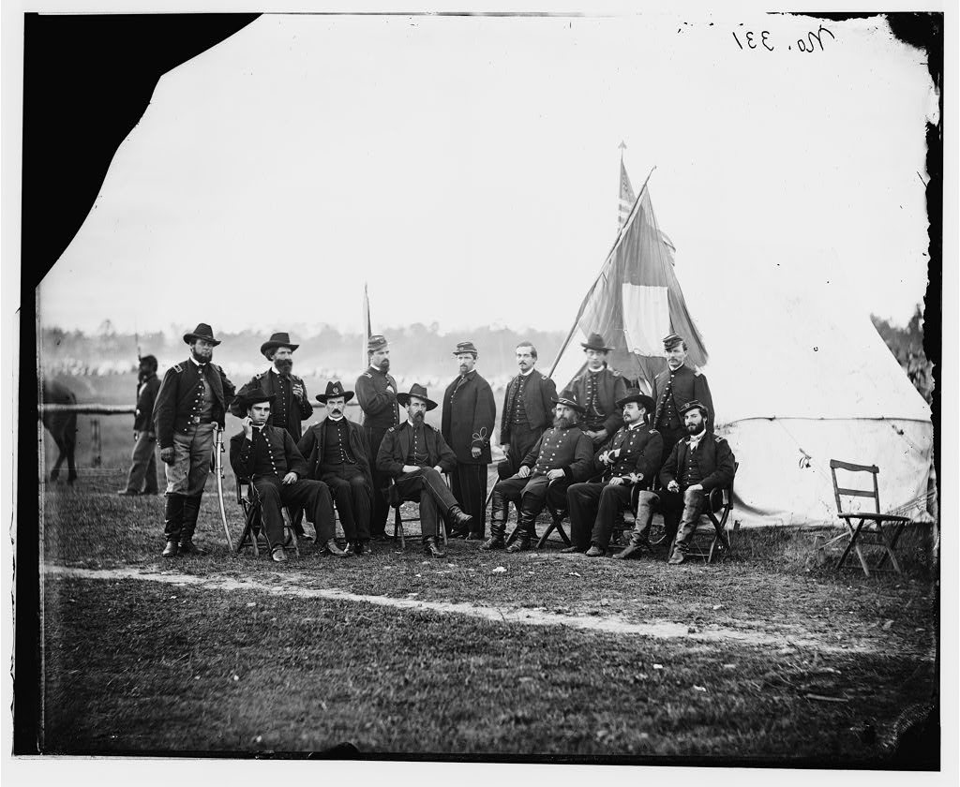
Journal # 23

General henry prince of the 2nd division 3rd cops and staff

