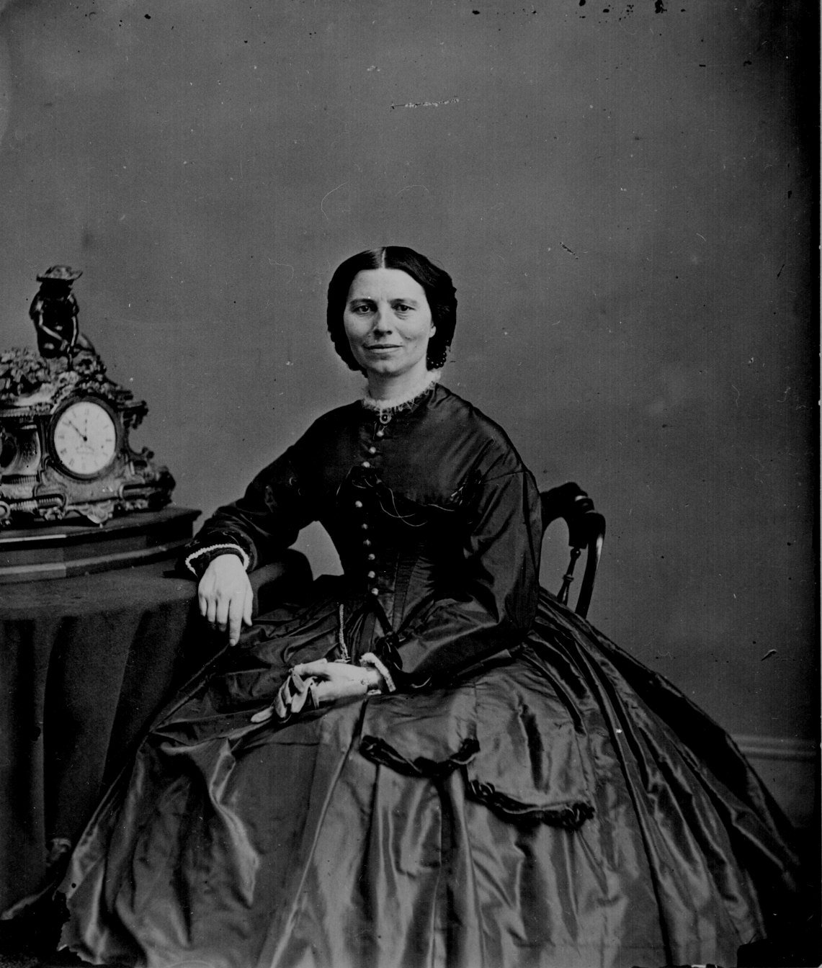
Journal 21 Mary Todd Lincoln

