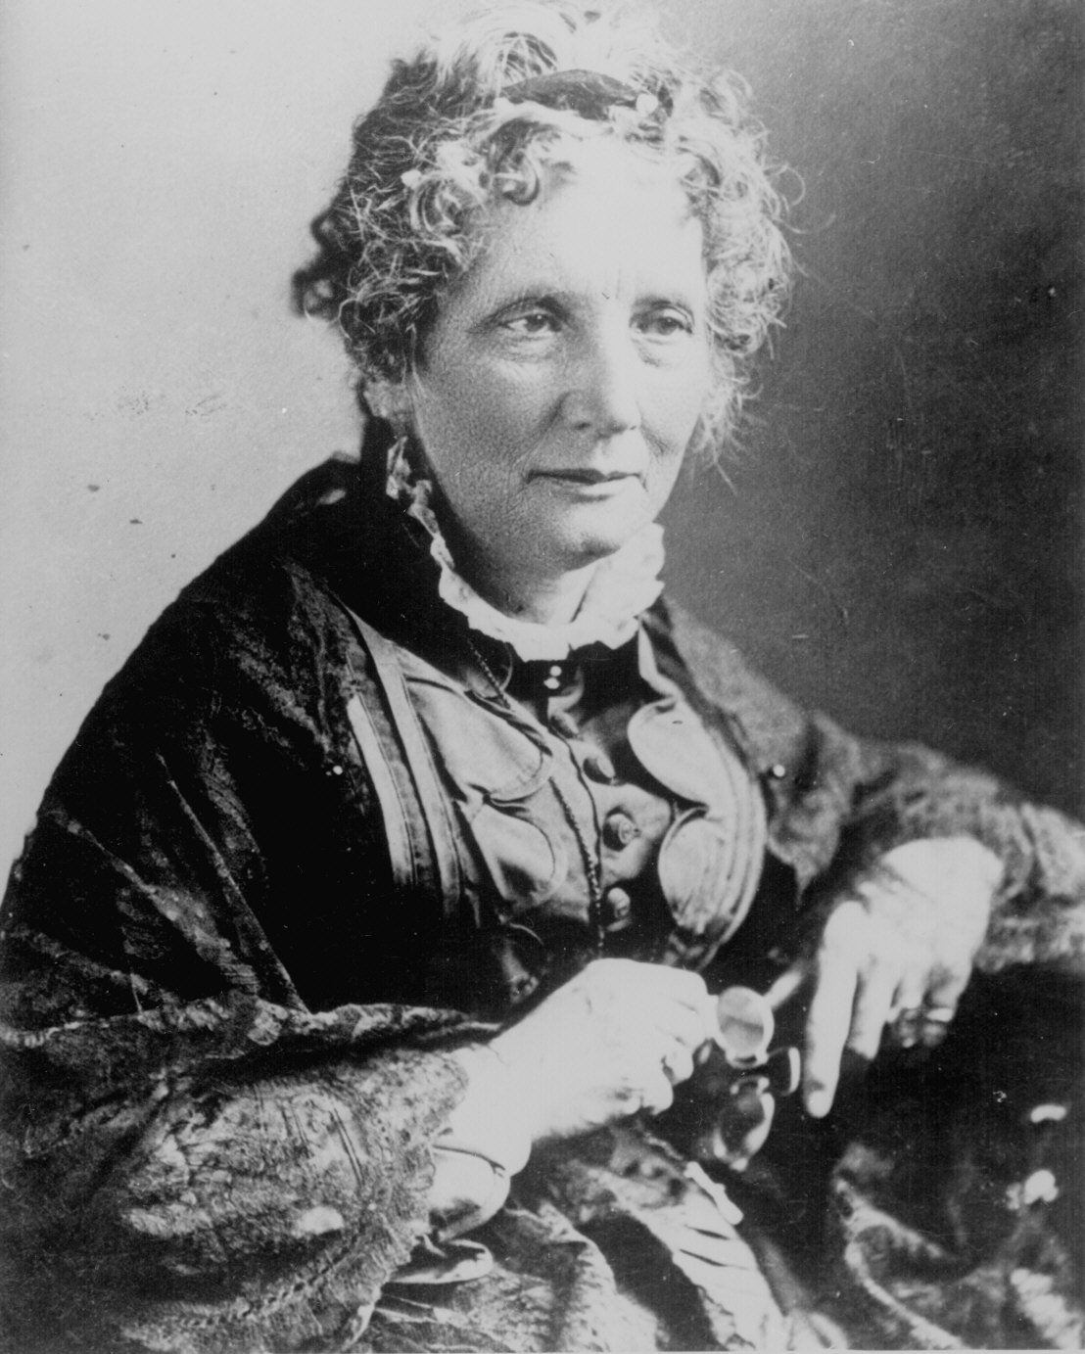
Journal 20 Harriet Beecher Stowe author of Uncle Tom’s Cabin

