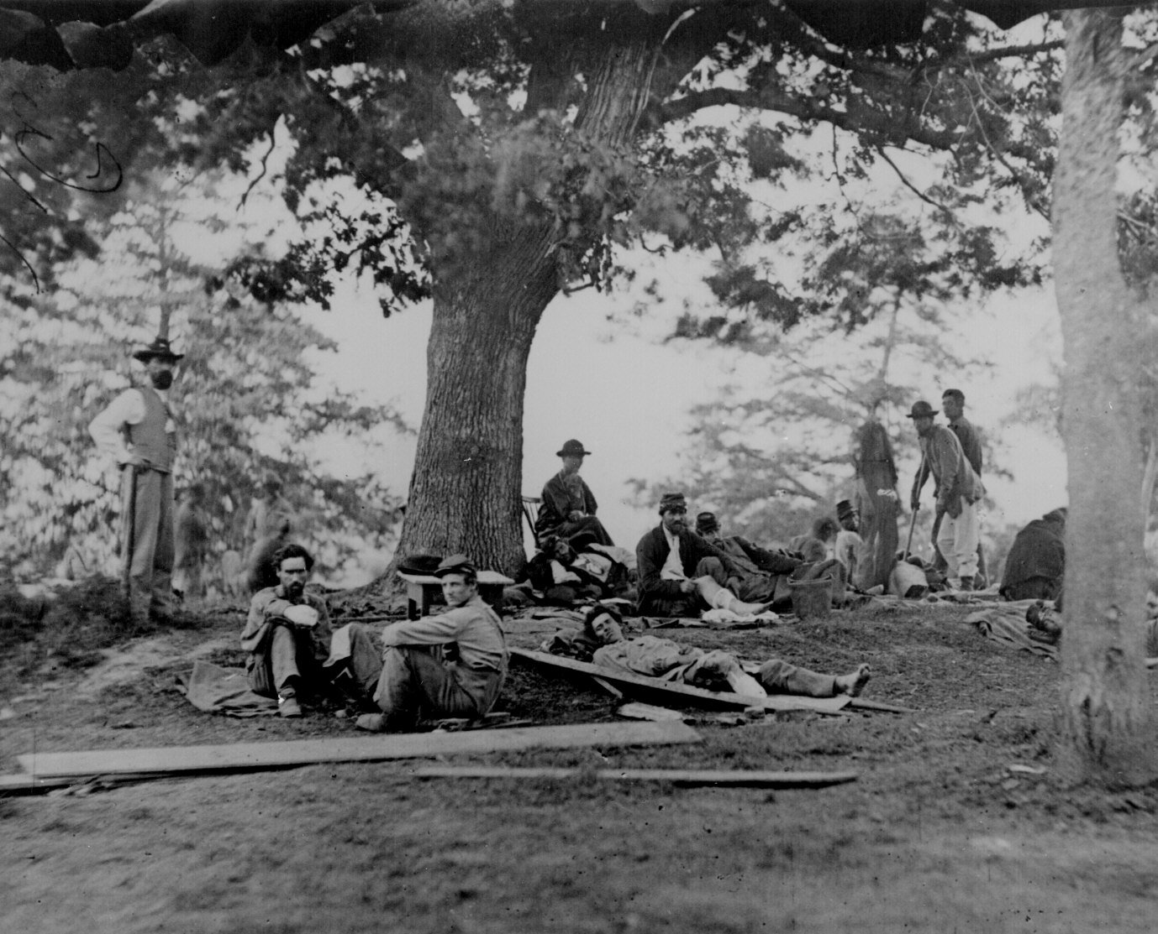
Journal # 12
Wounded soldiers being tended in the field after the battle of Chancellorsville , VA 5/2/1863

