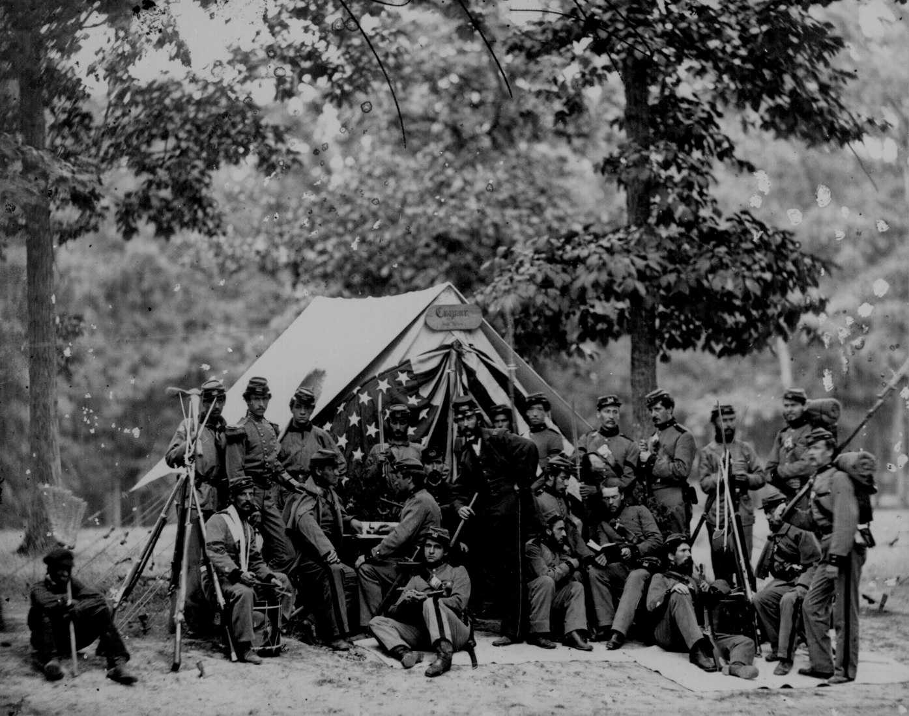
Journal # 7 Monday 3/29/10

