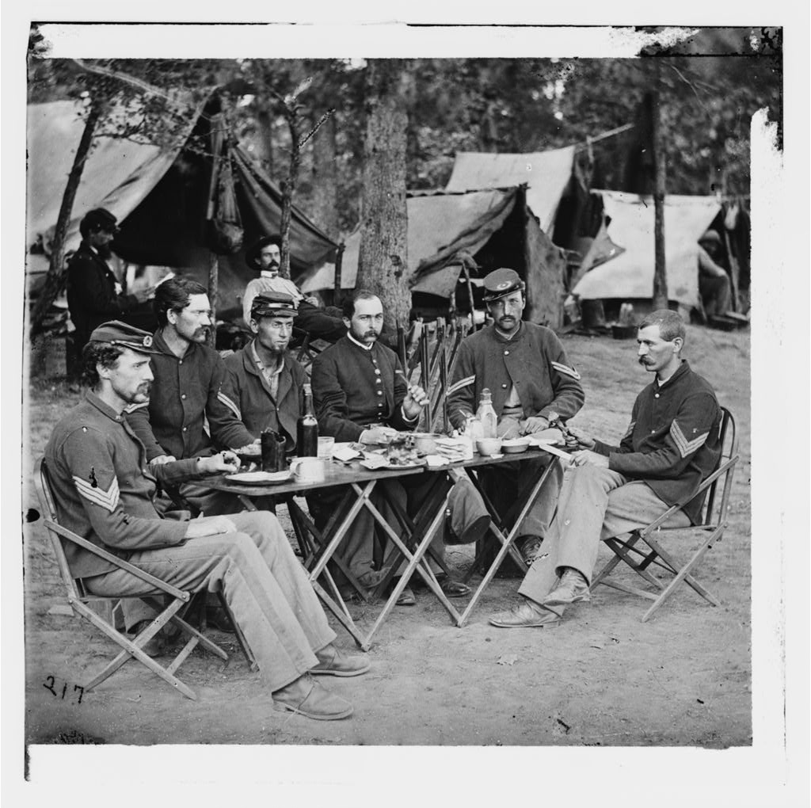
Journal for Tuesday 3/23/2010

